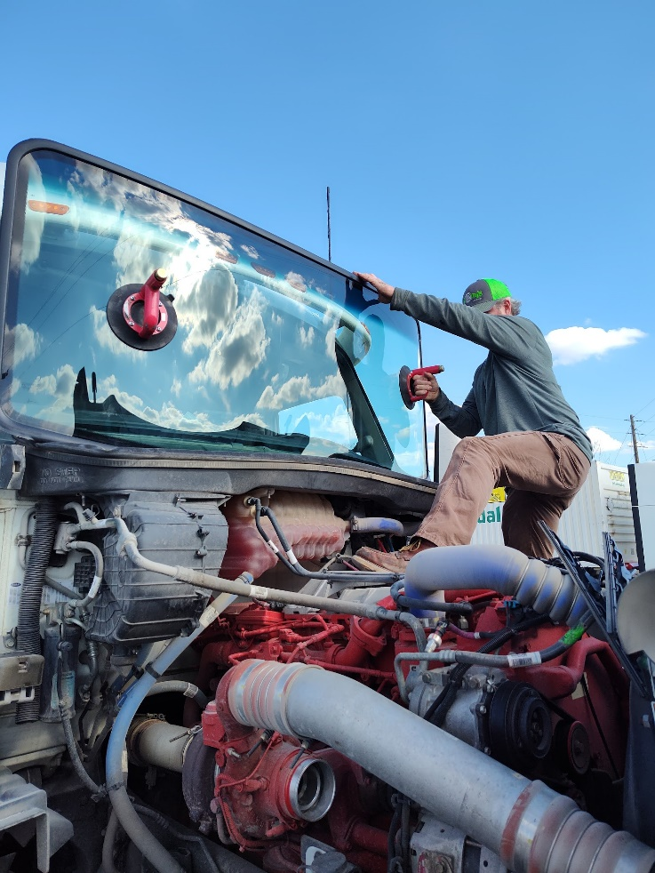

Contact us at

**417-483-0968**

or on the web at www.bigrigglassok.com

Congue nihil imperdiet doming id quod mazim placerat facer minim veni am ut wisi enim ad minimeniam, quis erat nostr uexe

rci tation ullamcorper nostru exerci tation ullam corper et iusto odio dig nissim qui blandit praesent lupta. Tummer delenit

augue duis dolore te feugait nulla facilisi. Con erattis sectetuer adip iscing elit, sed erat diam nonummy nibh magna erat.

*CAMPBELL’S BIG TRUCK GLASS*

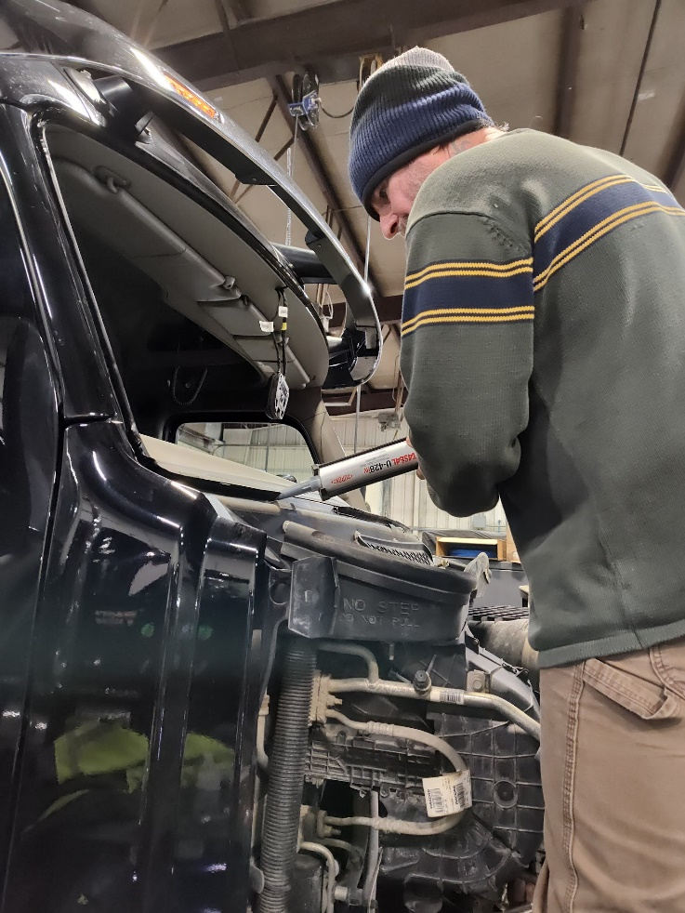

*Dean’s Big Rig Glass*



***Handling all your big truck glass needs!***

Please be sure to follow the instructions in this information sheet to ensure your windshield install is a success!

**Date and Time of Completion**

**_________________________**

*It was our pleasure to install a new windshield in this truck today!*

*Thank you for letting us serve you!*

***The urethane used in the installation process requires a FOUR HOUR cure time. To avoid leaks please follow the instructions listed below:***

**4.**

**1.**

**2.**

***Do NOT drive the truck for 4 hours after windshield installation is complete.***

***Be sure to crack a window in order to release the vacuum of cabin pressure before opening and closing doors.***

***Do NOT push out on the windshield for any reason.***

***Do not reinstall cameras, decals, toll scanners or stickers until 4 hours has passed from time of completion.***

**3.**

***NO power washing for ONE WEEK following install.***

***Thank you for your cooperation in getting you back on the road with a safe and leak free windshield!***