EXECUTIVE SUMMARY
Renaissance League LLC
An Innovative Sports Ecosystem for All Families
Thank you for your interest in Renaissance League LLC (the “League”), a groundbreaking initiative to transform access to amateur sports by making participation financially affordable for all families.

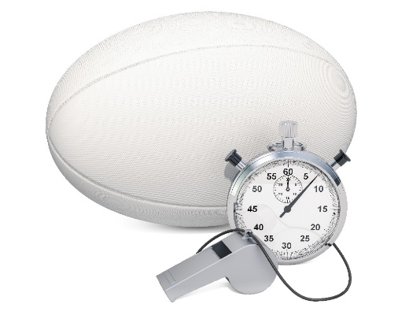
We are launching a new sports ecosystem that integrates professional and amateur athletics within a unified model designed to generate sustainable revenue, reduce operating costs, and reinvest in community participation. The sports ecosystem directly addresses the increasing financial burden on families due to failing professional and amateur sports organization models, declining public-school programs, and the transition of colleges from amateur to professional sports.

This opportunity begins with forming a pioneering women’s and girls’ rugby league, inclusive of all ages and skill levels, structured around local collectives known as “Tribes.”

Opportunity Overview
The League will create a vibrant fan experience through dynamic relationships between Tribes, their supporters, and sponsors. Revenue will be driven by:
- Athlete subscriptions
- Athlete training academies
- Ticket and merchandise sales
- Sponsorships targeting engaged, values-aligned audiences
Operating costs will be reduced through centralized procurement for essentials such as uniforms, gear, travel, insurance, facilities, and staffing. This dual strategy — higher revenues and reduced costs to achieve sustainable business operations — makes sports participation more affordable for families while building a scalable business model.

Community Impact
To ensure inclusivity, the League will allocate 5% of adjusted net revenues—equivalent to 25% of net profits—to the Citizens Sports Foundation, providing need-based scholarships to support family participation across all Tribes in connection with local youth programs. Additional scholarships will be funded through charitable lotteries managed by Gaming Solutions International LLC.

Investment Terms – Seed Round
We are offering ten $50,000 investments to raise $500,000 in Seed Funding. These funds will be used to:
- Launch League operations
- Recruit Tribe leaders and athletes
- Plan the first season of play
- Negotiate public-private partnerships with five pilot cities
- Conduct a $5,000,000 second-round raise
Seed investors will receive participation rights in the League Revenue Pool, Tribe Purchase Options, and additional legacy-related benefits.


Future Plans & Tokenization
Before initiating the second funding round, revenue rights will be tokenized via the issuance of League Coins, with listing and exchange services provided by Manaia LLC.
All funding rounds—including future Tribe-specific rounds—will be supported by 19th Hole LLC, a specialist in delivering unique, memorable investor experiences. 19th Hole will also manage the Triple Threat Champions, a private investment club advancing the League and the broader sports ecosystem model.

Growth Roadmap
Second-Round Funding ($5 million) will support:
- The inaugural season of play with five Tribes
- Participation of 1,800 athletes across nine tiers, from 8th-grade youth to professional
- Full-time management provided by Citizens Sports
Upon successful completion of the first season and proof of concept, the League will offer the first five Tribes for sale in exchange for a cash fee to the League, a grant of rights to share in revenues in a Tribe coin offering, and an additional investment into the Tribe.
Each Tribe is planned to raise $50 million in capital to develop a 15,000-seat multi-purpose stadium and sports complex. Following the second season, the League plans to scale to add five more Tribes.

The success of the Renaissance League will serve as a template for expanding the sports ecosystem across multiple sports worldwide to increase sports participation and fandom.

Join us in redefining the future of sports—with affordability, community, and sustainability at its core.

Thank you for your consideration.

For more information, contact:

Karl Dakin
Dakin Capital LLC
kdakin@dakincapital.com
720 296 0372

