FSA SET UP GUIDE

Dear Participant,
Take advantage of tools that are available with the ESG debit card to manage your FSA account.
Debit Cards
Two cards will arrive via USPS mail. Save these, the same cards will be used for 3 years. If you enroll in the same or different plan next year, the new funds will be attached to your existing card. Replacement cards will be mailed out before the expiration date.
Is there anything I need to do?
If you have an FSA, there’s nothing additional you need to do. Your account and debit card is active on the first day of the plan year and the cards will be active and ready to use.
Consumer Portal / Web Access
You already have access to your ESG Benefit Accounts Online Consumer Portal. This one-stop portal gives you 24/7 access to view information and manage your account(s). It enables you to:
- File a claim online and upload supporting documentation for your claim
- Upload receipts and track expenses
- View up-to-the-minute account balances
- View your account activity, claims history and payment (reimbursement) history
- Report a lost/stolen card and request a new one
- Update your personal profile information
- Change your login ID and/or password
- Access forms and documents including a listing of FSA eligible expenses

How do I log in to the Consumer Portal?
- Follow this link: https://esgcorp.lh1ondemand.com or download the mobile app ‘Benefits by ESG’ from your smartphone app store
- Enter your login ID and password. Initially both user and password are set to be your first initial, last name and last 4 digits of your social security number.
Example: Jane Doe with SSN# 201-33-5555 would use jdoe5555
- Click Login.
- You will be prompted to change your password and setup three personal security questions.

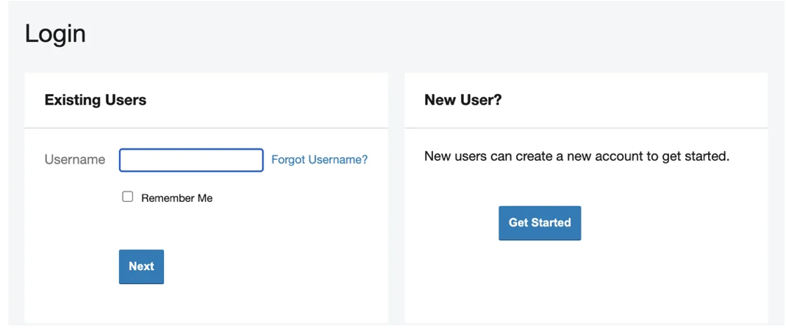
How do I get my reimbursement money faster?
For non-debit card claims, the fastest way to get your money is to sign up for direct deposit to your personal checking account.
To sign up for direct deposit:
- On the Home Page, under Accounts, select Banking/Cards
- Select Add Bank Account.
- Enter your bank account information and hit Submit.
You may be required to activate your account by watching for a micro deposit/withdrawal, an amount under $1.00. Record the actual amount to activate your account. Note, this may take a few days since money does move into your account.
- Update your bank account for reimbursements:
- Click on the Tools & Support tab at the top of the page.
- Click on Change Payment Method under the “How Do I?” section.
- Select Update for the Account, select Direct Deposit and then Submit.
Want to check your healthcare account balances and submit receipts anywhere, anytime? There’s an app for that!
‘Benefits by ESG’, the mobile app, provides time-saving options for you to:
- Check current health care account balances
- View account activity and receive alerts via text message
- View transaction details
- Submit claims and upload backup documentation using the mobile device’s camera
Get started with Benefits by ESG in minutes. After you’ve set up your online consumer portal with your selected password, you may simply download the Benefits by ESG App for your Android or iPhone and log in using the same ID and password you use to access the Consumer Portal. You will be asked to create a 4-digit passcode which you will use instead of the login/password for subsequent sessions.
For more information visit us at: https://employeesolutionsgroup.com/fsa
We are here to help! Please contact us with any questions.
ESG Customer Service
 | Toll Free · 877.668.8522  customerservice@esgcorp.biz   www.employeesolutionsgroup.com

