HRA SET UP GUIDE

Dear Participant,
Follow these instructions to access your ESG Health Reimbursement Arrangement (HRA) account for 2024! Your account is available via ESG’s Online Consumer Portal and mobile app.
My account:
ESG has already created a new account for you based on your health plan selection from open enrollment. The portal gives you 24/7 access to your Health Reimbursement Arrangement (HRA) in order to:
- File claims and upload documentation (EOBs– Explanation of Benefits) from carriers for your claim
- View current account balance
- View/download plan documents
- View your account activity, claims history and payment/reimbursement status
- Update personal profile information (address, email, and phone # changes)
- Change your login ID and/or password
How do I log in to the Consumer Portal online?
- Follow this link: https://esgcorp.lh1ondemand.com or download the mobile app ‘Benefits by ESG’ from your smartphone app store
- Enter your login ID and password. Initially both username and password are set to be your first initial, last name and last 4 digits of your social security number.
Example: Jane Doe with SSN# 201-33-5555 would use jdoe5555
- Click Login.
- You will be prompted to change your password and setup three personal security questions.

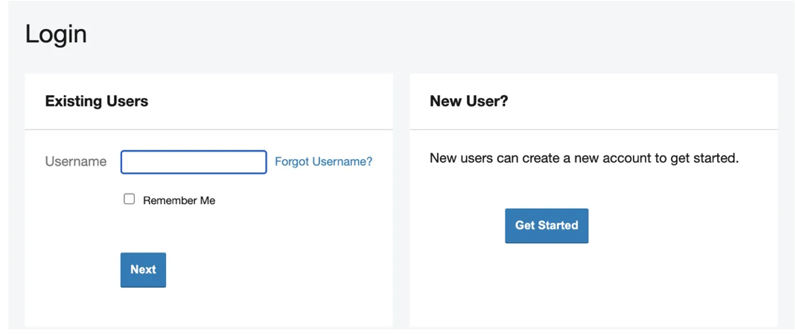
How do I get my reimbursement money faster?
For non-debit card claims, the fastest way to get your money is to sign up for direct deposit to your personal checking account.
To sign up for direct deposit:
- On the Home Page, under Accounts, select Banking/Cards
- Select Add Bank Account.
- Enter your bank account information and hit Submit.
You may be required to activate your account by watching for a micro deposit/withdrawal, an amount under $1.00. Record the actual amount to activate your account. Note, this may take a few days since money moves into your account.
- Update your bank account for reimbursements:
- Click on the Tools & Support tab at the top of the page.
- Click on Change Payment Method under the “How Do I?” section.
- Select Update for the Account, select Direct Deposit and then Submit.
Want to check your healthcare account balances and submit receipts anywhere, anytime? There’s an app for that!
‘Benefits by ESG’, the mobile app, provides time-saving options for you to:
- Check current health care account balances
- View account activity and receive alerts via text message
- View transaction details
- Submit claims and upload backup documentation using the mobile device’s camera
Get started with Benefits by ESG in minutes. After you’ve set up your online consumer portal with your selected password, you may simply download the Benefits by ESG App for your Android or iPhone and log in using the same ID and password you use to access the Consumer Portal. You will be asked to create a 4-digit passcode which you will use instead of the login/password for subsequent sessions.
We are here to help! Please contact us with any questions or visit us at: https://employeesolutionsgroup.com/hra
ESG Customer Service
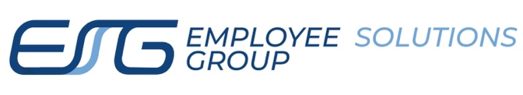 | Toll Free · 877.668.8522  customerservice@esgcorp.biz   www.employeesolutionsgroup.com

