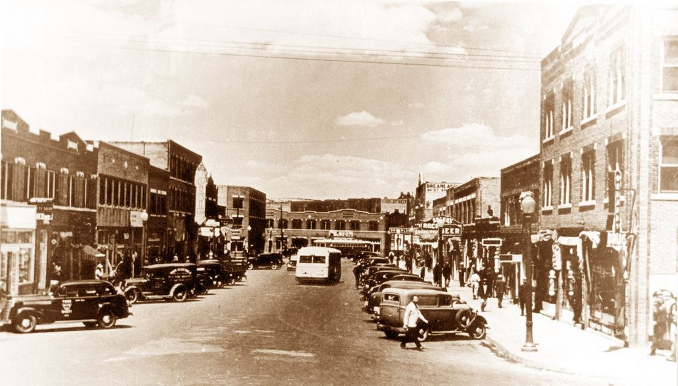

Follow Us on Social Media

@BWS_LL



Hash Tag us to be featured on our pages!

#BWSLL

**Not Coffee** 12oz 16oz

Golden Latte 4.95 5.25

Greenwood Latte 4.25 4.95

Sweet Willie J 3.45 3.95

(Hot Chocolate)

**Tea** 16oz

Black Tea $2.75

Green Tea $2.75

High Baller Tea $3.95

**Pastry Goods**

Pastry of the week Ask us about it!

**Add-Ons**

Syrups .50

*Vanilla, Hazelnut, Toffee Nut, Caramel, Brown Butter Toffee Nut, Cinnamon, Mint, Pure Cane Sugar*

Sauces .75

*Caramel, Chocolate*

Nuts .75

**Espresso** 12oz 16 oz

Latte 2.75 3.40

Cappuccino 2.75 3.40

Caramel Macchiato 4.25 4.75

Café Mocha 3.95 4.35

Café Africano 2.25 2.70

Espresso 1.25

Espresso-Double 2.25

Extra Shot .75

**Brewed** 12oz 16oz

Crude 2.00 2.25

Iced Crude 2.25 2.85

Ethiopian Press 7.50/6 cups 9.50/8 Cups

African Pour Over $2.50

**Fraps** 12oz 16 oz

Caramel Frap 3.95 4.50

Mocha Frap 3.95 4.50

**Specialty Fraps** 12oz 16oz

Cowboy Frap 4.20 4.75

OW Gurley Frap 4.45 5.00

Monday-Friday 7AM-3PM

539.867.2477

10 N Greenwood Ave S101 Tulsa, OK 74120

Liquid Lounge

**Black Wall Street**