

**GOVERNMENT'S APPROACH TO FLEET MANAGEMENT SERVICES**

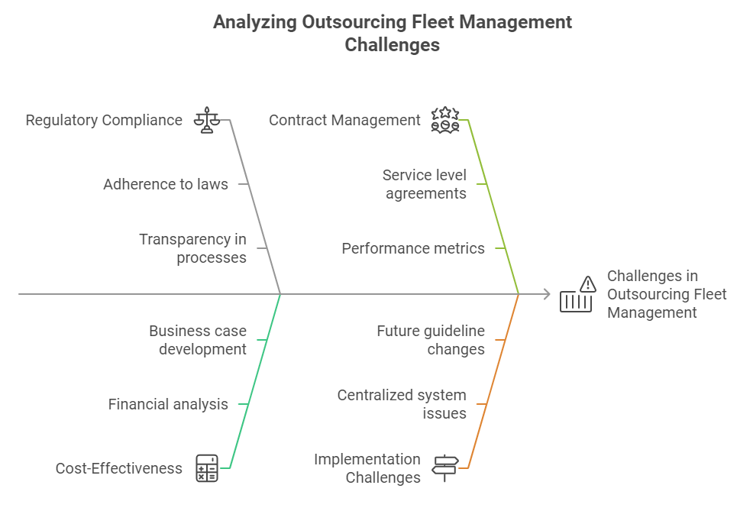

**The South African government's approach to outsourcing fleet management** is significantly influenced by the National Treasury's guidelines and regulations. These guidelines, as outlined in the National Treasury's Framework for the Management of Government Fleet (2015), are pivotal in the government's efforts to strike a balance between vehicle ownership and leasing, with a strong emphasis on cost-effectiveness and efficient management.

The framework unequivocally states that 'the outsourcing of fleet management services is a viable option for government departments and entities, provided that it is done in a manner that is transparent, fair, and in accordance with the relevant laws and regulations.' This commitment to transparency and fairness in the outsourcing process instils confidence in the government's integrity.

The South African government has entrusted the management of its centralised fleet management system to the State Information Technology Agency (SITA). As the custodian of this system, SITA is responsible for providing fleet management services to government departments and entities, including the management of vehicle leasing and outsourcing contracts.

In terms of outsourcing, the government has established a set of guidelines and regulations that must be followed by departments and entities when outsourcing fleet management services. These guidelines include the requirement for a thorough business case to be developed, which must demonstrate the cost-effectiveness and benefits of outsourcing. (Source: National Treasury, Guidelines for the Outsourcing of Fleet Management Services, 2017)

The government has also established a set of minimum requirements for outsourcing contracts, which include the requirement for service level agreements, performance metrics, and penalties for non-performance. (Source: National Treasury, Guidelines for the Outsourcing of Fleet Management Services, 2017)

It's important to note that the South African government's approach to outsourcing fleet management is not static. The government is committed to continuous improvement, and as such, new guidelines and regulations may be introduced in the future to enhance fleet management practices further.

**Sources:**

* National Treasury. (2015). Framework for the Management of Government Fleet.

* National Treasury. (2017). Guidelines for the Outsourcing of Fleet Management Services.

* State Information Technology Agency (SITA). (n.d.). Fleet Management Services.

Please note that the sources provided are subject to change, and it's always best to verify the information with the relevant authorities or check for updates.

The State Information Technology Agency (SITA) is a South African government agency responsible for providing information and communication technology (ICT) services to the public sector and fleet management services to government departments and entities.

The SITA Fleet Management Services protocol is a set of guidelines and procedures that outline the requirements and standards for fleet management in the South African public sector. It is based on the National Treasury's guidelines and regulations for fleet management and is intended to ensure that government departments and entities manage their fleets cost-effectively and efficiently.

**The SITA Fleet Management Services protocol covers the following key areas:**

* Fleet Management Policy: The protocol outlines the requirements for a fleet management policy, which must be developed and implemented by each government department and entity. The policy must include details on fleet management objectives, roles and responsibilities, and procedures for managing the fleet.
* Fleet Management Structure: The protocol requires that each government department and entity establish a fleet management structure, which must include a fleet manager, a fleet management committee, and a fleet management system.
* Vehicle Acquisition and Disposal: The protocol outlines the procedures for acquiring and disposing of vehicles, including the requirements for tendering, procurement, and disposal.
* Vehicle Maintenance and Repair: The protocol requires that government departments and entities establish a vehicle maintenance and repair program that includes regular maintenance schedules, repair procedures, and quality control measures.
* Fuel Management: The protocol outlines the requirements for fuel management, including the use of fuel cards, fuel monitoring systems, and fuel consumption reporting.
* Driver Management: The protocol requires that government departments and entities establish a driver management program that includes driver training, monitoring, and evaluation.
* Fleet Management Information System: The protocol requires that each government department and entity implement a fleet management information system, which must include data on vehicle usage, maintenance, and fuel consumption.
* Reporting and Monitoring: The protocol requires that government departments and entities submit regular reports on fleet management performance, including data on vehicle usage, maintenance, and fuel consumption.

**The SITA Fleet Management Services protocol also includes guidelines on the following**:

* Fleet Management Service Level Agreements: The protocol outlines the requirements for service level agreements between government departments and entities and fleet management service providers.
* Fleet Management Performance Metrics: The protocol outlines the performance metrics that must be used to measure fleet management performance, including metrics on vehicle usage, maintenance, and fuel consumption.
* Fleet Management Audits: The protocol requires that government departments and entities conduct regular audits of their fleet management systems and procedures.

Overall, the SITA Fleet Management Services protocol is designed to ensure that government departments and entities manage their fleets cost-effectively and efficiently and comply with the National Treasury's guidelines and regulations for fleet management.

Please note that the protocol is subject to change, and it's always best to verify the information with SITA or check for updates.

**Fleet management performance refers to the metrics and standards** used to measure the efficiency and effectiveness of a fleet management system. In the context of the South African government, fleet management performance is critical to ensuring that government departments and entities manage their fleets cost-effectively and efficiently.

**The National Treasury's guidelines and regulations for fleet management require that government departments and entities establish a fleet management performance framework that includes the following key performance indicators (KPIs):**

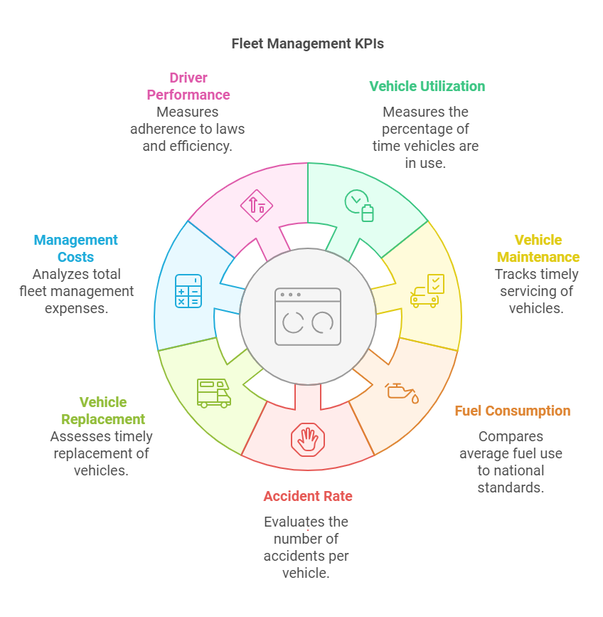

* Vehicle Utilization: This KPI measures the percentage of time that vehicles are in use compared to the total time they are available. The target is to achieve a minimum of 80% vehicle utilisation.
* Vehicle Maintenance: This KPI measures the percentage of vehicles that are serviced and maintained on time compared to the total number of vehicles in the fleet. The target is to achieve a minimum of 95% vehicle maintenance compliance.
* Fuel Consumption: This KPI measures the average fuel consumption per vehicle compared to the national average. The target is to achieve a minimum of 10% reduction in fuel consumption per vehicle.
* Accident Rate: This KPI measures the number of accidents per vehicle compared to the national average. The target is to achieve a minimum 20% reduction in the accident rate.
* Vehicle Replacement: This KPI measures the percentage of vehicles that are replaced within the recommended replacement cycle compared to the total number of vehicles in the fleet. The target is to achieve a minimum of 80% vehicle replacement compliance.
* Fleet Management Costs: This KPI measures the total cost of fleet management, including vehicle acquisition, maintenance, fuel, and other expenses, compared to the national average. The target is to achieve a minimum of 10% reduction in fleet management costs.
* Driver Performance: This KPI measures drivers' performance, including their adherence to traffic laws, vehicle maintenance, and fuel consumption. The target is to achieve a minimum of 90% driver performance compliance.

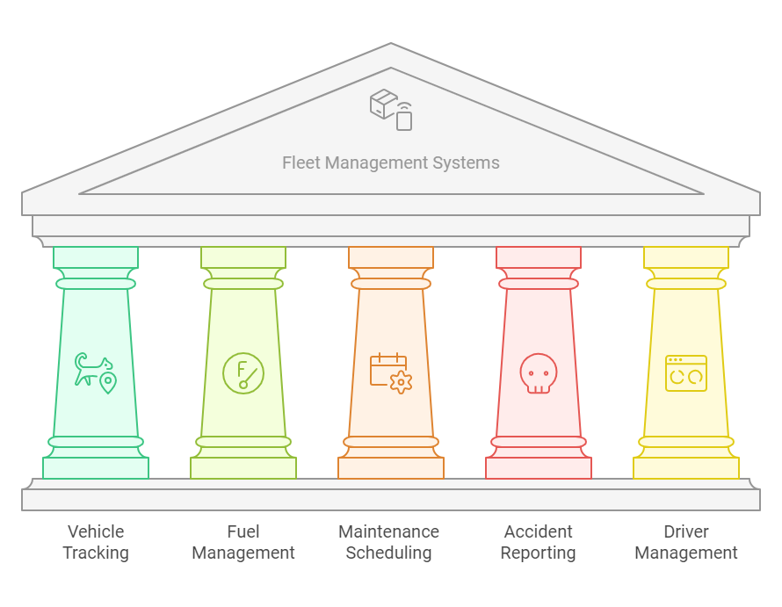These KPIs measure the performance of fleet management systems and identify areas for improvement. Government departments and entities are required to report on their fleet management performance regularly using a standardised reporting template.

**In addition to these KPIs,** the National Treasury's guidelines and regulations for fleet management also require that government departments and entities establish a fleet management information system that includes the following features:

* Vehicle Tracking: A system that tracks the location and movement of vehicles in real-time.
* Fuel Management: A system that tracks fuel consumption and monitors fuel usage.
* Maintenance Scheduling: A system that schedules and tracks vehicle maintenance.
* Accident Reporting: A system that reports and tracks accidents involving government vehicles.
* Driver Management: A system that tracks driver performance and monitors driver behaviour.

These features are designed to provide government departments and entities with the tools and information they need to manage their fleets effectively and efficiently.

Please note that these requirements are subject to change, and it's always best to verify the information with the relevant authorities or check for updates.

**Other Important Outsourcing Considerations by Government**

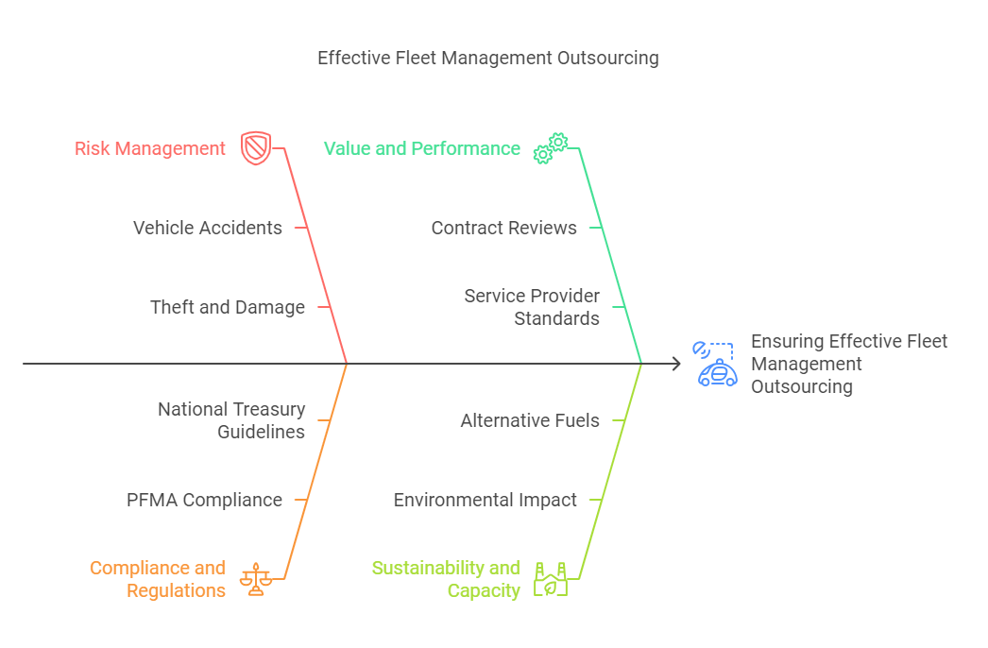

* Risk Management: When outsourcing fleet management services, government departments and entities must ensure that they have adequate risk management measures in place to mitigate potential risks, such as vehicle accidents, theft, and damage.
* Compliance with Regulations: Government departments and entities must ensure that their fleet management outsourcing contracts comply with relevant regulations, such as the Public Finance Management Act (PFMA) and the National Treasury's guidelines for fleet management.
* Value for Money: Government departments and entities must ensure that they are getting value for money from their fleet management outsourcing contracts. This can be achieved by conducting regular contract reviews and ensuring that the service provider meets the required standards.
* Service Level Agreements (SLAs): Government departments and entities must ensure that their fleet management outsourcing contracts include clear and measurable SLAs that outline the expected service standards and performance metrics.
* Data Management: Government departments and entities must ensure that they have adequate data management systems in place to track and monitor their fleet management activities, including vehicle usage, maintenance, and fuel consumption.
* Sustainability: Government departments and entities must consider the sustainability of their fleet management outsourcing contracts, including the environmental impact of their vehicle fleet and the potential for using alternative fuels or electric vehicles.
* Capacity Building: Government departments and entities must ensure that they have the necessary capacity and skills to manage their fleet management outsourcing contracts effectively, including the ability to monitor and evaluate the service provider's performance.
* Transparency and Accountability: Government departments and entities must ensure that their fleet management outsourcing contracts are transparent and accountable, including publishing contract details and performance metrics.
* Dispute Resolution: Government departments and entities must ensure that they have adequate dispute resolution mechanisms in place to resolve any disputes that may arise with the service provider.
* Contract Management: Government departments and entities must ensure that they have adequate contract management systems in place to manage their fleet management outsourcing contracts effectively, including the ability to monitor and evaluate the service provider's performance.

By considering these important fleet management matters, government departments and entities can ensure that their outsourcing contracts are effective and efficient and provide value for money.

Additionally, the South African government has implemented various initiatives to improve the management of its fleet, including:

* National Fleet Management Policy: The National Treasury has developed a National Fleet Management Policy that outlines the principles and guidelines for fleet management in the public sector.
* Fleet Management Unit: The National Treasury has established a Fleet Management Unit to provide guidance and support to government departments and entities on fleet management matters.
* Fleet Management Information System: The National Treasury has developed a Fleet Management Information System to track and monitor fleet management activities across the public sector.

These initiatives aim to improve the management of the government's fleet, reduce costs, and enhance the overall efficiency and effectiveness of fleet management in the public sector.

**Common criteria that are often used to evaluate the cost-effectiveness of outsourcing fleet management services:**

* Total Cost of Ownership (TCO): This includes the total cost of owning and operating the fleet, including vehicle acquisition, maintenance, fuel, insurance, and other expenses.
* Cost Savings: This includes the cost savings achieved through outsourcing, such as reduced labour costs, lower maintenance costs, and improved fuel efficiency.
* Return on Investment (ROI): This includes the return on investment achieved through outsourcing, such as increased productivity, improved customer satisfaction, and reduced costs.
* Cost-Benefit Analysis: This includes a detailed analysis of the costs and benefits of outsourcing fleet management services, including the costs, benefits, and potential risks and challenges.
* Benchmarking: This includes comparing the costs and performance of the outsourced fleet management services to industry benchmarks and best practices.
* Service Level Agreements (SLAs): This includes evaluating the service level agreements (SLAs) in place to ensure that the outsourced fleet management services meet the required standards and performance metrics.
* Key Performance Indicators (KPIs): This includes evaluating the key performance indicators (KPIs) in place to measure the performance of the outsourced fleet management services, such as vehicle utilisation, maintenance costs, and fuel consumption.
* Risk Assessment: This includes evaluating the potential risks and challenges associated with outsourcing fleet management services, such as service disruptions, data breaches, and non-compliance with regulations.
* Contract Management: This includes evaluating the contract management processes in place to ensure that the outsourced fleet management services are managed effectively and efficiently.
* Value for Money: This includes evaluating whether the outsourced fleet management services provide value for money, taking into account the costs, benefits, and risks associated with the services.

By evaluating these criteria, Departments can determine the cost-effectiveness of outsourcing fleet management services and make informed decisions about whether to outsource.

**Specific metrics that can be used to evaluate the cost-effectiveness of outsourcing fleet management services:**

* Cost per vehicle: This includes the total cost of owning and operating a vehicle, including acquisition, maintenance, fuel, insurance, and other expenses.
* Cost per mile: This includes the total cost of operating a vehicle per mile, including fuel, maintenance, and other expenses.
* Vehicle utilisation: This includes the percentage of time that vehicles are in use compared to the total time they are available.
* Maintenance costs: This includes the total cost of maintaining vehicles, including labour, parts, and other expenses.
* Fuel consumption: This includes the total amount of fuel consumed by vehicles, including the cost of fuel and the impact on the environment.
* Accident rate: This includes the number of accidents per vehicle compared to the national average.
* Driver performance: This includes driver performance, including their adherence to traffic laws, vehicle maintenance, and fuel consumption.

By tracking these metrics, the State can evaluate the cost-effectiveness of outsourcing fleet management services and make informed decisions about whether to outsource.

**Why is it that the Government prefers Full Maintenance Leases rather than purchasing the fleet for Cash?**

I would use a combination of financial calculations and comparisons to illustrate best that leasing a Toyota Corolla 1600 CC is more cost-effective than purchasing one for cash.

**Assumptions:**

* Purchase price of the Toyota Corolla 1600 CC Quest: R 250,000
* Lease term: 36 months
* Lease mileage: 15,000 km per year
* Lease interest rate: 10% per annum
* Residual value of the vehicle at the end of the lease term: 50% of the purchase price (R 125,000)

Lease Calculation:

* Monthly lease payment: R 4,500 (calculated using a lease calculator or spreadsheet)
* Total lease payments over 36 months: R 162,000 (R 4,500 x 36)
* Residual value of the vehicle at the end of the lease term: R 125,000 (50% of the purchase price)

Comparison to Purchasing for Cash:

* Purchase price of the Toyota Corolla 1600 CC Quest: R 250,000
* Total cost of ownership over 36 months (assuming no financing costs): R 250,000 (purchase price) + R 112,500 (fuel costs) + R 25,000 (maintenance costs) + R 50,000 (insurance costs) = R 437,500
* Total cost of leasing over 36 months: R 162,000 (lease payments) + R 112,500 (fuel costs) + R 25,000 (maintenance costs) + R 50,000 (insurance costs) = R 349,500

**Conclusion:**

* Leasing a Toyota Corolla 1600 CC Quest for 36 months would result in a total cost of R 349,500, compared to a total cost of ownership of R 437,500 if the vehicle were purchased for cash.
* ***This represents a saving of R 88,000 over the 36 months or approximately R 2,444 per month*.**

**Additional Benefits of Leasing:**

* No upfront capital outlay: The client does not need to pay the full purchase price of the vehicle upfront.
* Lower monthly payments: The monthly lease payments are typically lower than the monthly loan repayments if the vehicle were financed.
* Flexibility: The client can return the vehicle at the end of the lease term or purchase it at the residual value.
* No risk of depreciation: The client is not exposed to the risk of depreciation, as the vehicle is returned to the lessor at the end of the lease term.

**The main evaluation criteria for determining winning bidders during a full maintenance lease tender**

* Price: The total cost of the lease, including the monthly lease payment, maintenance costs, and any other fees.
* Technical Compliance: The bidder's ability to meet the technical requirements of the tender, including the type and quality of vehicles, maintenance services, and other specifications.
* Financial Stability: The bidder's financial stability and ability to fulfil the terms of the lease agreement.
* Experience and Reputation: The bidder's experience and reputation in providing full maintenance lease services, including their track record of delivering high-quality vehicles and maintenance services.
* Service Level Agreement (SLA): The bidder's ability to meet the service level agreement requirements, including response times, maintenance schedules, and other performance metrics.
* Vehicle Availability: The bidder's ability to provide the required number of vehicles, including the type and quality of vehicles and the availability of replacement vehicles in case of breakdowns or other issues.
* Maintenance and Repair: The bidder's ability to provide maintenance and repair services, including the quality of work, response times, and cost.
* Fuel Management: The bidder's ability to provide fuel management services, including fuel cards, fuel monitoring, and fuel reporting.
* Insurance: The bidder's ability to provide insurance coverage for the vehicles, including liability, collision, and comprehensive coverage.
* Environmental and Social Responsibility: The bidder's commitment to environmental and social responsibility, including their policies and practices related to sustainability, safety, and community engagement.

These evaluation criteria are important because they help ensure that the winning bidder can provide a high-quality full maintenance lease service that meets the State's needs. By evaluating these criteria, the organisation can assess the bidder's ability to deliver a reliable, efficient, and cost-effective service that meets its requirements.

**Here are some reasons why these evaluation criteria are important:**

* Price: The total cost of the lease is a critical factor in determining the winning bidder. A lower price can result in significant cost savings for the State.
* Technical Compliance: Ensuring that the bidder can meet the technical requirements of the tender is essential to ensure that the vehicles and maintenance services meet the State's needs.
* Financial Stability: The bidder's financial stability is critical to ensure that they can fulfil the terms of the lease agreement and provide a reliable service.
* Experience and Reputation: The bidder's experience and reputation are important factors in determining their ability to deliver a high-quality service.
* Service Level Agreement (SLA): The SLA is a critical component of the lease agreement, and the bidder's ability to meet the SLA requirements is essential to ensure that the service meets the State's needs.
* Vehicle Availability: The bidder's ability to provide the required number of vehicles is critical to ensure that the State's needs are met.
* Maintenance and Repair: The bidder's ability to provide maintenance and repair services is essential to ensure that the vehicles are kept in good condition and that downtime is minimised.
* Fuel Management: The bidder's ability to provide fuel management services is important to ensure that fuel costs are minimised and that the State can track fuel usage.
* Insurance: The bidder's ability to provide insurance coverage is critical to ensure that the State is protected in case of accidents or other incidents.
* Environmental and Social Responsibility: The bidder's commitment to environmental and social responsibility is important to ensure that the State is working with a responsible and sustainable partner.

By evaluating these criteria, the State can ensure that the winning bidder can provide a high-quality full maintenance lease service that meets their needs and provides value for money.

**Risk Management**

A comprehensive risk management strategy for the decision to outsource a government fleet to a qualifying service provider refers to a systematic approach to identifying, assessing, and mitigating potential risks associated with outsourcing a government fleet.

The goal of a comprehensive risk management strategy is to ensure that the outsourcing decision is made with a thorough understanding of the potential risks and that measures are taken to minimise or mitigate those risks.

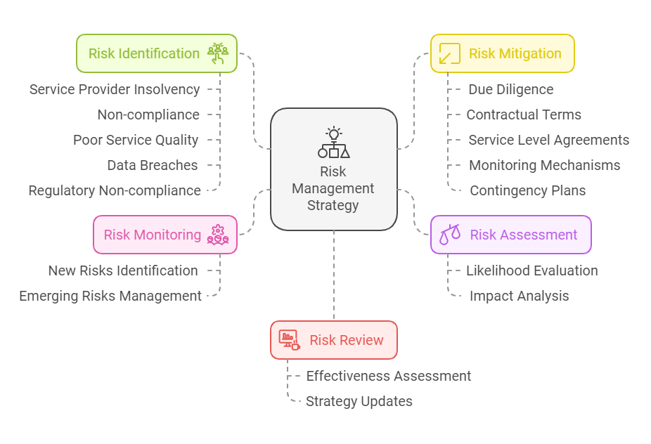

**Here are some key components of a comprehensive risk management strategy:**

1. Risk Identification: Identify potential risks associated with outsourcing a government fleet, such as:

* Service provider insolvency or bankruptcy

* Non-compliance with contractual obligations

* Poor service quality

* Data breaches or cybersecurity threats

* Regulatory non-compliance

1. Risk Assessment: Use a risk assessment matrix or other tools to assess the likelihood and potential impact of each identified risk.
2. Risk Mitigation: Develop strategies to mitigate or minimise the risks identified, such as:

* Conducting thorough due diligence on potential service providers

* Negotiating robust contractual terms and conditions

* Establishing clear service level agreements (SLAs)

* Implementing monitoring and reporting mechanisms

* Developing contingency plans for potential risks

1. Risk Monitoring: Continuously monitor the outsourcing arrangement to identify and address any new or emerging risks.

5. Risk Review: Regularly review the risk management strategy to ensure it remains effective and up-to-date.

A comprehensive risk management strategy should also consider the following:

* Service provider selection: Ensure that the service provider is qualified, experienced, and has a good reputation.
* Contractual terms: Negotiate contractual terms that clearly outline the responsibilities and obligations of both parties.
* Service level agreements: Establish clear SLAs that define the expected service quality, response times, and other performance metrics.
* Monitoring and reporting: Implement monitoring and reporting mechanisms to track the service provider's performance and identify any potential issues.
* Contingency planning: Develop contingency plans to address potential risks, such as service provider insolvency or non-compliance with contractual obligations.

By implementing a comprehensive risk management strategy, government agencies can minimise the risks associated with outsourcing a government fleet and ensure that the outsourcing arrangement is successful and beneficial to all parties involved.

**Here are some benefits of a comprehensive risk management strategy:**

* Reduced risk: A comprehensive risk management strategy can help reduce the risks associated with outsourcing a government fleet.
* Improved service quality: Government agencies can ensure that service quality meets their expectations by establishing clear SLAs and monitoring the service provider's performance.
* Increased transparency: A comprehensive risk management strategy can provide transparency into the outsourcing arrangement, enabling government agencies to make informed decisions.
* Better decision-making: By identifying and assessing potential risks, government agencies can make more informed decisions about outsourcing a government fleet.
* Cost savings: A comprehensive risk management strategy can help government agencies avoid costly mistakes and minimise the risks associated with outsourcing a government fleet.

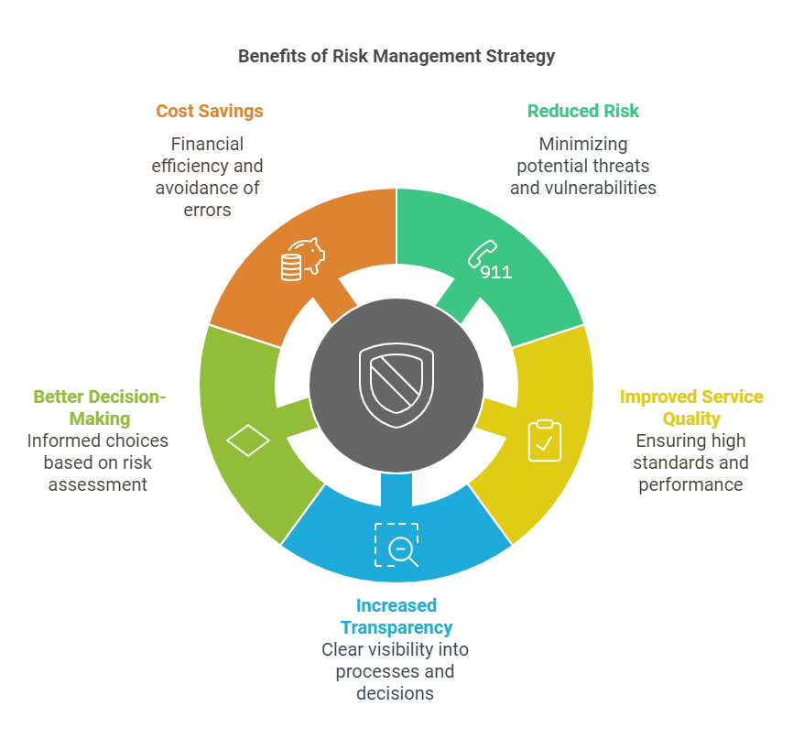

**Tools used by the Government to Measure and Monitor Performance by Service Providers**

The government monitors compliance with the minimum requirements set for outsourcing contracts through a variety of mechanisms, including:

* Contract Management: The government agency responsible for the outsourcing contract manages the contract and ensures that the service provider complies with the minimum requirements.
* Service Level Agreements (SLAs): The government agency and the service provider agree on SLAs that define the expected service quality, response times, and other performance metrics.
* Performance Metrics: The government agency tracks the service provider's performance against the SLAs and other performance metrics, such as customer satisfaction, quality of service, and timeliness.
* Regular Audits: The government agency conducts regular audits to ensure that the service provider is complying with the minimum requirements and to identify any potential issues.
* Compliance Monitoring: The government agency monitors the service provider's compliance with regulatory requirements, such as data protection and security standards.
* Reporting Requirements: The service provider is required to provide regular reports to the government agency on their performance, including any issues or concerns.
* Escalation Procedures: The government agency has escalation procedures in place to address any issues or concerns that arise during the contract period.

By using these mechanisms, the government can ensure that the service provider is complying with the minimum requirements set for outsourcing contracts and that the outsourcing arrangement is successful and beneficial to all parties involved.

**Here are some benefits of monitoring compliance with the minimum requirements:**

* Improved Service Quality: By monitoring compliance with the minimum requirements, the government can ensure that the service provider is delivering high-quality services that meet citizens' needs.
* Increased Transparency: Monitoring compliance with the minimum requirements provides transparency into the outsourcing arrangement, enabling the government to make informed decisions.
* Better Decision-Making: By tracking the service provider's performance, the government can make more informed decisions about the outsourcing arrangement and identify areas for improvement.
* Reduced Risk: Monitoring compliance with the minimum requirements can help reduce the risks associated with outsourcing, such as non-compliance with regulatory requirements.
* Cost Savings: By identifying and addressing any issues or concerns early on, the government can avoid costly mistakes and minimise the risks associated with outsourcing.

In South Africa, the government has established various mechanisms to monitor compliance with the minimum requirements set for outsourcing contracts, including:

* The Public Finance Management Act (PFMA): The PFMA sets out the framework for public finance management in South Africa, including the requirements for outsourcing contracts.
* The National Treasury's Guidelines for Outsourcing: The National Treasury has issued guidelines for outsourcing that set out the minimum requirements for outsourcing contracts.
* The State Information Technology Agency (SITA): SITA is responsible for managing the government's IT infrastructure and ensuring that service providers comply with the minimum requirements set for outsourcing contracts.

By using these mechanisms, the government can ensure that the service provider is complying with the minimum requirements set for outsourcing contracts and that the outsourcing arrangement is successful and beneficial to all parties involved.

**Ensuring Continuous Improvement**

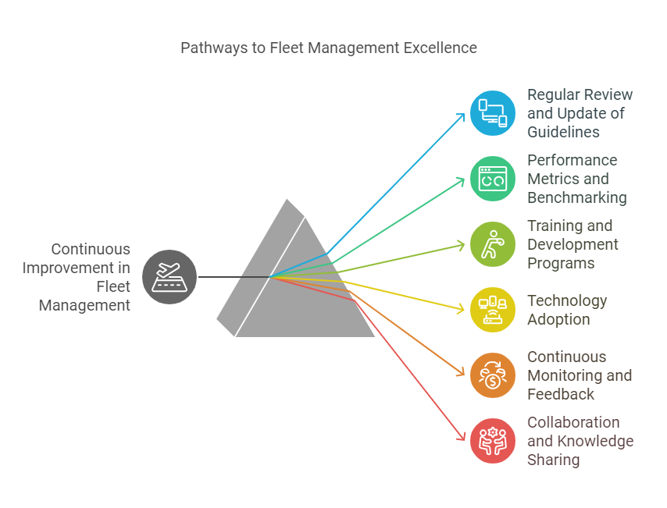

To ensure continuous improvement in fleet management practices beyond the establishment of new guidelines, several measures can be implemented:

* Regular review and update of guidelines: Guidelines should be reviewed and updated regularly to reflect changes in technology, regulations, and best practices.
* Performance metrics and benchmarking: Establishing key performance indicators (KPIs) and benchmarking against industry standards can help identify areas for improvement and track progress over time.
* Training and development programs: Providing ongoing training and development programs for fleet managers and drivers can help ensure they have the necessary skills and knowledge to implement best practices.
* Technology adoption: Staying up-to-date with the latest fleet management technologies, such as telematics and fleet management software, can help improve efficiency and reduce costs.
* Continuous monitoring and feedback: Regular monitoring of fleet operations and soliciting feedback from drivers, managers, and other stakeholders can help identify areas for improvement and inform future changes.
* Collaboration and knowledge sharing: Encouraging collaboration and knowledge sharing between fleet managers, drivers, and other stakeholders can help identify best practices and drive continuous improvement.
* Regular audits and assessments: Conducting regular audits and assessments of fleet operations can help identify areas for improvement and ensure compliance with guidelines and regulations.