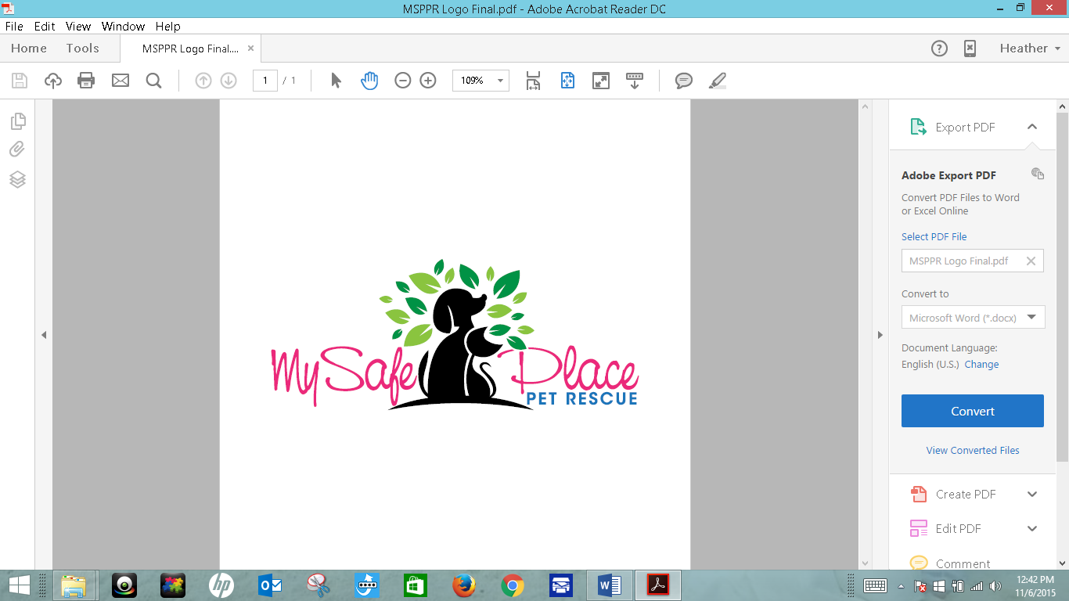

Cat/Kitten Adoption Application

Date: _____________________ Name of pet applying for: _______________________________

Applicant Name:_________________________________________________________
Complete Address: ___________________________________________
___________________________________________
Telephone: Home: _____________________________ Mobile: _______________________________
Work Phone: _______________________ Email: __________________________________________
 How long have you lived at your current address?_________ Years ________ Months
Do you: Rent Own
If you rent, provide Landlords name, address and phone:
____________________________________________________
____________________________________________________
____________________________________________________
If you rent, do you have permission from your landlord to get a cat? Yes No
Are you aware of pet deposit and monthly fees (if any) required? Yes No
Would you allow the cat access to the outside? Yes No
Would you declaw the cat if scratching was a major issue? Yes No
What is your family’s lifestyle like? Active and on the go Quiet and relaxed
Entertain frequently Lots of kids in & out Travel frequently
Do you have childen? Yes No If you have childen, please list name(s) and age(s):

Name Age

Name Age

Is everyone in your household in agreement on adoption a new pet? Yes No
If no, who is not: _______________________________________________________________
Is anyone in your household allergic to animals? Yes No
Where will the cat stay when no one is at home?________________________________________
Where will the cat stay when you are home?___________________________________________
Where will the cat stay at night?____________________________________________________
How often will you exercise/spend time playing with your cat? ____________________________
____________________________________________________________________________________
Under what condition(s) would you have to give up your cat? _____________________________
____________________________________________________________________________________
____________________________________________________________________________________
Do you own any pets now? Yes No
Your current dogs, cats, or other pets:
1. Name:___________________________________ Species: cat dog other : _______________
Breed: _______________________ Sex: M F Age:_________ Spayed/Neutered? Yes No

2. Name:___________________________________ Species: cat dog other : _______________
Breed: _______________________ Sex: M F Age:_________ Spayed/Neutered? Yes No
Do you have more than two current pets? Yes No If yes, please list the rest on back of application.
If applicable, please provide the following information about any pets you have had in the last 5 years that are no longer with you:
Pet Name & Type | Reason Pet Is No Longer With You
Your Veterinarian’s name:__________________________________________________________
Practice Name: _________________________________________________________________
Address: ______________________________________________________________________
Phone Number: _________________________________________
Agreements for Adoption:

I am prepared to make a 10 to 20 year commitment to my cat.

I will keep my cat on a regular routine of internal worm preventative.

I will provide flea/tick control as needed.

I will work with my vet and agree on a regular schedule for wellness visits, inoculations, and any other tests we agree are necessary for the health and well-being of my cat.

My cat will be an indoor only cat and an important member of my family.

If, for any reason, I am unable or unwilling to keep this cat, I agree to work with My Safe Place Pet Rescue to place the cat in a good home.

I am financially able to provide routine and emergency care for this cat for his/her lifetime. This includes, but is not limited to: food, boarding (if necessary), regular vet care & vaccinations, internal worm preventative and flea & tick preventative.

SIGNATURE:___________________________________________DATE:______________________

PRINT NAME:______________________________________________________________________

Current pets continued:

3. Name:___________________________________ Species: cat dog other : _______________
Breed: _______________________ Sex: M F Age:_________ Spayed/Neutered? Yes No

4. Name:___________________________________ Species: cat dog other : _______________
Breed: _______________________ Sex: M F Age:_________ Spayed/Neutered? Yes No

5. Name:___________________________________ Species: cat dog other : _______________
Breed: _______________________ Sex: M F Age:_________ Spayed/Neutered? Yes No

6. Name:___________________________________ Species: cat dog other : _______________
Breed: _______________________ Sex: M F Age:_________ Spayed/Neutered? Yes No

7. Name:___________________________________ Species: cat dog other : _______________
Breed: _______________________ Sex: M F Age:_________ Spayed/Neutered? Yes No

8. Name:___________________________________ Species: cat dog other : _______________
Breed: _______________________ Sex: M F Age:_________ Spayed/Neutered? Yes No

