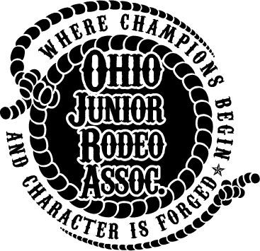
The Ohio Junior Rodeo Association
Sponsorship Form

The Ohio Junior Rodeo Association (OJRA) was founded to provide a quality rodeo opportunity for boys
and girls, regardless of state of residence, who are attending kindergarten through twelfth grade. OJRA
consists of four grade divisions (K-2, 3-5, 6-8, 9-12) and twenty rodeo events, from dummy roping to bull
riding, and sheep riding to barrel racing. These events are fashioned after collegiate and professional
rodeo events with modified rules and stock to accommodate age and ability.

The OJRA season is very expensive. Your generous sponsorships are used to provide awards for
the competitors. These awards include end of the year All-Around Cowboy/Cowgirl for each grade
division, Reserve All-Around Cowboy/Cowgirl for each grade division, Event Champions, Reserve Event
Champions, and OJRA Queen awards, as well as finals awards.

OJRA operates using competitor and family volunteers. There are no paid administrative staff positions.
Without generous sponsorships, OJRA cannot recognize our outstanding youth competitors in a manner
in which they deserve. We greatly appreciate your support. All of your sponsorships go directly to our
awards program.

Please make your check payable to: Ohio Junior Rodeo Association. In kind sponsorships, such as
products or services, are welcome as well.

Sponsorship forms with payment should be returned to OJRA Treasurer Gail Bevington, 12545 State Route 41, South Solon, Oh 43153. Information may also be provided in electronic format.

Sponsor Name: __________________________________________________________________
Address: __________________________________________________________________
City/State/Zip: __________________________________________________________________
Phone: __________________________________________________________________
Email: __________________________________________________________________
Web Address: __________________________________________________________________
Sponsorship Amount: ____________________________________________________________
OJRA Representative(s): ____________________________________________________________
*This sponsorship is not tax deductible*

• Website listing and link at www.OhioJuniorRodeo.org

