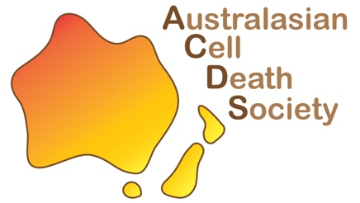
ACDS Prize for Outstanding ECRs - 2025

The Australasian Cell Death Society (ACDS) is thrilled to offer the 2025 ACDS Prize for Outstanding ECRs. This prestigious prize is offered annually to celebrate a rising star who has made a significant contribution to the Australasian cell death community. Applicants will be assessed on a competitive basis, relative to opportunity. Please note that ECRs are limited to one award during their candidature/postdoctoral training.

Award details:
- $500
- Medal and certificate
- Invited oral presentation at an ACDS seminar/related event

Eligibility criteria:
- Applicant must be a member of the ACDS
- Applicant is an ECR, defined as a PhD student or postdoc <5 years post-PhD
- Career disruption will be taken into account
- Applicant must have performed majority of the described work in Australasia and worked within Australasia in the last 12 months
- For example, PhD students who have recently left Australia to pursue postdoctoral tenures in the USA are eligible.

Application requirement:
- Nomination by ACDS member
- Two-page CV
- One-page research summary
- Research vision statement
- Career disruption statement (if applicable)

Applications will be assessed by a panel of ACDS Committee members, Pioneers and Luminaries. The scoring is as follows: CV and research summary are both scored out of 10, and research vision is scored out of 5, for a total application score out of 25.

Submit this form (with attached CV) to general@australasiancelldeathsociety.com by 5 pm (AEDT),
Friday 7th of November. The successful applicant will be announced at the end of the year ACDS Seminar and Networking event on Tuesday December 9th.

Please note that applications are all assessed relative to opportunity i.e. PhD students will be assessed based on achievements relative to a PhD, and similar for postdocs.
Diversity will be taken into fair consideration.

Applicant contact details
Name:
Email:
Organisation:
Position: | PhD student Postdoc (< 5 years post PhD)
Relative to opportunity eligibility statement: | e.g. I am eligible as I am a 3rd year PhD student.  e.g. I am eligible as I completed my PhD in 2020 and took 12 months of parental leave in 2022.
Gender: | Male Female Non-binary Prefer not to say
Applicant signature:
Nomination
Name of ACDS nominator:
Nominator organisation:
Nominator signature:
Career Disruption (if applicable)
Please provide a brief statement (max 200 words) outlining any circumstances that should be taken into consideration when assessing your application. Examples include parental leave, carer’s responsibilities, illness.

One-page research summary (/10 marks)
Include a description of research, research impact, achievements and contribution to the cell death field.
CV (/10 marks)
Please attach a two-page CV. Please include information such as publications, grants, awards as well as any leadership involvement that demonstrates your contribution to the cell death community
(e.g. scientific presentations, conference participation, outreach, committee roles, society involvement, supervision etc).

Have you attached your two page CV: YES NO

Research vision (/5 marks)
Please provide a brief explanation of your research vision and career aspiration (200 words)

