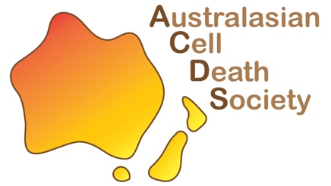
Japan and Australia Meeting on Cell Death 2023 (JAM2023) Travel Award
for Postgraduate Students and Early Career Researchers in the society

The Australasian Cell Death Society (ACDS) is pleased to offer the following travel awards:

Three travel awards, each of $400, are available to promising postgraduate students and early career researchers who will be attending JAM2023. These awards are intended to support the cost of attending the meeting (including travel and/or registration) and will be given on a competitive basis, relative to opportunity.
Applicants should supply information about their research and outline how the Travel Award would benefit their career. Awardees are required to attend and present their research at the JAM2023 and submit a written report for publication in the ACDS newsletter.
Applications will be assessed by a panel of ACDS Pioneers and Luminaries. The applicant’s track record will be assessed taking into account the relative opportunity statement.
Submit this form and a 2-page CV to auscelldeathsociety@gmail.com with your name and “JAM2023 Travel Award” in the subject heading by 5pm (AEST), Friday, June 2nd.
Successful applicants will be announced at the ACDS seminar on the 5th of July 2023.

Eligibility criteria:
- The applicant must be a member of the ACDS.
- The applicant must have submitted an abstract to the JAM2023 as the first author.
- The applicant must register for JAM2023.
- Students must be Master or PhD candidates.
- ECRs must be no more than 5 years post-PhD.

Name of applicant |  | Position (Student/Postdoc)
Name of the Supervisor/Mentor
Applicant contact details
E-mail
Organisation
Purpose of application Provide a brief statement (approximately 400 words) describing your research and how your career would benefit from the JAM2023.
Relative to Opportunity Provide a brief statement describing any disruptions that may have impacted relative career opportunities. We will be taking into consideration COVID impact statements.

Supervisor’s Signature Date

Applicant’s Signature Date

