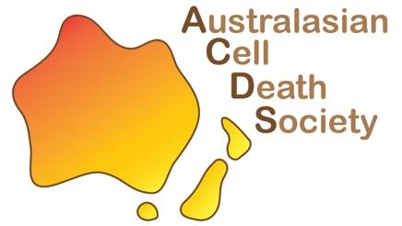
ACDS Professional Development Award
for Postgraduate Students and Early Career Researchers in the society

The Australasian Cell Death Society (ACDS) is thrilled to offer 1x $2000 award for national or international professional development-related activities. These awards will be given on a competitive basis, relative to opportunity. These awards aim to facilitate the career development of early-career ACDS members as they embark on their careers in cell death research. Supported activities include, but are not limited to, attending a conference or workshop, instrument or data analysis training, or a research visit in a collaborator’s laboratory. Students and ECRs are limited to one award during their candidature/postdoctoral training.

Applicants should supply information about the proposed use of the award using this application form and outline how it would benefit the applicant. Awardees are required to attend the supported activity within a year and must provide invoices as proof of actual costs. Please note that the award may not cover the full cost of the proposed activity. The supervisor’s signature confirms that any remaining expenses will be supported through alternative funding sources.

Applications will be assessed by a panel of ACDS Committee members, Pioneers and Luminaries. Applicants’ track record will be assessed taking into account relative opportunity. Please note diversity will also be taken into fair consideration.
To apply, submit this form and a 2 page CV to general@australasiancelldeathsociety.com with your name and “ACDS Professional Development Award” in the subject heading by 5pm (AEST), Friday, June 12th. Successful applicants will be announced at the end of July, 2026.

Eligibility criteria:
- Must be a member of the ACDS including ACDS committee members
- Students must be Masters or PhD candidates
- ECRs must be no more than 5 years post-PhD
- Funding must be used within 12 months of award notification

During and Post-Award requirements:
- The awardee must provide a written report (see template below) for publication in the ACDS newsletter and the ACDS website within four weeks after the supported activity
- Where appropriate, the awardee should acknowledge the ACDS’ support by including the ACDS logo in presentations arising from the funded activity
- Reimbursements will be provided upon submission of receipts and completion of the terms listed above

Name of applicant | Position (Student/Postdoc) |  | Gender
Name of the Supervisor/Mentor
Applicant contact details
E-mail
Organisation
Purpose of application Provide a brief statement (approximately 400 words) describing:
- Your research and how it relates to the cell death field
- How your career would benefit from the proposed activities.
Relative to Opportunity Provide a brief statement describing any disruptions that may have impacted relative career opportunities. We will be taking into consideration COVID impact statements.

Supervisor’s Signature Date

Applicant’s Signature Date

Travel Award Report

This report is to be completed by all recipients of ACDS Travel Awards.
All reports must be submitted within four weeks of the completion of travel.
Awardee Details
Name: | Research Group:
Supervisor’s Name:
Award Date received:
Conference/Workshop Details
Name:
Location:
Dates:
Highlights: (minimum 300 words)

Additional Travel Destinations
Institution Name:
Hosts Name:
Highlights and Experiences: (minimum 300 words)

NB: If you visited more than 1 institution, copy and paste required fields below.
Summary
How did this travel benefit ACDS? Describe the outcomes and how you will communicate and leverage these outcomes to benefit the ACDS community.

How did this travel benefit your professional development? Describe the specific benefits and steps that have been made towards your research and leadership growth.

Expenditure of ACDS Travel funds (as listed on your application form)

Please submit your report to general@australasiancelldeathsociety.com within four weeks of returning from your travel.

