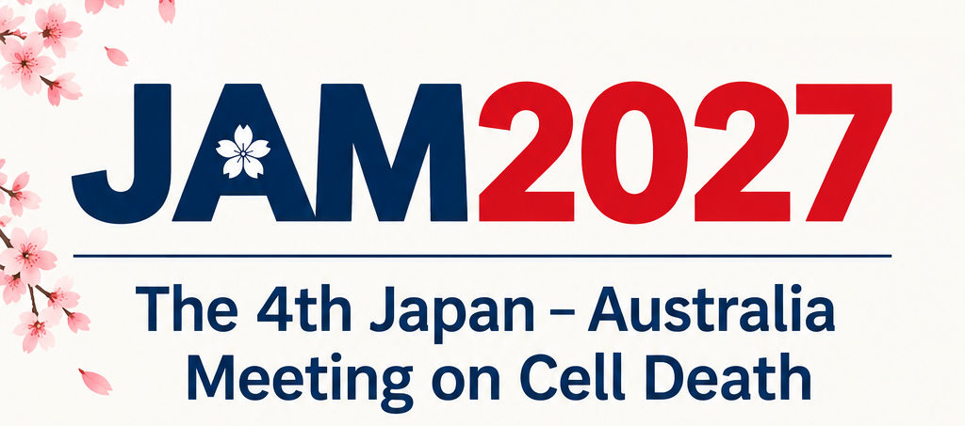
ACDS-JAM Travel Award
for Postgraduate Students and Early Career Researchers in the ACDS

The Australasian Cell Death Society (ACDS) is thrilled to offer 4x $500 awards for early career researchers to attend the 2027 Japan and Australia Meeting (JAM) on Cell Death. These awards will be given on a competitive basis, relative to opportunity. They aim to aid the career development of junior ACDS members as they embark on their careers in cell death research and build their international reputation.

AWARD DETAILS:
- $500 towards travel or accommodation to attend JAM2027
- Free conference registration
- Attendence at JAM ECR Networking Session

Please note that this award is not expected to cover the full cost associated with attending JAM. The supervisor’s signature confirms that any remaining expenses will be supported through alternative funding sources.

Applications will be assessed by a panel of ACDS Committee members. Applicants’ track record will be assessed relative to opportunity and diversity will be taken into fair consideration.

To apply, submit this form and a 2 page CV to general@australasiancelldeathsociety.com with your name and “ACDS-JAM Travel Award” in the subject heading by 5pm (AEDT), Friday, 27th of November. Successful applicants will be announced at the End of Year ACDS Networking Event.

Eligibility criteria:
- Must be a member of the ACDS (including ACDS committee members)
- Students must be Masters or PhD candidates
- Postdoctoral researchers must be no more than 7 years post-PhD
- Funding must be used to attend the 2027 JAM on Cell Death

Award requirements:
- The awardee must provide a written report (see template below) for publication in the ACDS newsletter and the ACDS website within four weeks after the supported activity
- Where appropriate, the awardee should acknowledge the ACDS’ support by including the ACDS logo in presentations arising from the funded activity
- Reimbursements will be provided upon submission of receipts and completion of the activity

Name of applicant | Position (Student/Postdoc) |  | Gender
Name of the Supervisor/Mentor
Applicant contact details
E-mail
Organisation
RESEARCHER STATEMENT Provide a brief statement (approximately 400 words) describing:
- Your research and contribution to the cell death field
- How your career would benefit from this opportunity
Relative to Opportunity Provide a brief statement describing any disruptions that may have impacted relative career opportunities (e.g. parental leave, long term illness etc).

Supervisor’s Signature Date

Applicant’s Signature Date

Travel Award Report

This report is to be completed by all recipients of ACDS Travel Awards.
All reports must be submitted within four weeks of the completion of travel.
Awardee Details
Name: | Research Group:
Supervisor’s Name:
Award Date received:
Conference/Workshop Details
Name:
Location:
Dates:
Highlights: (minimum 300 words)

Additional Travel Destinations
Institution Name:
Hosts Name:
Highlights and Experiences: (minimum 300 words)

NB: If you visited more than 1 institution, copy and paste required fields below.
Summary
How did this travel benefit ACDS? Describe the outcomes and how you will communicate and leverage these outcomes to benefit the ACDS community.

How did this travel benefit your professional development? Describe the specific benefits and steps that have been made towards your research and leadership growth.

Expenditure of ACDS Travel funds (as listed on your application form)

Please submit your report to general@australasiancelldeathsociety.com within four weeks of returning from your travel.

