**Spartan Little League Meeting Minutes**

**January 7, 2025**

1. Call Meeting to order: Time:_5:44 pm

|  |  |  |
| --- | --- | --- |
| Hector Navarro | Ruben Leyva | Eric Bautista |
| Yasmine Navarro | Elizabeth Leyva | Delores Smith |
| Miguel Mejia | Andrew Sotelo | Daisy Gomez |
| Frankie Bocanegra | Rossana Omelo | Jeanette Fernandez |

1. Members present:
2. Is there a quorum? Yes_X__ No________
   1. Yes. Voting can take place
3. **Approve last meeting minutes:**

Approve___12__ Disapprove_________ Abstain_______

1. **Approve Financials:**

Approve__12___ Disapprove_________ Abstain_______

1. **$1,000 for 501C3 ($500 now,$500 when approved):**

Approve__12___ Disapprove_________ Abstain_______

1. **$159.90 for Zoom:**

Approve__12__ Disapprove_________ Abstain_______

1. **$203.88 for website + $22.99 for Domain:**

Approve__12__ Disapprove_________ Abstain_______

1. **$25/jersey and $25/hat, Last name on uniforms:**

Approve__12___ Disapprove_________ Abstain_______

1. **1 free sign up per board member (1 per household)**

Approve__12___ Disapprove_________ Abstain_______

1. **Schedule**

Approve__12___ Disapprove_________ Abstain_______

ASAP plan, In person sign ups, Training, fundraising, and Ordering Uniforms.

Sign Ups:

* Majors – 10/12 (2 in shopping cart)
* Minors – 15/24 (10 in shopping cart)
* Peewee/Farm – 7/48 (10 in shopping cart)
* Tee Ball – 5/24 (4 in shopping cart)

Teams:

* Majors Andrew – RAYS
* Minor 1 Rueben, JR - BRAVES
* Minor 2 Miguel – SPARTANS
* Farm 1 Eric – CHARROS
* Farm 2 Justin – SHARKS?
* PeeWee 1 Fernando – BRAVES
* **PeeWee 2 – SPARTAN BLACK (Hector will coach these teams until coach is found)**
* **Tee Ball 1 – SPARTAN BLUE**
* **Tee Ball 2 – SPARTAN BLACK**

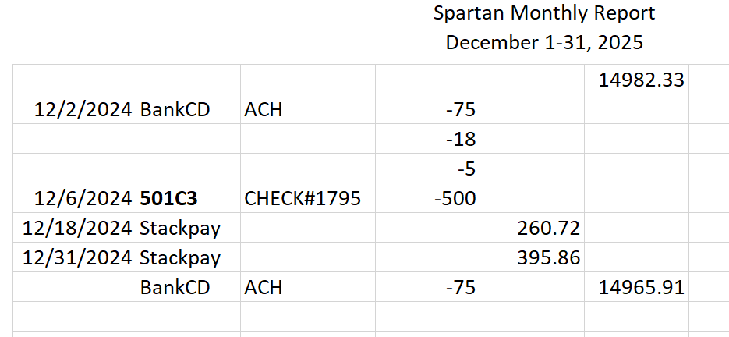

Schedule

**Jan 18 – In person sign ups Mt Mikes on Aborn 11am-1pm**

Feb 1 – Coaches Clinic

Feb 2 – Umpire Clinic

**Feb 6 – Tryouts**

March 22 – Start Games

June 14 – Closing Ceremonies

ASAP – Jurnee working on it.

Trainings- Will send email with all required trainings and links.

Fundraiser: Superbowl Squares, bakesale?

1. Next Meeting Date. 2/ 3 /2025 @ 5:30pm – 6:30pm, 652 Platte River Ct
2. Motion to adjourn.
3. End Meeting: Time:__6:20pm__