Spartan October Board Meeting

1. Call Meeting to order: Time: 7:11p
2. Members present:
3. In Person: Yasmine, Miguel, Ruben, Liz, Frankie, Rossana, Jeannette, Delores, Hector
4. Phone: Jurnee
5. Absentee Ballot : Regina, Andrew, Daisy
6. Minutes from previous meeting:
7. n/a – new season
8. Reports from Board members:
9. President
10. Review new league website
11. No more TOCs moving forward for D59. Keeping slugfest
12. Regulation 2: Ages 4-7 no longer have league boundaries
13. Review constitution
14. Secretary
15. Vice President
16. Treasurer – Approval of Monthly Financial Report: Yes _ No _ Abstain x_
17. Field Maintenance Manager
18. Team Parent Coordinator
19. Manager/Coach Coordinator
20. Marketing/Public Relations Manager
21. Concession
22. Player Agent
23. Safety Officer
24. Equipment Manager
25. UIC
26. Softball Manager
27. Looking for a pitching coach for the clinic
28. Free clinic, 3 days 10/27, 11/17, 12/15 1-3p at Herman Intermediate. At the end, there will be a sandlot game and BBQ
29. Spartan will be providing softballs for clinic
30. Spartan has some gloves and masks to loan for clinic
31. When playing softball, players should wear masks. Not required but highly encouraged.
32. Link for clinic registration is currently up on district website. Please share
33. Santa Teresa has 2 softball fields available all year round
34. Special items to be discussed
35. Board of Directors elections

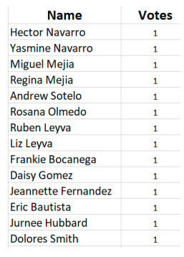

1. Officer Election:

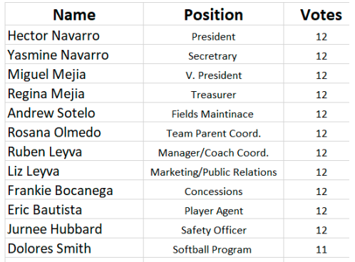

1. Any New Business
2. Treasurer should be sending out monthly reports
3. Secretary should be sending out minutes from each meeting
4. Challenger Jamboree will be hosted by Gilroy. Gilroy PD will BBQ. Date TBD
5. Chartering opened 10/1/2024
6. Background checks are to be down via SportsConnect for leagues only.
7. Treasurer training will be held 11/14
8. Player Agent training will be held 11/19
9. Safety Officer training will be held 1/15
10. Fingerprinting is required for all volunteers
11. Next Meeting Date: December 6, 2024 5:30pm
12. Motion to Adjourn
13. 1st: Hector
14. 2nd: Delores
15. Meeting adjourned at 8:00p