**Spartan Little League Meeting Minutes**

**February 3, 2025**

1. Call Meeting to order: Time 5:45pm

|  |  |  |  |
| --- | --- | --- | --- |
| Hector Navarro | Rueben Leyva | Eric Bautista | Jurnee-zoom |
| Yasmine Navarro | Elizabeth Leyva | Jeanette |  |
| Miguel Mejia | Andrew Sotelo-zoom | Frankie |  |
| Regina Mejia | Rossana Omelo-zoom | Daisy |  |

1. Members present: 13
2. Is there a quorum? Yes_x__ No________
   1. Yes. Voting can take place
3. **Approve last meeting minutes:**

Approve_13_ Disapprove_________ Abstain_______

1. **Approve Financials:**

Approve__13___ Disapprove_________ Abstain_______

1. **Approve Teams:**

Approve__13___ Disapprove_________ Abstain_______

1. **Approve Coaches:**

Approve__13__ Disapprove_________ Abstain_______

1. **Approve 2 Minor Teams:**

Approve__11__ Disapprove____2_____ Abstain_______

Tryouts moved to Monday February 10

Opening Day Sunday March 23

Little League Patches - $200-250

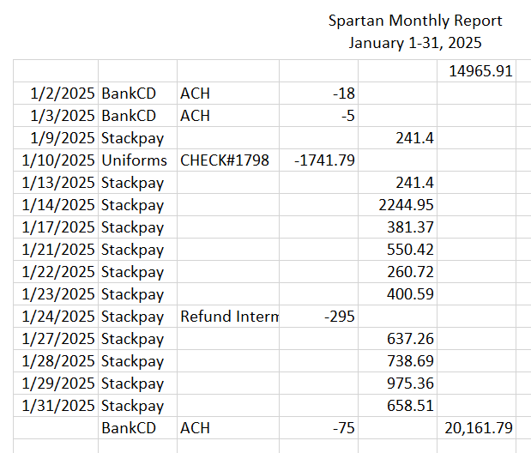

1. Next Meeting Date. 3/4/2025 @ 5:30pm – 6:30pm, 652 Platte River Ct
2. Motion to adjourn.
3. End Meeting: Time:_6:30pm