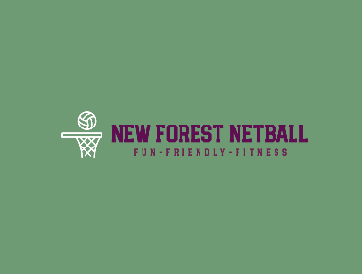
Codes of Conduct Parents/ Guardians/Carers

The enjoyment and safety of your Child when involved in a netball activity is of paramount importance to New Forest Netball (NFN).
Every Child and Young Person will be encouraged and asked to ensure that their behaviour and actions meet the values and standards expected of them at all times.
As parents, guardians or carers you are asked to support our Codes of Conduct and embrace the spirit of our game.
As a parent/guardian/carer, I will:
• Encourage my Child to play within the rules and respect officials’ and coaches’ decisions
• Support my Child’s efforts and performance, give positive comments that motivate and encourage continued effort and learning
• Understand that Competition is about winning and losing, so results are always accepted without undue disappointment
• Be a positive role model to my Child by helping them work towards skill improvement and high standards of sporting behaviour
• Remember that Children and Young People learn best by example; I will applaud good play by both my Child’s team and their opponents
• Thank the coaches, officials and other volunteers who give their time for my Child and not interfere with their decisions
• Help when asked by a coach or official
• Respect the rights, dignity and worth of all people involved in the game, regardless of gender, marital status, race, colour, disability, sexuality, age, occupation, religion or political opinion
• Never engage in discriminatory abuse or anti-social behaviour which could include but is not limited to racism, sexism, antisemitic, Islamophobic, homophobic or transphobic behaviour.
• Read the rules of The Sport to understand better what I am watching and discussing with my Child
• Promote this Code of Conduct to other parents, carers and supporters
• Be aware of my Child’s Club safeguarding policy and ensure that any concerns are reported to the Club’s Safeguarding Officer or England Netball’s Lead Safeguarding Officer.

As a parent/guardian/carer, I will not:
• Pressure my child in any way; I know that this is their Sport not mine
• Use inappropriate language, harass athletes, coaches, officials or other spectators
• Criticise or ridicule my child for making a mistake or losing after the game
• Force my child if they are unwilling to participate in the Sport
• Use Social Media technology to bring the game into disrepute or make an inappropriate comment about an athlete, coach, official, volunteer or member of NFN
• Arrive at a netball activity under the influence of or consume illegal substances, alcoholic drinks, smoke or vape either immediately prior to or while being at a netball activity where my child is participating in the Sport.
I will endeavour to abide by this code of conduct and promote it to others.
I understand that if I fail to follow the code NFN may ask for my child to be removed from the club and take action against me either informally or under the Disciplinary Regulations in accordance with the EN Misconduct List, which may result in Sanctions including suspension

