e.g. +61 1234 456789

dd/mm/yyyy

Coloured

Photo



*# Name / date of birth / gender / relationship / occupation / student / others…….*

1.

2.

3.

4.

5.

6.

*For non Australian residents*

City / State

dd/mm/yyyy

e.g. AUD 100,000.00

CITY – STATE eg. Sydney - NSW

Ebikes & ATV Distributor / Hobby Farms / Retirement Farm Stay / Others please specify……….

**Fillable Application form**

*(Please complete, save and email to us)*

Date:

Name: Passport/I.D. Nationality

Residential address:

Email address: Whatsapp Contact No: D.O.B

Contact address **if** different from Residential Address:

Subject/s of interest:

Target budget, Currency & Amount:

Preferred location :

Target date for commencement of business:

Previous & Current business profile:

Preferred location of residence in Australia if non Australian resident:

Academic Qualifications:

Condition of health :

Number of family members below 18 years of age (on date of application) accompanying applicant:

Remarks and further information as required. Click [**here**](https://aussieebike.com/biz-opportunities) for further information.

Five Star Global Resources Australia Pty. Ltd.

225, Fullarton Road, Eastwood SA 5063

**AUSTRALIA**

**Tel: 1300 ABN ABN**

**fivestarglobalresources.au@gmail.com**

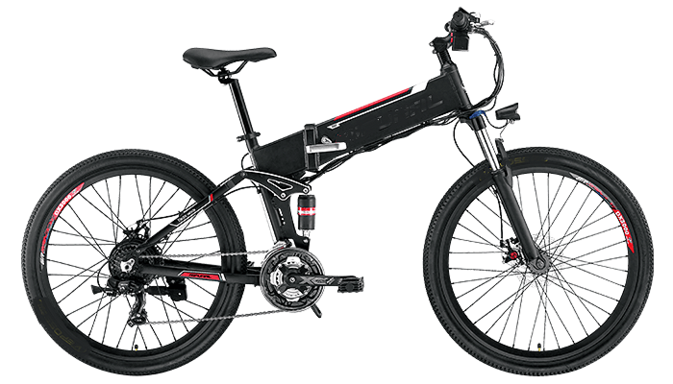 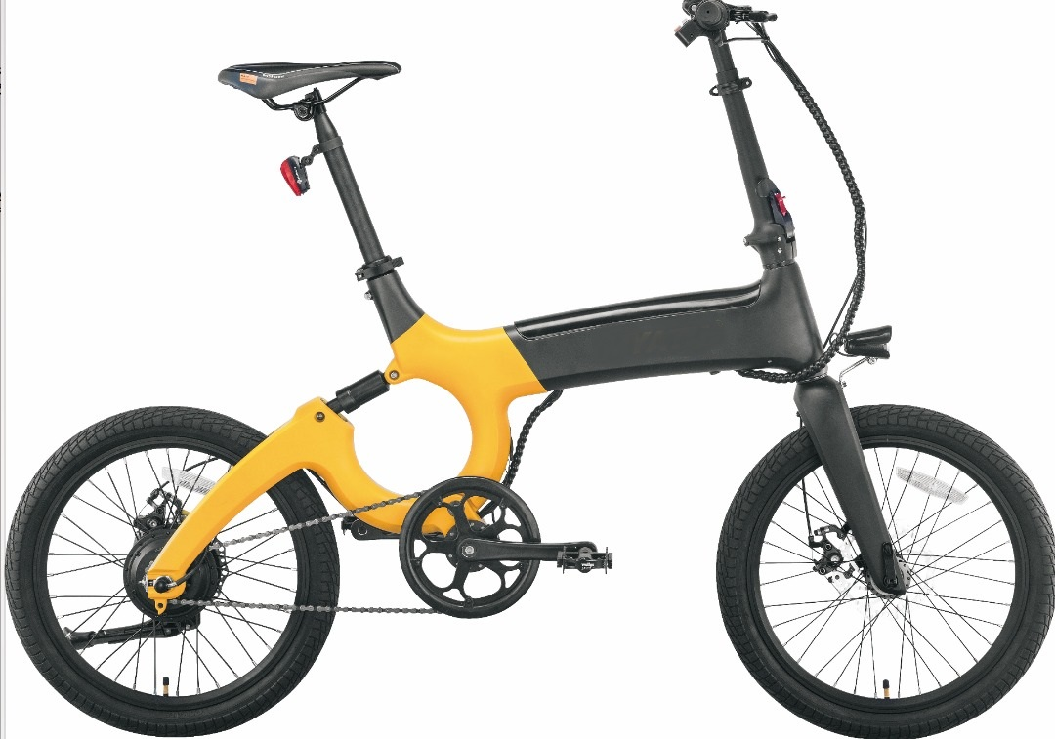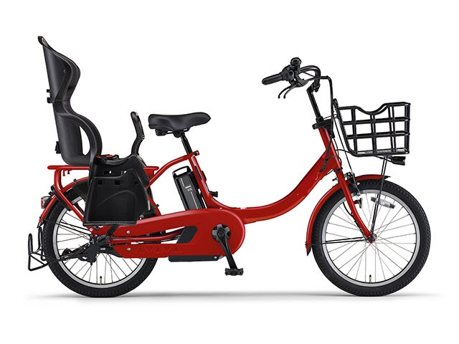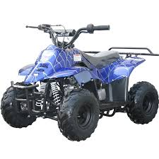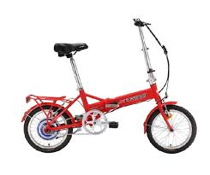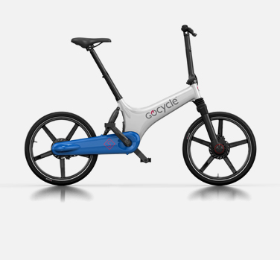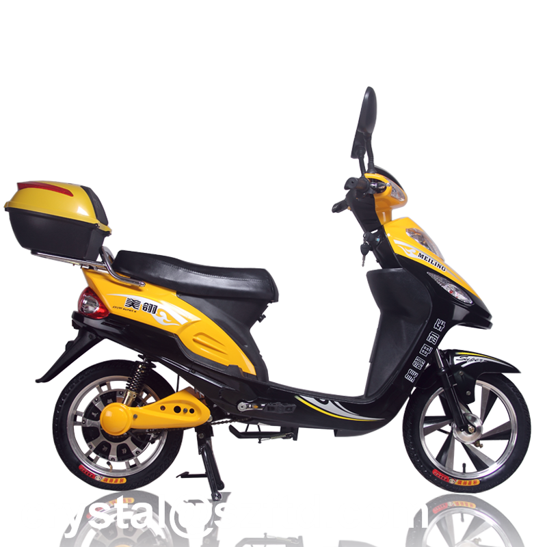

Mountain eBike Standard Commuter 3 in 1 family eBike All Terrain Vehicle Folding eBike Go Cycle eBike Electric Pedal Scooter