**Description:**

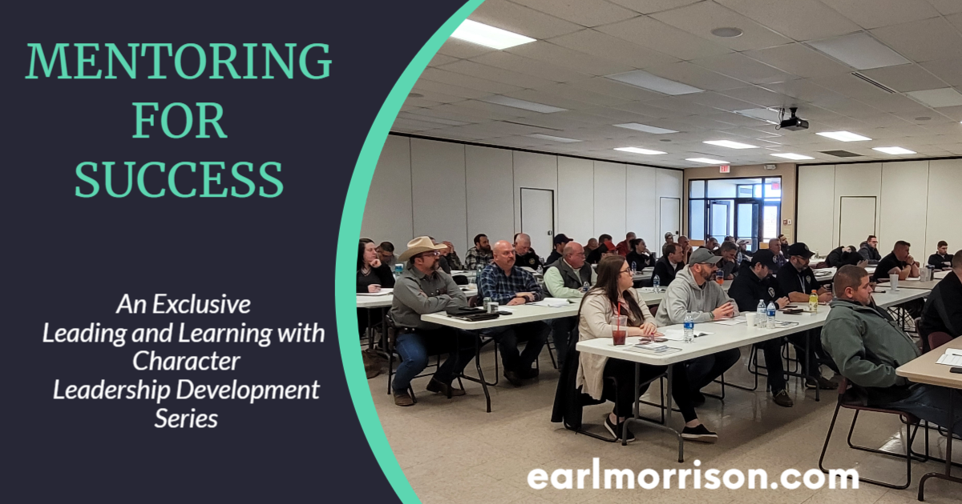

# **Date:**

**June 21-23, 2022**

**Three Day Training**

**Time:**

**0800-1700**

**CLEET Hours:**

**24**

**Location:**

**CLEET**

**2401 Egypt Road**

**Ada, OK 74820**

**CLEET Catalog Number:**

**22-2373**

**Max Capacity: 25**

**A comprehensive program to provide an avenue of growth and development to aid in the success of an organization for recruitment, retention and succession. This program is designed for all individuals no matter the level of influence or leadership position. Taught by creator and author Earl Morrison, Assistant Director of CLEET.**

**To Register:** [**https://earlmorrison.com/register**](https://earlmorrison.com/register)