horizontal line

MACC Board Meeting Minutes

Friday, 6.17.22 changed to Virtual  
Zoom Link: <https://us02web.zoom.us/j/84278191947?pwd=NVBFK24xSDZCaUo4bjJpT3JxSmgyUT09>

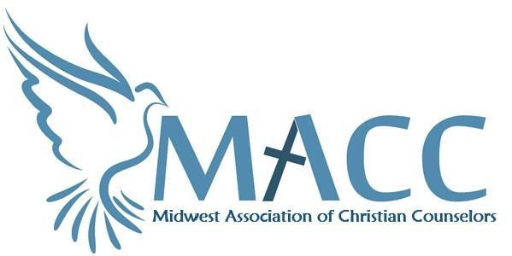

# Minutes

## Opening Prayer

## Attendees: Candi Schmechel, Reagan West, Daphne DeMaris, Tracey Ronning, Cindy Hodgson, Ray William, Jim Farm,

## Approval of agenda

## 

## Last Meeting Follow-up (Action Items From Last Meeting/ Previous Month)

1. Venmo set up for donations.
2. Status of search page -Reagan wants to use Wild Apricot but needs to test a few things.
3. New sponsors - Faithful and True are sponsoring, MNTC, Daphne doing a magazine ad for the rest of the year,
4. Magazine status; people are reading based on Mail Chimp opens, more clicks come when email goes out that magazine is available, When magazine came out last month it correlated to registrations for the last workshop.
5. New magazine contributions—theme is Shame - submit articles to Reagan by July 10th.

Link for Marketing Content Calendar for 2022 https://docs.google.com/spreadsheets/d/1RKZqumeF_rgEdY8Nsv3fqQEu98aAxxtanW_vVHnAC9k/edit?usp=sharing

## New Business

1. Financial Update: Treasurer Sadie– P&L for Jan to June, some categories need to be changed and income foremost recent workshop needs to be added.
2. Executive Director Update: Reagan
   1. Membership Update- we have doubled our membership to 129, on track for 200 by the end of the year.
   2. Workshops—timelines for workshops and magazine articles (see content calendar link above. Reagan and Daphne meeting to develop the content calendar for 2023.
   3. Website
      1. Revisit supervisors for LMFTs and LPCCs
      2. Find a Therapist search engine is being addressed with Wild Apricot
3. Committee Updates:
   1. Conference—Candi
      1. Venue update - Stevens Chapel
      2. Bits and Pieces - Tim Walsh, Moderator for panel discussion, Reagan to put a list together of collateral materials (banner for conference, etc.) together.
      3. Speaker update: everyone is in place. It is a relief to be set so early.
      4. Schedule: Keynote, worship (and we have a worship leader), keynote, breakouts, lunch, panel discussion (need two more pastors for the panel),

Email Candi questions for the panel by July 10

* + 1. Vendors and Sponsors
  1. Networking— seeking hosts for connect over coffee
     1. Update on May 21st Saturday—Lydia from Center for Hope and Healing

9:00 @ Caribou Coffee 4135 Division Street, Saint Cloud, MN 56301

* + 1. June 24th - Ray / Alicia, Ambrosia Coffee in Edina.
    2. Friday, July 22, 2022 - 9am Ray / Alicia - Location TBD
    3. Friday, August 26, 2022 - 9am Ray / Alicia - Location TBD
  1. New Member / Mentor - Cindy

Mentor Program Online Form: https://forms.gle/ERfuWWvfY1McKexW8

* 1. Pastoral Program- Jenni has been seeing people wanting to get involved. There will be a focus group to find out what is wanted/needed most.
  2. Vision – Executive Committee
  3. Committees Link: Committee Link: https://docs.google.com/spreadsheets/d/1UKhFa7T41h2d1jsA3InUN-AP1m40pmiSp2D9aMatIWg/edit?usp=sharing

# Other Business

* Steph Rossing will be doing the Immanuel Approach Training next year. Tracey will check to see if we can do it at Steven’s Chapel.
* Next meeting—July 15th Virtual
* Personal prayer needs
* Closing prayer

# Action Items

1. ***we need sponsors and vendors for the conference
2. ***replace all marketing material to reflect the name change

# 

# Meeting Attendance

# Matthew 18:20 “For where two or three are gathered together in my name, there am I in the midst of them.”

In order to offer MACC’s amazing programs, trainings, service and support, **we need you!**