horizontal line

MACC Board Meeting Agenda

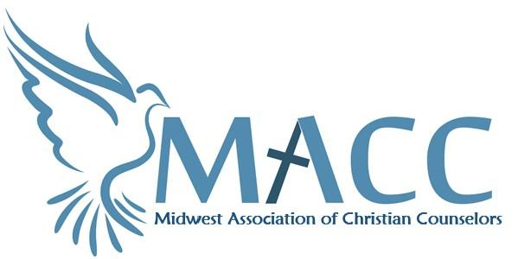Friday, 11.17.23

Virtual

# Agenda

## Opening Prayer

Introduction of visitors

## Approval of agenda & Approval of October Minutes

New Business

1. **Financial Update:** Treasurer Sadie
   1. Financial Update
2. **Committee Updates:**

**Vision** – Executive Committee—met on Monday 10.23.23

Ideas discussed

*Discuss workshop ideas

*Full day retreat?

**Conference**—update on conference 2024--

Conference 2024---*North Heights has us confirmed for September 26 and 27, 2024

Discuss mobilizing a prayer task force—has commenced. Candi sent an email to all wanting to be a part of the task force.

Key questions to answer:

*What is the purpose/goal we’re setting out to accomplish?

*Are we just trying to open a dialogue, or are there specific positions MACC needs to take on these issues?

*If MACC does want to communicate certain beliefs/positions, what may be the impact/fallout be?

Discuss speakers---Amber has been working on this…

Title--

**New Member / Mentor** – Bre and Amber

**Pastoral Program**- Jenni/Deirdre

**Networking**—Connect over coffee—update Bre

1. **Executive Director Update:** Reagan
   * 1. Membership Update
        1. Discuss retired therapists and a reduced membership rate—has this been communicated on our website?
        2. Marketing Update
        3. The need for another admin person—new hire in place

# Other Business

* Other unfinished business—I’d like to suggest that some of us meet at 8:30 for some focused prayer time…many are under significant attack from the enemy…it would be great to engage our prayer warriors.
* Next BOD meeting December 15—Virtually. January will be in person—location TBD—Voting in new board members. PLEASE MARK YOUR CALENDARS!
* Personal prayer needs / Closing prayer

# Action Items

1. We need conference committee members for next year’s conference.
2. We need pastor committee members and next steps to determine how to bridge the gap

# Matthew 18:20 “For where two or three are gathered together in my name, there am I in the midst of them.”

In order to offer MACC’s amazing programs, trainings, service and support, **we need you!**

In person attendance is preferred. We thrive when we work together, and we would love to see you!

If you need to zoom, here is the link  
<https://us02web.zoom.us/j/82948705881?pwd=bE5rUkNZcUpzREdjMXJIcFRnbzlHUT09>