Alpha league
Start date: TBD
$30 per shooter, per session
Length: 6 sessions bi-weekly
Shooting times Monday 9am to
Friday 5pm during normal business hours
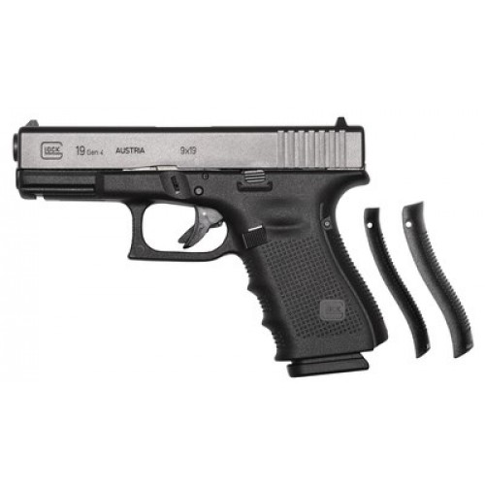
Prizes
1st Glock 19 gen 4
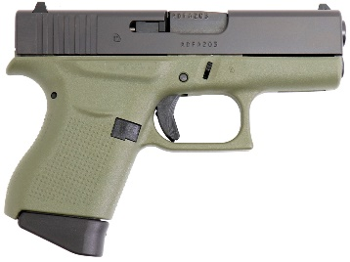
Or $500.00 west armory gift card or a one year range membership
2nd glock 43 battlefield green
Or $400.00 west armory gift card, or a six month range membership
3rd $250.00 west armory gift card
4th $150.00 west armory gift card
5th $100.00 west armory gift card
6th thru 10th $50.00 West armory gift card
See official rules for all details.

Sign up sheet.
Name Phone Number
1._________________ __________________ a01_____
2._________________ __________________ a02_____
3._________________ __________________ a03_____
4._________________ __________________ a04_____
5._________________ __________________ a05_____
6._________________ __________________ a06_____
7._________________ __________________ a07_____
8._________________ __________________ a08_____
9._________________ __________________ a09_____
10.________________ __________________ a10_____
11.________________ __________________ a11_____
12.________________ __________________ a12_____
13.________________ __________________ a13_____
14.________________ __________________ a14_____
15.________________ __________________ a15_____
16.________________ __________________ a16_____
17.________________ __________________ a17_____
18.________________ __________________ a18_____
19.________________ __________________ a19_____
20.________________ __________________ a20_____

