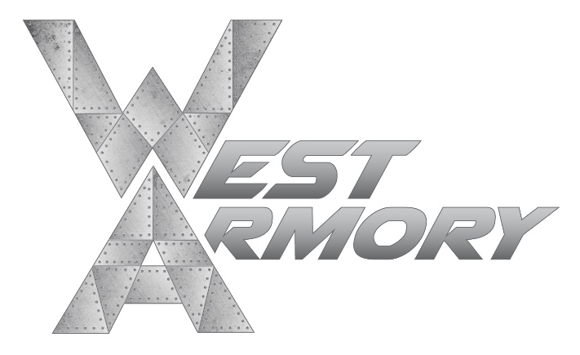

PRICE MATCH POLICY
At West Armory LLC, we try to make sure we are bringing our customers the lowest prices every day, but we know other competitors have sales. During those times, their price is our price and their sale is our sale, because that is our commitment: to always have the best price.
We are committed to saving our customers money by having the lowest prices in the market. However, if a customer finds a lower Everyday or Advertised price on an identical stock item from any local competitor, WE WILL PRICE MATCH!
West Armory LLC will match verifiable, online prices for the following retailers (“verifiable” is defined as pricing that is able to be verified by West Armory Management as current, valid, and in stock):
- Any local competitor
- Bass Pro
- Buds Guns
- Cabela’s
- Dick’s Sporting Goods
- RK Guns
- Sportsman’s Outdoor Superstore

Acceptable Criteria
- The item must be the identical brand, color and model number.
- The price and item must appear in a local competitor’s ad.
- The local competitor must be in the same market.
- The proximity of a “local” competitor will be at the store manager’s discretion.
- The price can be from a local online competitor ad. Shipping & handling costs and transfer fees must be included.

Unacceptable Criteria
- Ads when the actual price cannot be determined
- Competitor ads from outside of the store’s local market
- It is the store’s general manager’s discretion as to what defines a local market
- Items listed by the other retailer as Clearance, Closeout, Liquidation, Special Hour/ Flash/ Limited Quantity, or Going Out of Business
- Misprinted local competitor ads & incorrect internet pricing
- 3rd party internet seller pricing (e.g. eBay, Amazon or Walmart Marketplace, GunBroker, Armslist, ect…)

