Empowering Futures 

Registered Charity Number (CIC) 1182139

Tel: 07743 57 57 87

Email: admin@empoweringfutures.co.uk

Website: www.empoweringfutures.co.uk

Address: Stables, No 2 Bury Hill, Moorend, Winterbourne, Bristol BS16 1SS

**Empowering Futures Safeguarding Children & Young People Policy**

**POLICY PURPOSE**

Empowering Futures is a CIO (Charitable Incorporated Organisation) registered Charity that provides a range of indoor and outdoor activities on our Care Farm.

● Forestry School

● Arts and crafts

● Animal Care

● Horticulture

● Cooking

● And more..

Whilst we deliver direct services or support for children, young people and adults at risk, Empowering Futures recognises that safeguarding those members of society is everyone’s business and that all may become vulnerable at many stages in their lives.

Empowering Futures is committed, therefore, to ensuring that the Management Committee, volunteers and those who participate in activities run by the organisation have an understanding of Safeguarding Children and what forms abuse may take and that they know where to raise concerns if abuse is suspected or reported.

**Safeguarding Children**

This policy therefore applies to all staff, including senior managers and the board of trustees, paid staff, volunteers and sessional workers, agency staff, students or anyone working on behalf of the organisation to **safeguard children.**

**Definition of Children & Young People**

Children - 0 - 16 years of age, Young people Ages 14 - 17. From the age of 18, the person will be defined as an adult. In this instance, please see our Safeguarding Adults Policy.

***Embedding this policy to participants with learning needs***

*Prior to commencing engagement on the farm, inductions are held for all staff, volunteers and participants to ensure this policy is understood and achievable. We have ensured this policy is accessible to all by providing easy-read information with clear, easy-read, basic instructions and pictures to help educate and deliver the message.*

**Date of Policy Creation:** 1st February 2019

**Last Reviewed:** 19/04/2024

**Next Review Due:** 19/04/2025

**Signed off by:** Maria Needs

**Signature Sign-Off: **

We follow the Social Model of Disability. We offer bespoke opportunities to ensure we remain person centred. Our services are firmly embedded with quality and purpose for each individual we work with. Our approach is holistic. We encourage personal responsibility. We aim to increase independence and to empower individuals. We have a proven track record of significant success.

Empowering Futures 

Registered Charity Number (CIC) 1182139

Tel: 07743 57 57 87

Email: admin@empoweringfutures.co.uk

Website: www.empoweringfutures.co.uk

Address: Stables, No 2 Bury Hill, Moorend, Winterbourne, Bristol BS16 1SS

**STEP 1) CONTACTING THE DSL - (Designated Safeguarding Leads)**

● 1st Line DSL – Kelly Rogers - 07443 575 787

● 2nd Line Deputy DSL – Maria Needs - 07443 575 787 (If 1st DSL is unavailable) ● 3rd Line 2nd Deputy DSL - Grant Rogers - 07443 575 787

Contacting DSLs in writing? Please send a text message or contact by email admin@empoweringfutures.co.uk

Empowering Futures has appointed Maria Needs as the named DSL - Designated Safeguarding Lead. Training is refreshed annually to ensure training and competencies are kept up to date and in line with laws and regulations.

**STEP 2) PROCEDURES FOR RAISING A CONCERN**

Please follow the below steps to raise a safeguarding concern

**1. IMMEDIATELY PHONE THE DSL OR DEPUTY DSL.** IF UNABLE TO COMMUNICATE VERBALLY, THEN AN EMAIL OR TEXT MESSAGE MUST BE SENT. THE TEXT OR EMAIL SHOULD BE SENT WITH THE SUBJECT OF ‘SAFEGUARDING CONCERN’ Emails must be sent to

**ADMIN@EMPOWERINGFUTURES.CO.UK**

**2. DSL’s ACT IMMEDIATELY** - DSL must escalate the concern and refer to appropriate authorities within one hour.

**3. LOG THE CONCERN** - Safeguarding issues and the safeguarding log are confidential to the DSLs but are kept on file and password protected.

**Part One: Safeguarding Children**

This policy has been drawn up based on law and

guidance that seeks to protect children, namely; 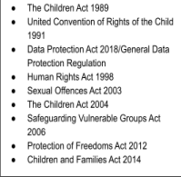

● Working Together to Safeguard Children 2018 You

can access this guidance here

● Information sharing: Advice for practitioners

providing safeguarding services to children, young

people, parents and carers. 2018: You can access

this guidance here

● Special educational needs and disability (SEND)

code of practice: 0-25 years 2015. You can access

this guidance here

In addition, reference is made to the documents listed

in the box on the right.

We follow the Social Model of Disability. We offer bespoke opportunities to ensure we remain person centred. Our services are firmly embedded with quality and purpose for each individual we work with. Our approach is holistic. We encourage personal responsibility. We aim to increase independence and to empower individuals. We have a proven track record of significant success.

Empowering Futures 

Registered Charity Number (CIC) 1182139

Tel: 07743 57 57 87

Email: admin@empoweringfutures.co.uk

Website: www.empoweringfutures.co.uk

Address: Stables, No 2 Bury Hill, Moorend, Winterbourne, Bristol BS16 1SS

**Safeguarding and promoting the welfare of children**:

Safeguarding and promoting the welfare of children is defined for the purposes of this policy as:

● Protecting children from maltreatment;

● Preventing impairment of children's health or development;

● Ensuring that children grow up in the circumstances consistent with the provision of safe and effective care; and

● Taking action to enable all children to have the best outcomes.

(Working Together to Safeguard Children 2018)

**Safeguarding is everyone's responsibility**

Everyone who works with children has a responsibility to keep them safe. No single practitioner can have a full picture of a child’s needs and circumstances, and if children and families are to receive the right help at the right time, everyone who comes into contact with them has a role to play in identifying concerns, sharing information and taking prompt action.

In order that organisations, agencies and practitioners collaborate effectively, it is vital that everyone working with children and families, including those who work with parents/carers, understands the role they should play and the role of other practitioners. They should be aware of, and comply with, the published arrangements set out by the local safeguarding partners. (Working Together to Safeguard Children 2018)

**The organisation** believes that a child or young person should never experience abuse of any kind. We have a responsibility to promote the welfare of all children and young people and adults at risk and to keep them safe. We are committed to practice in a way that protects them.

**Abuse can take various forms:**

● Physical

● Emotional

● Neglect

● Sexual

● Child Sexual Exploitation

● On Line abuse

(*See Appendix A for further details*)

We follow the Social Model of Disability. We offer bespoke opportunities to ensure we remain person centred. Our services are firmly embedded with quality and purpose for each individual we work with. Our approach is holistic. We encourage personal responsibility. We aim to increase independence and to empower individuals. We have a proven track record of significant success.

Empowering Futures 

Registered Charity Number (CIC) 1182139

Tel: 07743 57 57 87

Email: admin@empoweringfutures.co.uk

Website: www.empoweringfutures.co.uk

Address: Stables, No 2 Bury Hill, Moorend, Winterbourne, Bristol BS16 1SS

All Empowering Futures activities with children are run with the parents or carers of the children present. Volunteers and Management Committee members are not permitted at any time to be alone with children.

All Empowering Futures volunteers and Management Committee members and those who participate in activities run by the organisation are inducted into this policy and procedure and have an understanding of what forms abuse can take and how to report any concerns.

Empowering Futures will ensure all who are arranging events on their behalf are made aware of this policy.

**Advice and information**

**For children and young people**:

South Gloucestershire Council ART Team can be accessed for advice or information contact on 01454 866000

South Gloucestershire Safeguarding Children’s Board Website:

www.southglos.gov.uk/safeguarding/children

South West Child Protection Procedures:

http://www.proceduresonline.com/swcpp/southglos/index.html

If a child is in immediate danger dial 999 and ask for police assistance

**Reporting Concerns**

**If a crime may have been, or is being, committed contact the Police on 101 or 999**

Volunteers and Management Committee members should report any concern that they have about a child or an adult at risk to the Named Safeguarding Lead and Chair of the Management Committee unless the concern is about the Lead or Chair where it should be reported to the Vice Chair who will contact the South Gloucestershire Council Team below.

**Children and Young people**

Contact South Gloucestershire Council ART Team on 01454 866000 or the Emergency Duty Team (out of hours and weekends) on 01454 615165

Be open and honest with the individual (and/or their family where appropriate) from the outset about why, what, how and with whom information will, or could be shared, and seek their agreement, unless it is unsafe or inappropriate to do so.

**Record Keeping**

If a concern is raised this should be documented and sent through to the DSL of Empowering Futures, as outlined above.

We follow the Social Model of Disability. We offer bespoke opportunities to ensure we remain person centred. Our services are firmly embedded with quality and purpose for each individual we work with. Our approach is holistic. We encourage personal responsibility. We aim to increase independence and to empower individuals. We have a proven track record of significant success.

Empowering Futures 

Registered Charity Number (CIC) 1182139

Tel: 07743 57 57 87

Email: admin@empoweringfutures.co.uk

Website: www.empoweringfutures.co.uk

Address: Stables, No 2 Bury Hill, Moorend, Winterbourne, Bristol BS16 1SS

**Managing allegations against staff or volunteers**

Any allegation will be fully investigated and Empowering Futures will support staff/volunteers during this process. It is important that allegations are thoroughly investigated through the Safeguarding process so that allegations can be either proved or disproved for the protection of the child(ren), adult(s) at risk and staff.

All allegations should be reported within one working day to the senior manager of the organisation.

Any allegation related to staff and/or volunteers working with Children and Young People and Adults must be reported to the South Gloucestershire Local Authority Designated Officer (LADO) on 01454 866000.

It is important to remember that abuse is defined by the impact on the individual not the intention of the abuser, in other words if someone does not have their needs cared for this can be just as damaging whether it is done deliberately or because a carer can no longer manage. Obviously the way of then supporting the situation would be likely to be different.

People who behave abusively come from all backgrounds and walks of life. They may be doctors, nurses, social workers, advocates, staff members, volunteers or others in a position of trust. They may also be relatives, friends, neighbours or people who use the same services as the person experiencing abuse.

**Contact Details for allegations (Escalating immediately)**

| Local Authority  Designated Officer  (LADO) | Tina Wilson | 01454 866000 |
| --- | --- | --- |

We follow the Social Model of Disability. We offer bespoke opportunities to ensure we remain person centred. Our services are firmly embedded with quality and purpose for each individual we work with. Our approach is holistic. We encourage personal responsibility. We aim to increase independence and to empower individuals. We have a proven track record of significant success.

Empowering Futures 

Registered Charity Number (CIC) 1182139

Tel: 07743 57 57 87

Email: admin@empoweringfutures.co.uk

Website: www.empoweringfutures.co.uk

Address: Stables, No 2 Bury Hill, Moorend, Winterbourne, Bristol BS16 1SS

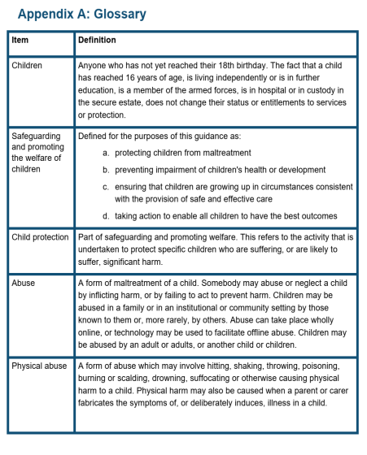

We follow the Social Model of Disability. We offer bespoke opportunities to ensure we remain person centred. Our services are firmly embedded with quality and purpose for each individual we work with. Our approach is holistic. We encourage personal responsibility. We aim to increase independence and to empower individuals. We have a proven track record of significant success.

Empowering Futures 

Registered Charity Number (CIC) 1182139

Tel: 07743 57 57 87

Email: admin@empoweringfutures.co.uk

Website: www.empoweringfutures.co.uk

Address: Stables, No 2 Bury Hill, Moorend, Winterbourne, Bristol BS16 1SS

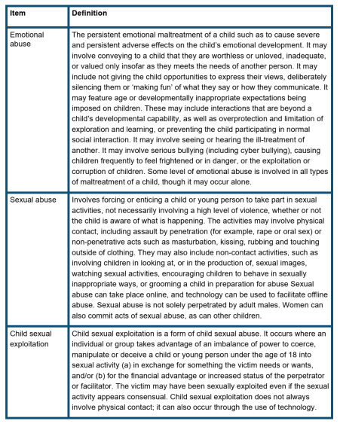

We follow the Social Model of Disability. We offer bespoke opportunities to ensure we remain person centred. Our services are firmly embedded with quality and purpose for each individual we work with. Our approach is holistic. We encourage personal responsibility. We aim to increase independence and to empower individuals. We have a proven track record of significant success.

Empowering Futures 

Registered Charity Number (CIC) 1182139

Tel: 07743 57 57 87

Email: admin@empoweringfutures.co.uk

Website: www.empoweringfutures.co.uk

Address: Stables, No 2 Bury Hill, Moorend, Winterbourne, Bristol BS16 1SS

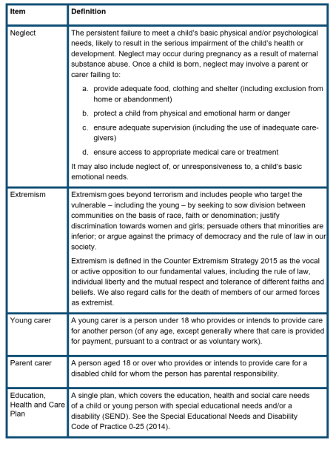

We follow the Social Model of Disability. We offer bespoke opportunities to ensure we remain person centred. Our services are firmly embedded with quality and purpose for each individual we work with. Our approach is holistic. We encourage personal responsibility. We aim to increase independence and to empower individuals. We have a proven track record of significant success.

Reviewed 19/4/24