Drawing class Supply list

Gray Scale Pan Pastel | 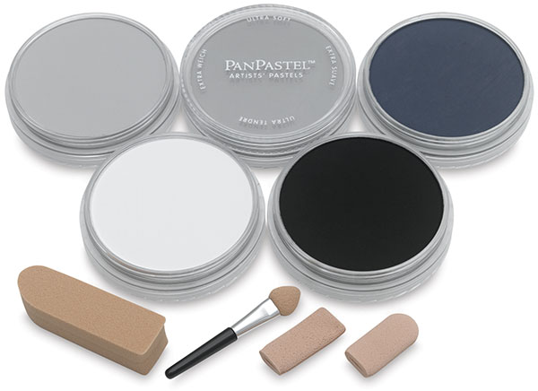 | Soft Knifes and Covers for application of pan pastel | 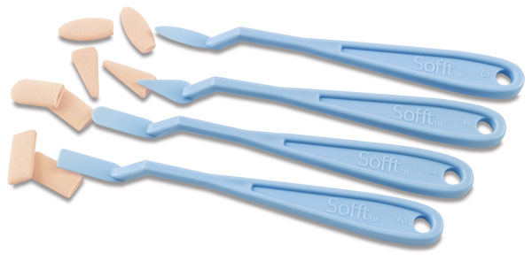
Ebony prismacolor pencil | 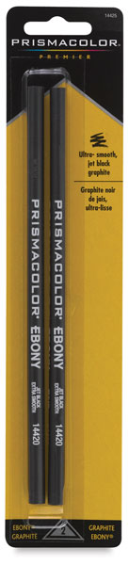 | You can buy items individually or in sets. Just make sure you have Charcoal Sticks, pencils, graphite, paper stump and kneaded eraser | 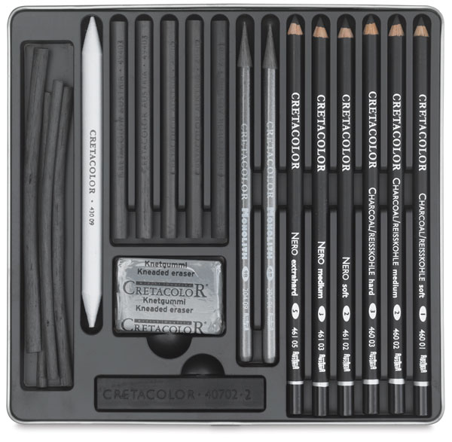
Charcoal Pencils (white)  If you get the set above only get a white pencil. | 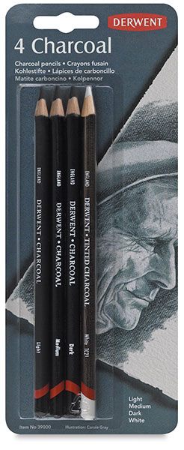 | Sand paper block  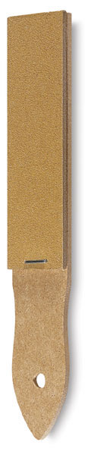 | Soft Cloth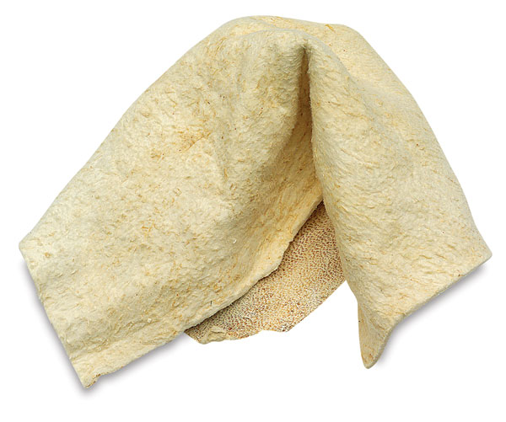
Newsprint smooth block 12x18  Any brand | 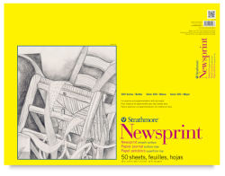 | Exacto knife for sharpening pencils | 