
Cancer Gene Detection:
Westminster College
Investing the p53 Tumor Suppressor Gene Using Pedigree Analysis and Gel Electrophoresis

STEELS STANDARDS
- 3.1.9-12.A
- 3.1.9-12.D
- 3.1.9-12.P
- 3.1.9-12.Q
- 3.1.9-12.R

*Components of this lab have been taken both directly and indirectly (with modification) from the EDVOTEK Cancer Gene Detection Lab (EDVO-Kit #115)

OBJECTIVES
- Explain the function of the p53 gene and its role as a tumor suppressor in regulating the cell cycle and preventing cancer.
- Differentiate between normal and mutated alleles of the p53 gene, describe the implications of mutations for hereditary risk.
- Construct and interpret pedigrees to trace the inheritance pattern of a p53 mutation.
- Analyze gel electrophoresis results to identify individuals with normal (wildtype), mutated, or heterozygous p53 alleles.
- Correlate molecular data (gel results) with pedigree analysis to draw conclusions about gene inheritance and disease risk.

EXPERIMENTAL OVERVIEW

- Module I: Construction of Family Pedigree
- Module II: Gel Electrophoresis- Analysis of DNA samples
- Module III: (Optional) Sanger Sequencing Analysis of DNA to search for p53 mutations

BACKGROUND INFORMATION

Chances are that you have a personal connection to cancer. Worldwide, cancer is the second leading cause of death, with about 1 in 6 deaths caused by cancer. Many more people have been treated for cancer. This means that the likelihood is high that a friend, family member, or colleague has been diagnosed with cancer at some point. But what is cancer, how does it affect the human body, and how can we test for it?

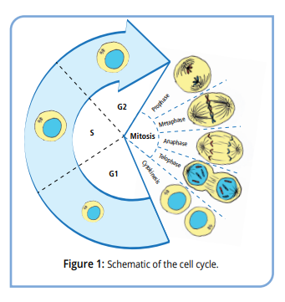
All cells divide in order to create more cells. In most cases, one parent cell will split into two identical daughter cells. This allows an organism to grow, to develop, and to replace old cells. In order for a cell to divide, it must increase in volume, duplicate its DNA and organelles, and then split all of the cellular components into two separate cells. This sequence of events, called the cell cycle, is tightly controlled so that cells only divide when and where they are supposed to. Cellular checkpoints block the passage of the cell from one phase to the next, preventing cells from dividing when they should not (Figure 1). Only when the cell has successfully completed one step is it allowed to clear the checkpoint and move to the next step of mitosis.

The cell cycle must be carefully regulated to ensure that the cell divides at the right time and in the right place. For example, cells in the epidermis divide frequently to replace the outer layers of skin, whereas mature neurons in the brain divide rarely if at all. Red blood cells, which have ejected their nuclear material, no longer divide; instead, when they are no longer useful, they are broken down and recycled into new cells. When mutations in a cell’s DNA change the timing of signals that tell it when to grow and divide, it can multiply in a rapid, unregulated way.

This unregulated, abnormal growth of cells results in a group of diseases called cancer. Over time the over-abundance of cells forms masses called tumors. Common cancer include skin, lung, breast, and colorectal cancer, each of which has similar characteristics. However, different tissues respond differently, and different gene mutations affect the progression of cancer. As the cells rapidly divide, proofreading during DNA replication becomes sloppy, creating additional mutations in genes. This can result in cancer cells leaving their primary site and invading surrounding tissues where they form satellite tumors in a process called metastasis.

Tumor Suppressor Proteins and Oncogenes

The vast majority of cancers arise from mutations in genes controlling cellular growth. These mutations change the way proteins function and the way a cell behaves and divides, eventually leading to cancer. There are two main classes of genes that cause cancer.

- Oncogenes: In healthy tissues, cells contain DNA that codes for proteins that promote normal cell growth and division. Mutations in the DNA sequence can cause these genes to become active at the wrong time or place. These “gain-of-function” mutations cause the genes to become more active, signaling for the cell to divide uncontrollably. Many of these mutations are dominant, meaning that only one mutant copy of the gene is necessary to cause unrestricted cell growth. For example, in healthy tissues MYC genes code for proteins called transcription factors that turn on genes necessary for cell growth at specific times during development. When the genes are mutated, MYC is able to continuously turn on these pro-growth genes, resulting in uncontrolled cell proliferation.
- Tumor Suppressor Genes: In healthy cells, tumor suppressor proteins inhibit cell growth and prevent tumor formation. Mutations in these genes remove the barriers preventing uncontrolled cell growth. To promote cancer, both copies of the gene must be mutated. One example of a tumor suppressor protein is p53, encoded by the TBP53 gene. P53 is an important protein in tumor suppression, regulating DNA damage repair, arresting cell growth, and initiating cell death in unhealthy cells.

It is important to remember that cancer is not one disease. Even within a single type of cancer, like breast or colorectal cancer, different mutations can lead to the overgrowth of cells. Furthermore, it is rare for cancer cells to contain only a single mutation. In fact, initial mutations in pre-cancerous cells can destabilize the genome, leading to further mutations in that cell and its daughter cells. Cancer cells will often contain one or more oncogenes combined with the inactivation of an important tumor suppressor gene. Since cancer changes the nature of the cells, these mutations can be identified using modern molecular biology techniques.

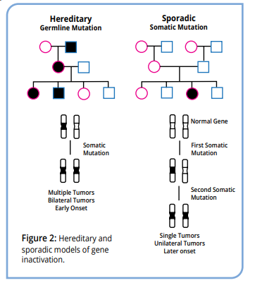
Molecular Analysis of Inherited Cancer Genes

The vast majority of cancers result from acquired (somatic) mutations, which are changes in the DNA sequence that happen during a person’s lifetime. These changes occur either through exposure to mutagens that change the DNA sequence or through errors in DNA replication. Now, not every change in a somatic cell’s DNA (i.e., non-germ cells) may cause cancer; the changes may be in non-coding DNA, or they may be recessive to a functioning copy of the gene. But since these mutations occur in the body’s cells, and not the germ cells, they cannot be passed to an individual’s progeny so there is no direct genetic link between family members. In contrast, germline mutations are directly inherited through DNA changes that can be passed from one generation to the next as they are present in the gametes. As a result, they appear more frequently among family members. They can be tracked by creating a diagram that describes the relationships between family members, called a familial pedigree. Overall, familial cancers constitute a very small fraction of the total reported cancers. Pedigrees for both somatic and inherited cancers appear in Figure 2.

Some of the first cancer genes identified by researchers are responsible for inherited cancers. For example:

The retinoblastoma (RB) Gene: a tumor suppressor gene that slows cell cycle progression. Mutations in this gene result in childhood cancer of the eye.

The Wilms’ Tumor 1 Susceptibility (WT1) Gene: a tumor suppressor gene that turns on genes necessary for development of the urogenital system. Mutations in this gene result in nephroblastoma, a cancer of the kidneys.

The Neurofibromatosis Type II (Merlin) Gene: a tumor suppressor gene that codes for a protein that links the cytoskeleton to itself and to the cell membrane. Cells with mutations in this gene ignore contact inhibition when growing; that is, the signals that tell cells to stop dividing when they are touching other cells.

Li-Fraumeni Syndrome (P53 gene): a tumor suppressor gene that acts as a master regulator for the genes responsible for cell division and death. This gene is often called the “Guardian of the Genome” as it plays a major role in preventing changes to the genomic DNA. Just a single mutation in the gene greatly increases a person’s susceptibility to cancer. Not surprisingly, p53 is the most commonly mutated gene in cancer cells.

By studying inherited cancers, cancer biologists can search for genes that are critical for normal cell development and carcinogenesis. Using molecular biology techniques, researchers developed gene maps that describe the chromosomal locations of genes. These maps are used as tools for the identification of cancer-causing mutations for both inherited and non-inherited cancers. To create these maps, researchers isolate cancer cell DNA and analyze point mutations in hot spot areas in cancer-related genes, such as p53. Cancer genomes or the whole DNA sequence from cancer cells can be analyzed using techniques like Restriction Fragment Length Polymorphism (RFLP) analysis and DNA sequence analysis by chain termination.

For RFLP analysis, researchers first amplify DNA using the polymerase chain reaction (PCR), a biotechnology technique that quickly and accurately creates large amounts of DNA in vitro in a process similar to replication in a cell’s nucleus. The DNA samples are heated, which separates the two strands of the DNA duplex. Short, synthetic DNA primers, designed by researchers to target a specific sequence, bind to the DNA. This directs the DNA-building enzyme Taq DNA polymerase to build new DNA, starting at the primer location and continuing along the sequence. After the initial elongation, the sample is heated again to denature the newly formed DNA duplex, then cooled to allow primer binding and extension to happen again (Figure 3). Each time the sample cycles through the different temperatures, the amount of DNA doubles. This simple cycle- denature, anneal, extend- is the basis of PCR. By repeating this sequence of heating and cooling many times, billions of copies of a specific DNA sequence are produced in a matter of minutes. After amplification, the DNA is digested with restriction enzymes, which cut double-stranded DNA in a sequence -specific manner. The fragments are analyzed using agarose gel electrophoresis, a technique that separates DNA into discrete bands on their molecular size.

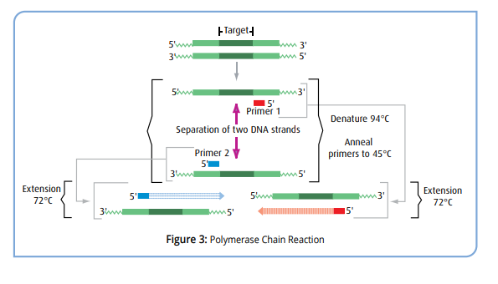
Li-Fraumeni Syndrome (LFS) and p53 Mutations
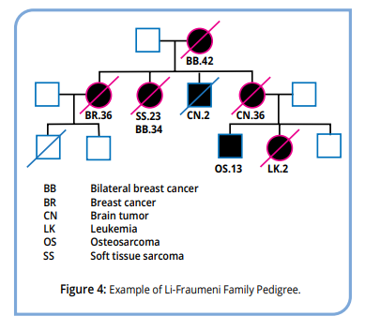
Two physicians, Frederick Pei Li and Joseph F. Fraumeni, Jr. first described a rare syndrome in 1969 after identifying 24 families with a history of childhood sarcomas, an uncommon bone and connective tissue cancer. Further analysis showed more than 50% of the family members were susceptible to cancers that include brain, colorectal, breast cancers and leukemias. To study the heredity of the syndrome, researchers too, detailed patient histories and created family pedigrees tracing the occurrences of cancer back through several generations (Figure 4). After carful analysis of the family pedigrees, researchers concluded that this syndrome followed a dominant inheritance pattern. Using the data, Li and Fraumeni established specific guidelines for diagnosis of this familial cancer. All three of these guidelines must be met before LFS can be diagnosed.

- A tumor (sarcoma or other cancer common in Li-Fraumeni Syndrome patients) diagnosed before the patient is 45.
- One immediate relative (parents, siblings, or children) was diagnosed with cancer before the age of 45.
- A second relative, either immediate or second-degree (grandparents/grandchildren, aunts/uncles, or nieces/nephews) diagnosed with cancer before the age of 45.

With the advent of DNA sequencing in the 1990s, researchers were able to link this condition, now called Li-Fraumeni Syndrome (or LFS) to the p53 gene. The data showed that individuals with LFS have inherited one wildtype p53 allele and one mutated allele. In LFS, the mutated TP53 gene acts in a dominant-negative fashion. This means the mutated protein can interfere with the function of the normal p53 protein produced by the other, unaffected copy of the gene. Cells with two altered copies of this gene do not make functional p53 protein which allows tumors to develop. In contrast, individuals with two wildtype copies of the p53 gene require two sequential mutations to initiate tumors. This model is referred to as the “two-hit hypothesis.” While the inherited mutation in TP53 is dominant at the organismal level, the classic “two-hit hypothesis” still applies at the cellular level. For a cancer to develop in Li-Fraumeni Syndrome, a second somatic mutation involving the other copy of the TP53 gene must occur in the body’s cell during a person’s lifetime.

Cancer biologists have extensively studied and mapped the DNA sequence changes in p53 that cause Li-Fraumeni syndrome and other cancers and found that over 50% of cancer genomes have mutations in this gene. Homozygous loss of p53, where mutations have arisen in both copies of the gene, is found in 65% of color cancers, 30-50% of breast cancers and 50% of lung cancers. Due to the prevalence of p53 mutations, and the importance of the gene in driving cancer progression, it has become one of the most well studied cancer genes. Because of p53s role as a mater regulator in cell division and cell death, both he DNA and protein have come the focus of many cancer biology studies.

The gene of the p53 protein is located on the short arm of chromosome 17. It was initially identified as a 53 kilodalton (kDa) protein by SDS-PAGE, hence the name p53 (p for protein, 53 for the apparent molecular weight). After the sequence was determined, it was discovered that the proteins’ molecular weight was actually 43.7 kDA; the discrepancy in size came from the large number of prolines in the protein sequence which affected its migration through the gel. In the cell, p53 regulates cell division and cell death through its function as a transcriptional regulator. Specific amino acids in the protein (called residues) allow it to bind to specific DNA sites. By binding the DNA, p53 activates the transcriptions of genes necessary for cell division and cell death.

The p53 protein can be divided into three main domains (Figure 5A). The N-terminal region of the protein contains the transcriptional activation domain (TAD), which bind s to and activates transcription factors. The central region of the protein is the DNA-binding domain (DBD), which binds to a specific promoter sequence to activate gene transcription. Sequences within this region are also responsible for binding to important co-factors. The C-terminal region of p53 is the most complex section of the protein. Oligomerization domains within this region allow p53 to bind to itself, and nuclear localization sequences (NLSs) allow the protein to be transported to the cell’s nucleus.

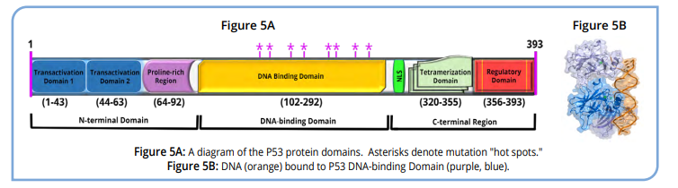

The majority of critical mutations are located within the central region of p53, which is where the protein binds DNA and transcriptional co-factors (Figure 5B). In human cancer genomes, mutations are detected in high frequency in these “hot spots”; in fact, nearly 95% of p53 mutations occur within this region. By changing the DNA sequence, the amino acid sequence changes, and p53 loses its ability to function. Examples of DNA hot spots that change the p53 protein sequence are found in the codons for residues 165 and 175 in exon 5, residues 196 and 213 in exon 6, residues 245 and 248 in exon 7, and residues 273 and 282 in exon 8. These mutations can change the conformation of the p53 protein, affect its ability to bind to DNA, and increase the stability of the protein. Most mutations are recessive to the wild-type gene, meaning that for a tumor suppressor gene such as p53 to play a role in transformation in cancer, both alleles need to be altered. However, once both alleles have mutated, cells can grow uncontrolled.

Today, diagnosis of LFS includes sequencing to determine whether an individual has mutations in one or both copies of the p53 gene, and where those mutations are located. Family pedigrees are constructed to identify other relatives who may have LFS. Under the guidance of their doctors, patients with LFS will be regularly screened for common cancers, including leukemia, brain, breast, and colorectal cancer. Furthermore, genetic counselors advise affected individuals about their disease and counsel them for any emotional distress that may arise from the diagnosis.

MATERIALS

- Horizontal Gel Electrophoresis Apparatus
- DC Power Supplies
- 1X TAE (Tris-acetate-EDTA) Electrophoresis Buffer)
- Microcentrifuge
- Micropipettes with Tips
- 0.8% Agarose Gels (*Gels will be prepared, unless requested otherwise)
- SmartGlow™ DNA Pre-Stain/ Loading Dye
- Visible Blue Light Transilluminator
- DNA Samples (Pre-Digested)
- DNA Standard Marker/Ladder
- Control DNA (unmutated p53 allele)
- Patient (Valerie) Peripheral Blood DNA
- Patient (Valerie) Breast Tumor DNA
- Patient (Valerie) Normal Breast Tissue DNA

SAFETY

- Gloves, glasses, and aprons should be worn routinely as good laboratory practice
- Exercise extreme caution when working with equipment that is used in conjunction with the heating and/or melting of reagents (if preparing/ pouring gels)
- DO NOT MOUTH PIPET REAGENTS- use pipet pumps/ micropipettes
- Exercise caution when using the power supply. The area around the power supply and the electrophoresis chamber should be dry. Be sure the electrical leads are sitting on the electrophoresis chamber properly and all the connections are in place before turning on the power. Likewise, the power supply should be shut off before disconnecting any of the electrical leads.
- When analyzing gels using the Blue Light Transilluminator, always view through the provided, protective screen. The Transilluminator uses high intensity LED lights. DO NOT stare directly at the viewing surface without the amber cover in place.
- Always wash hands thoroughly with soap and water after handing reagents or. biological materials in the laboratory.

Module I: Construction of a Family Pedigree.

Breast cancer is the second most common form of cancer in women (behind skin cancer), yet if detected early the survival rate is very high. Most breast caners begin when cells in the milk ducts begin to divide abnormally, though cancer cells can develop in the glandular or other breast tissues. They may begin as small, benign (non-cancerous) growths of cells that remain in the breast for many years. In some cases, cancerous cells can form within the “lump”. These cells break away from the growths and begin to spread into the surrounding tissue (metastasis), including the nearby lymph nodes.

Early symptoms of breast cancer tend to be mild, if noticeable. Since these symptoms are subtle, regular screening is important.

Once a potential tumor is identified, doctors evaluate it to determine the proper medical treatment. This includes:

- Detailed imaging of the breast tissue, either by mammogram or magnetic resonance imaging (MRI)
- Removing small samples of tissues from the breast and surrounding lymph nodes for closer examination by doctors (biopsy)
- Whole body imaging by Positron Emission Tomography (PET scan) to determine whether the cancer has spread.

Risk factors for breast cancer include sex (female), weight, level of activity, diet, and more. While uncommon, breast cancer can also occur in men, as they do have the undeveloped duct and gland tissue. Furthermore, there is a genetic risk—it is estimated that 5-10% of breast cancers are inherited. When researchers analyzed genomic DNA from breast tumor cells, they found that many patients had mutations in their p53 gene. Due to the mutations, individuals with Li-Fraumeni syndrome have an increased risk of developing breast cancer.

The first part of the experiment is based on the information made available as part of a diagnosis by the family physician and the oncologist. The pedigree information that you will develop is for a young woman who is suspected to have the Li-Fraumeni syndrome. The first step in the search and assignment of Li-Fraumeni syndrome is to sequence the patient’s DNA and establish their family pedigree.

(Patient Information for Developing Family Pedigree)

At her yearly physical, doctors identified a lump in Valerie Brown’s breast (age 44). The lump was biopsied and shown to be precancerous. Valerie was concerned because she knew that her mother had breast cancer when she was in her late thirties. She made an appointment with her physician, who referred her to a specialist at a local cancer center, where she was diagnosed as having breast cancer. As part of the medical work-up, the oncologist had inquired about her family history of cancer.

Upon consultation with her mother, Valerie learned that her father and his family appeared to be free of cancer. However, in Valerie’s mother’s family, several family members had been diagnosed with different types of cancer. Given the high incidence of cancer in the family, the genetic counselor decided to chart the family’s pedigree to determine whether there was a heredity component to the cancer.

PROCEDURE

With the information given below, chart the family pedigree:
- Her mother, Diane, was diagnosed and treated for breast cancer at the age of 39.
- Valerie did not know that Diane had a sister, Mabel, who died at age 2 of a brain tumor.
- Diane’s brother, James (age 40) underwent surgery, followed by chemotherapy for breast cancer.
- Her maternal grandmother, Elsie, died at age 42 from bilateral breast cancer.
- Her maternal grandfather, Elmer, was free of cancer and is 88 years old.
- Her maternal cousin, Patrick, (son of James), died of brain cancer at 14.
- Her cousin (Patrick’s sister), Jane, was diagnosed with childhood leukemia and subsequently died at age 2.
- Patrick’s two other brothers, Richard (age 28) and Curtis (age 30), are in good health and free of cancer.
- Valerie’s sister, Nancy (age 38), is cancer free.
- Nancy’s son, Michael, was diagnosed at age 3 as having sarcoma. Recently, at age 18, he was diagnosed as having osteosarcoma.
- Nancy’s other son, John (age 16), and daughter, Jessica (age 8), are free of cancer.
- Valerie has five children, none have been diagnosed with cancer: Justin (male, age 16), Sheila (female, age 14), Robert (male, age 10), Angela (female, age 8), and Anthony (male, age 6).
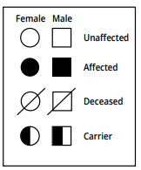
When drawing a family pedigree, the following are general guidelines to the symbols used and their representations:

- A circle represents a female.
- A square represents a male.
- A shaded circle or square refers to a person having some form of cancer.
- An open (non-shaded) square or circle represents a person who is free of cancer.
- A circle or square (either shaded or open) with a diagonal slash through it represents a person who is deceased.

Draw Valerie’s family pedigree below:

Pedigree Analysis Questions:

- Using the family pedigree, do you believe that there is a genetic component to Valerie’s cancer? Explain.

- Does Valerie meet the criteria for LFS? Why or Why Not?

- How can Li-Fraumeni syndrome be inherited as an autosomal dominant condition, while still maintaining the “two-hit” hypothesis used to describe the expression of most tumor-suppressor genes?

Module II: RFLP Analysis of DNA Samples

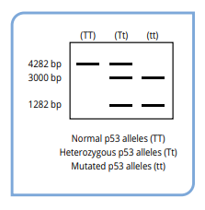
After building a family pedigree and analyzing it using the LFS criteria, there is strong evidence that Valerie has Li-Fraumeni Syndrome. In such a case, a secondary diagnostic test is normally conducted in the form of DNA analysis. Doctors collect a blood sample, a tumor sample, and a sample from healthy tissue near the tumor for RFLP analysis of the p53 gene. DNA is extracted from the patient samples and a region of the p53 gene is amplified using PCR. The PCR sample is then digested using a restriction enzyme that recognizes the mutant sequence of the hotspot codon at position 165. This mutation creates the palindrome CAGCTG which is recognized by the PvuII restriction enzyme. The normal DNA sequence at this location cannot be cut by this enzyme because it is not recognized by the enzyme.

In this module, you will perform agarose gel electrophoresis on Valerie’s simulated samples. After amplification by PCR, the PvuII restriction enzyme was used to digest all three of Valerie’s DNA samples, together with a wild-type control that does not have the DNA mutation. The samples will be analyzed using agarose gel electrophoresis, a biotechnology technique that uses electricity and a porous gel matrix to separate DNA fragments by size. If Valerie is positive for Li-Fraumeni syndrome, the DNA obtained from blood lymphocytes and the healthy tissue will show a pattern representing one normal allele and the second which is the mutant. If the mutation in the tumor cells occurred in the p53 gene, DNA analysis from the tumor tissue samples would only show the pattern representing mutant alleles.
PROCEDURE

Electrophoresis- Loading the GEL
- Obtain five labeled microtubes containing the pre-digested DNA samples. Each sample should contain approximately 20 μL of DNA.

Tube | Sample
A | DNA standard Marker
B | Control (unmutated) DNA
C | Patient Peripheral Blood DNA
D | Patient Breast Tumor DNA
E | Patient Normal Breast Tissue DNA

- Your instructor will demonstrate the proper way to hold, adjust, and use a micropipette.
  - Using a clean tip and properly adjusted micropipette, add 2μL of SmartGlow™ to each of your five DNA samples to be analyzed. Be sure to use a new pipette tip for each sample to avoid possible cross contamination.
  - After adding the SmartGlow™ to each sample, place all four tubes into the microcentrifuge and pulse-spin for approximately 30 seconds. Be sure the centrifuge is balanced before switching the power on!
  - DNA samples may be stored at 4º C if gels are not going to be run on the same day. (You may elect to re-centrifuge samples prior to performing the gel electrophoresis)
  - If gels are going to be run on the same day, proceed to step 3.
- Carefully remove the 0.8% agarose gel from its protective covering and place the gel (still in the hard plastic casting tray) into the electrophoresis chamber. Orient the gel so that the wells are closer to the negative (black) terminal. Please have the orientation of your gel confirmed by your instructor before proceeding. Correct gel orientation is critical for proper band separation.
- Fill the electrophoresis chamber with 1X TAE to the designated fill line. Be sure that there is just enough buffer to completely submerge the agarose gel.

- Using a fresh tip for each sample, load approximately 10-15 μL of each sample into separate wells in the gel according to the table and directions below:
Lane | Sample
1 | DNA Standard Marker/ Ladder
2 | Control (Unmutated) DNA
3 | Patient Peripheral Blood DNA
4 | Patient Breast Tumor DNA
5 | Patient Normal Breast Tissue DNA

  - Place the tip over the top of one of the wells. The tip should be submerged in the buffer at this point. Do not place the pipet tip directly into the well or you run the risk of poking a hole in the side or bottom of the well. If this happens, your sample will leak out of the gel, rendering the sample useless. Holding the micropipette steady, gently and SLOWLY dispense the sample into the well.
  - Once dispensed, keep the micropipette plunger fully depressed until the tip is completely out of the buffer solution. This avoids drawing the sample back up into the tip.
  - Record the order in which the samples are loaded on the lines provided on the gel schematic on the Data Sheet.
  - Repeat this process for each of your DNA samples. Be sure to use a new pipet tip for each sample!
Electrophoresis- Running the GEL
- Place the lid on the electrophoresis chamber, being careful not to tip it over. Be sure the lid is pushed all the way down onto the posts
- Plug the leads into the power supply. The red wire goes to the red on the power supply. The black goes to the other plug.
- Make sure that the area around the electrophoresis chamber and power supply is dry before plugging the electrode wires into the unit. Turn the power supply ON. There is an ON button on the side of the power supply. The unit is “on” when a red “0” is displayed on the LED at the front of the machine.

- There are several buttons on the front of the power source. Using the up and down arrows, adjust the voltage to 100-125 V.
- Check to be sure that the leads from the gel are correctly plugged into the power supply. When the leads are connected properly (red to red, black to black), press the “run” button (a picture of a man running). A green light should come on next to the run button to indicate the power supply is working.

- There should be bubbles forming on the electrode wires at the anode (black) end of the electrophoresis chamber if the current is flowing properly.
- Check the gel after approximately 5 minutes. to make sure the sample is migrating through the gel in the correct direction (towards the cathode/red electrode). Allow the gel to run for a total of 30 to 40 minutes.

Analysis- Reading the Gel
- When it is time, turn off the power, unplug the leads, and remove the lid from the gel box.
- Carefully lift the gel and its tray out of the electrophoresis chamber. The gels will be fragile and slippery! Keep your fingers over the open ends of the gel tray so that the gel does not slide out.

- Open the lid of the blue light box, gently slide the gel out of the tray and onto the blue light transilluminator and place the amber filter shield in the correct orientation for safe viewing.
**Make sure the lights of the Blue Light Transilluminator are off. This product uses high intensity LED lights. Do not stare directly at the viewing surface without the amber cover in place. **
- Turn on the blue light transilluminator and view the stained DNA in the gel through the amber shield. Turning off the room lights may be helpful to view the glowing bands. If permitted by your instructor, take a few pictures to use for analysis.

- Visualize and record your results. Use your results to answer the study questions.

Gel Electrophoresis Questions

Use the schematic below to record the order in which your samples are loaded. You will also sketch the positions of the DNA fragments in each lane once you have done the analysis of the gel.
Wells

Optional Data Table
Lane | Number of Bands | Distance Migrated (mm) | Size (bp)  (See Teacher Notes)
1 | 7 |  | 6751, 3652, 2827, 1568, 1118, 825, 630

2
3
4
5

- What is the difference between tumor suppressors and oncogenes? Describe how mutations affect each type of protein, and name specific examples.
- What are p53 “hot spots,” and how do they affect p53 protein structure?
- Why does Valerie’s tumor DNA sample have fewer bands than the peripheral blood sample?

- What is the purpose of the experimental controls?

- Can a physician proceed with diagnosis of LFS based on the molecular data alone?

Module III: Analysis of DNA Sequences to Search for p53 Mutations (Optional)
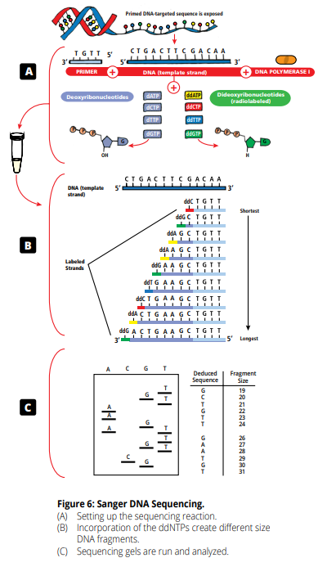
DNA sequence analysis by chain termination (or Sanger Sequencing) allows researchers to specifically target and sequence nucleotides from a specific location within a strand of DNA. As with PCR, genes are targeted using a short, synthetic DNA primer that base-pairs with a specific DNA sequence. The sample to be sequenced is combined with the primer, the DNA-building enzyme DNA polymerase, and a blend of nucleotides. This mixture includes a high concentration of deoxynucleotides (dNTPs) and low concentration of dideoxynucleotides (ddNTPs) (Figure 6A). During the sequencing reaction, DNA Pol I reads the DNA template and adds nucleotides to the primer to build a complementary stand of DNA. Most times, the polymerase will add a dNTP to the growing nucleotide chain. However, when DNA Pol I adds a ddNTP to the DNA strand, it is impossible for the polymerase to add another nucleotide to the end of the growing strand. This is because the ddNTPs lack the 3’ hydroxyl group that DNA Pol I uses to link nucleotides to the growing DNA chain (Figure 6B). This stops the reaction, creating a series of DNA fragments of differing sizes. The site of the dideoxynucleotides incorporation allows one to determine the position of that base. The shortest fragments result from DNA strands that terminated near the primer, whereas longer fragments had more dNTPs linked to the growing DNA chain before the incorporation of the ddNTP (Figure 6B). Each ddNTP is labeled with a radioactive phosphate to allow the DNA fragments to be detected.

To read the sequence, the DNA fragments are separated by polyacrylamide electrophoresis. The A, C, G, and T samples are loaded into separate sample wells in the gel. Well #1 contains the “A” reaction; Well #2 the “C” reaction; Well #3 the “G” reaction; and Well #4 the “T” reaction. The unique sequencing polyacrylamide gels can resolve fragments which differ in size by a single nucleotide, based on size. The smaller fragments move faster, while the larger ones are slowest. After electrophoretic separation is complete, autoradiography is performed. The polyacrylamide gel is placed into direct contact with a sheet of x-ray film. Since the DNA fragments are radioactively labeled with 32P, their position can be detected by a dark exposure band on the sheet of x-ray film. For a given sample well, the horizontal “bands” appear in vertical lanes from the top to the bottom of the x-ray film (Figure 6C)

Activity

Like RFLP analysis, DNA sequencing can be used to analyze the p53 gene. Valerie has five children. None of the children show signs of cancer currently. Valerie has requested that DNA sequencing be performed for each of her children to determine whether they also have LFS.

- Justin (male, age 16)
- Sheila (female, age 14)
- Robert (male, age 10)
- Angela (female, age 8)
- Anthony (male, age 6)

In this part of the experiment, clinicians have taken blood samples from each child and isolated the DNA. Using Sanger sequencing, they determined the nucleotide sequence of each child’s p53 gene to determine whether there are mutations.

- For each of Valerie’s children, READ the DNA sequence information from the gel sequence printout. The sequencing reactions have all been loaded in order: G-A-T-C. Begin analysis of the DNA sequence at the bottom of the autoradiograph with the circled band, which is an A.
- COMPARE each child’s DNA sequence to the wildtype sequence shown in the box below. IDENTIFY the location(s) of any mutant nucleotides. Which children have mutations in the p53 gene? What was the mutation?
- Using the information, UPDATE Valerie’s family pedigree.

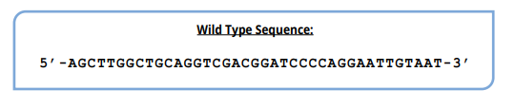

DNA Sequences

