**TEACHER NOTES**

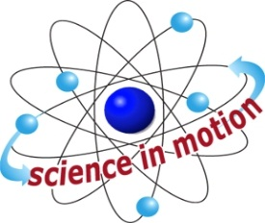

Westminster College

**CANCER GENE DETECTION**

# NEXT GENERATION SCIENCE STANDARDS (NGSS)

**STEELS STANDARDS**

* **3.1.9-12.A**
* **3.1.9-12.D**
* **3.1.9-12.P**
* **3.1.9-12.Q**
* **3.1.9-12.R**

**Module I: Experiment Results and Analysis**

**Module II: Experimental Results and Analysis**

**Module III:** **Experimental Results and Analysis**

