A STUDY OF LENSES
LAB LIGH.1
From Laboratory Manual of Elementary Physics, Westminster College

INTRODUCTION
A lens is a piece of transparent material bounded by two curved surfaces or a curved surface and a plane surface. Most lenses are made of glass and the curved surfaces are often sections of a sphere. Some special lenses may have parabolic and others cylindrical surfaces. The lenses used in this experiment will all be spherical lenses.
If a beam of parallel light strikes the surface of a lens it will be bent or refracted as shown in Fig. 1a and Fig. 1b. If the rays converge to a point, as in Fig. 1a the lens is called a converging lens. If they diverge as in Fig. 1b the lens is called a diverging lens. In either case the point through which the rays pass (Fig. 1a) or from which they appear to come (Fig. 1b) is called the principal focus of the lens and the distance from this point to the lens is the focal length, f.

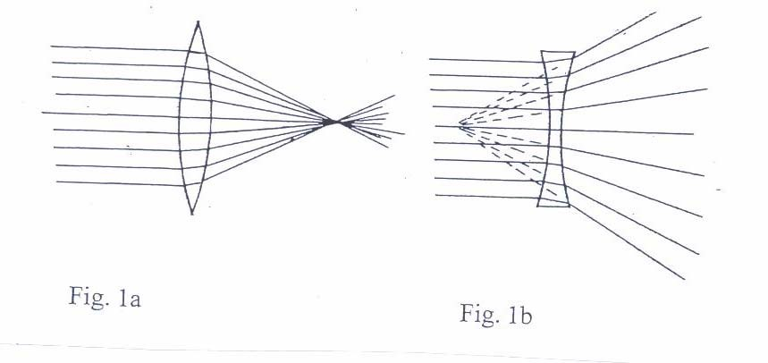

If an object is placed in front of a converging lens, an image will be formed. For the lens, light passes through the lens and the image, if real, will be formed on the side of the lens opposite from the object, as shown in Fig. 2. Certain rays can be drawn to locate the image.

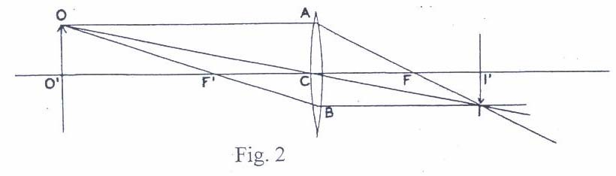

A Study of Lenses

One such ray is OAFI. Since OA is parallel to the axis O′C, after refraction it will pass through the focus, F. Another ray, OCI, passes through the center of the lens and is unaffected. (Actually it will be displaced slightly but will be parallel to its original direction and if the lens is thin this displacement can be neglected as in the drawing). A third ray, OF′BI, passes through the focus, F′, and after refraction will be parallel to the axis. These three rays will intersect at position I and will locate the position of the image II′. If another set of similar rays were drawn from some other point on the object, they would locate a corresponding point on the image.

If the object distance O′C, is called p and the image distance, CI′ is called q, it can be shown that

1/f = 1/p + 1/q (1)

where f is the focal length.

PURPOSE

To study and explore the formation of images by a lens or a lens system.

MATERIALS
Optical bench (meter stick) Screen
Converging and diverging lenses Ruler
Lens holders Position indicator
Illuminated object

PRELIMINARY QUESTIONS
- By what physical understanding of light traveling in “empty” space, enables the drawing of the light rays for a lens arrangement?
- What physical principle determines how the light bends at an interface, such as at a lens surface?
- For a flat, that is, a plane mirror, where is the image that you see of yourself formed with respect to the mirror surface and how does its (image) size compare to that of the object, considered as being your face?

A Study of Lenses

PROCEDURE/ANALYSIS
- Place one of the converging lenses on the optical bench with the screen near one end. Point the bench out the window or towards something at a distance and focus the image of a distant object on the screen. Measure the distance from the center of the lens to the screen. This is approximately the focal length of the lens. Repeat for the other converging lens provided. Be sure to record the identifying letter or number on the lens.
- Place the illuminated object near one end of the bench and the screen near the other end. Place the converging lens of shorter focal length between the object and the screen and move the lens until a sharp image is formed on the screen. Record the positions of the lens, the object, and the screen. See if you can find a different position of the lens which will produce a sharp image. Record this position. How do the object and the image distances compare for the two positions? Examine the image in each case to determine whether it is erect or inverted. Is it reversed from right to left? How does the size of the image compare with the size of the object?
- The diverging lens will not form a real image of a real object. Place the diverging lens on a meter stick and point the meter stick toward a distant object. By looking into the lens you will see an erect virtual image. Since the light from the distant object can be considered approximately parallel, this virtual image will be formed very near the principal focus of the lens. The approximate position of this image can be determined by the method of parallax. Place the position indicator beyond the lens. By looking over the lens at the position indicator and at the same time looking through the lens at the image of the distant object, move the position indicator until it appears to be the same distance from the eye as the image of the distant object. Record the positions of the position indicator and of the lens. The distance between them is equal to the focal length of the lens and is negative because the image is virtual.
To obtain a better value for this focal length, we can use a converging lens to form a real image and then use this image as the object of the diverging lens. Place the converging lens with the shorter focal length on the bench and form an image on the screen. The smaller of the two images found in (B) will probably be best and the screen should be at least 20 cm from the end of the meter stick optical bench. Record the position of the object, image, and lens. Move the screen a few cm away from this position and place the diverging lens between the converging lens and the screen. Move the diverging lens and if necessary the screen until a sharp image is again formed. Record the position of the diverging lens and the new position of the screen. The real image formed by the first lens is now the object for the second lens, but since it no longer exists it is a virtual object and the distance from the diverging lens to the point where it was formed is the object distance and will be negative. From these distances compute the focal length of the lens and compare with that found above.

A Study of Lenses
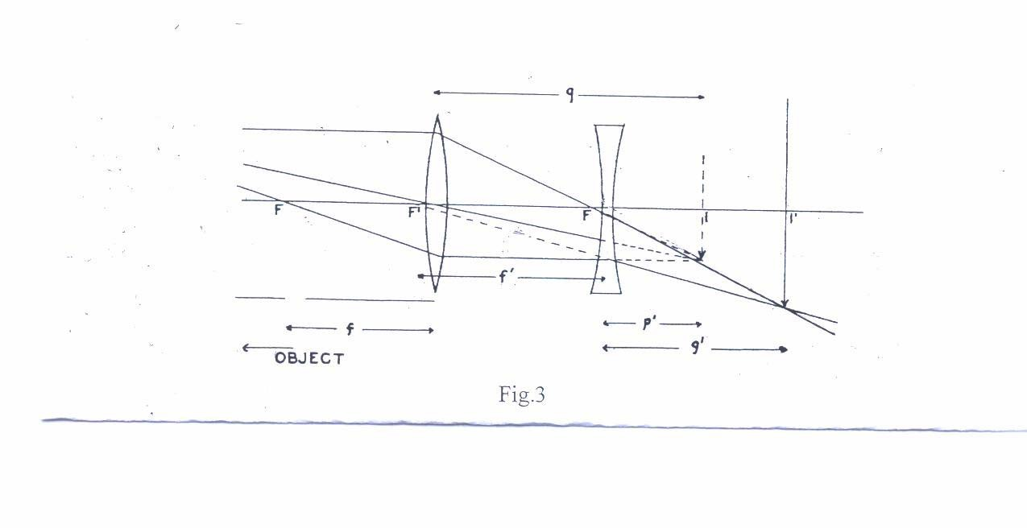

- Two converging lenses may be used to form a simple telescope. A lens with a long focal length should be used as the objective lens and one with a short focal length as the eyepiece. The simple telescope is constructed as shown in Fig. 4. The image of the distant object is formed at a distance f ' from the objective lens, and this image serves as the object for the eyepiece and so should occur at its focus. The distance between the lenses should be about f '+f. Theoretically, the magnification of such a combination is

M=f ' /f. (2)

Mount the converging lens with the shorter focal length that is provided, near one end of the meter stick. Place the second converging lens with the longer focal length on the meter stick so that the distance between the two lenses is equal to the sum of the focal lengths. Sight through this combination at some object, some distance away and adjust (not greatly) the distance between the lenses until a clear image is formed. This constitutes a telescope.

Now focus this telescope at some “scaled” relatively distant object. With a little practice you can look through the lens at the scale with one eye and around the lens with the other, and thus compare the magnified and unmagnified scales with each other. Estimate the magnification. Compare with the ratio of focal lengths, Eq. (2).

Study of Lenses

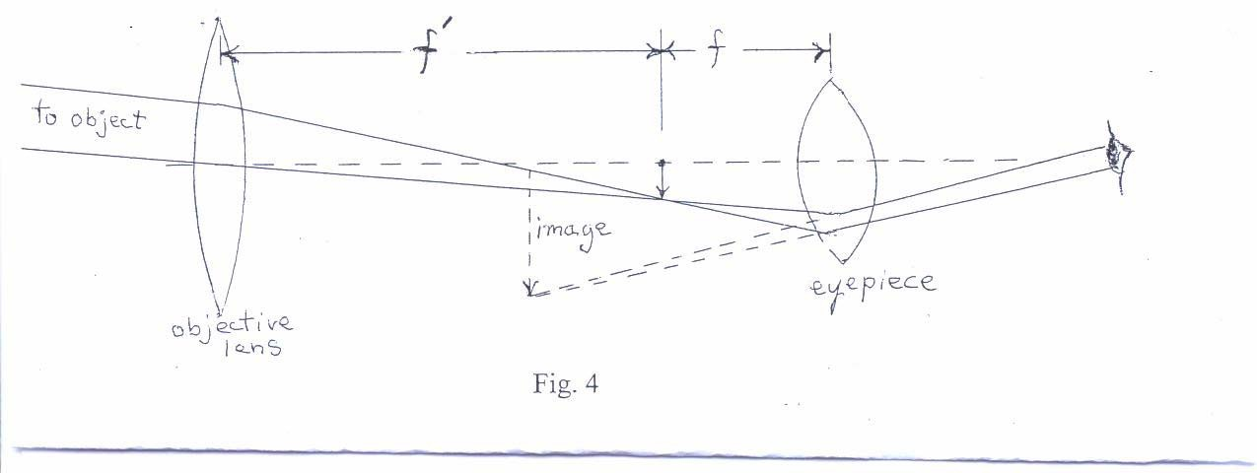

FURTHER ANALYSIS

- For one of the lenses of part (B), draw a ray diagram to scale, similar to Fig. 2.
- For the last part of (C), draw a ray diagram to scale, similar to Fig. 3.

EXTENSION

- Show by a labeled ray diagram how a single lens simple magnifier enlarges an image.
- Also by a labeled diagram, show how two converging lenses can be combined to form an optical microscope (hint: functions as a two-stage simple magnifier) which yields an enlarged image. Explain.

