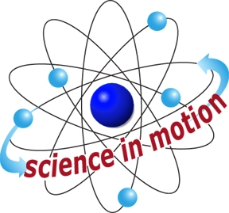
TEACHER NOTES
Westminster College

ACID-BASE TITRATIONS
GUIDED INQUIRY VERSION
From Vernier Investigating Chemistry through Inquiry

LAB 17

OVERVIEW
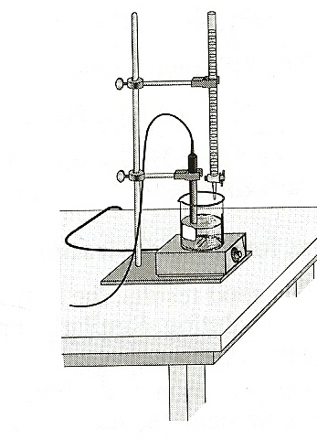
In the Preliminary Activity, your students will gain experience using a pH sensor and learn titration technique as they titrate a solution of the strong acid hydrochloric acid, HCl, with a solution of the strong base sodium hydroxide, NaOH. They will deter;mine the unknown concentration of the HCl solution using the given concentraion of the NaOH solution.

During the subsequent Inquiry Process, your students will first learn more about acids and bases and acid-base titrations using the curse textbook, other available books, and the internet. They will hten generate and investigate researchable questions involving acid-base titrations.

LEARNING OUTCOMES
In this inquiry experiment, students will
- Identify variables, design and perform the experiment, collect data, analyze data, draw a conclusion, and formulate a knowledge claim based on evidence from the experiment.
- Gain understaing of titration curves.
- Determine unknown acid and base concentrations.
- Gain titration skills.

CORRELATIONS
IB Topic and Sub-Topic
Topic 8-Acids and Bases
Sub-Topic 8.2 – Properties of acids and bases
Sub-Topic 8.3 – Strong and weak acids and bases
Sub-Topic 8.4 – The pH scale

THE INQUIRY PROCESS
Suggested Time to Complete the Experiment
See the section in the introduction, Doing Inquiry Experiments, for information on carrying out each phase of an inquiry experiment.

 | Inquiry Phase | Open Inquiry | Guided Inquiry
I | Preliminary Activity | 45 minutes | 45 minutes
II | Generating Researchable Questions  (Ommitted in Guided Inquiry Approach) | 15 minutes | 0 minutes
III | Planning | 15 minutes | 15 minutes
IV | Carrying out the Plan | 60 minutes | 50 minutes
V | Organizing the Data | 10 minutes | 10 minutes
VI | Communicating the Results | 15 minutes | 10 minutes
VII | Conclusion | 10 minutes | 10 minutes

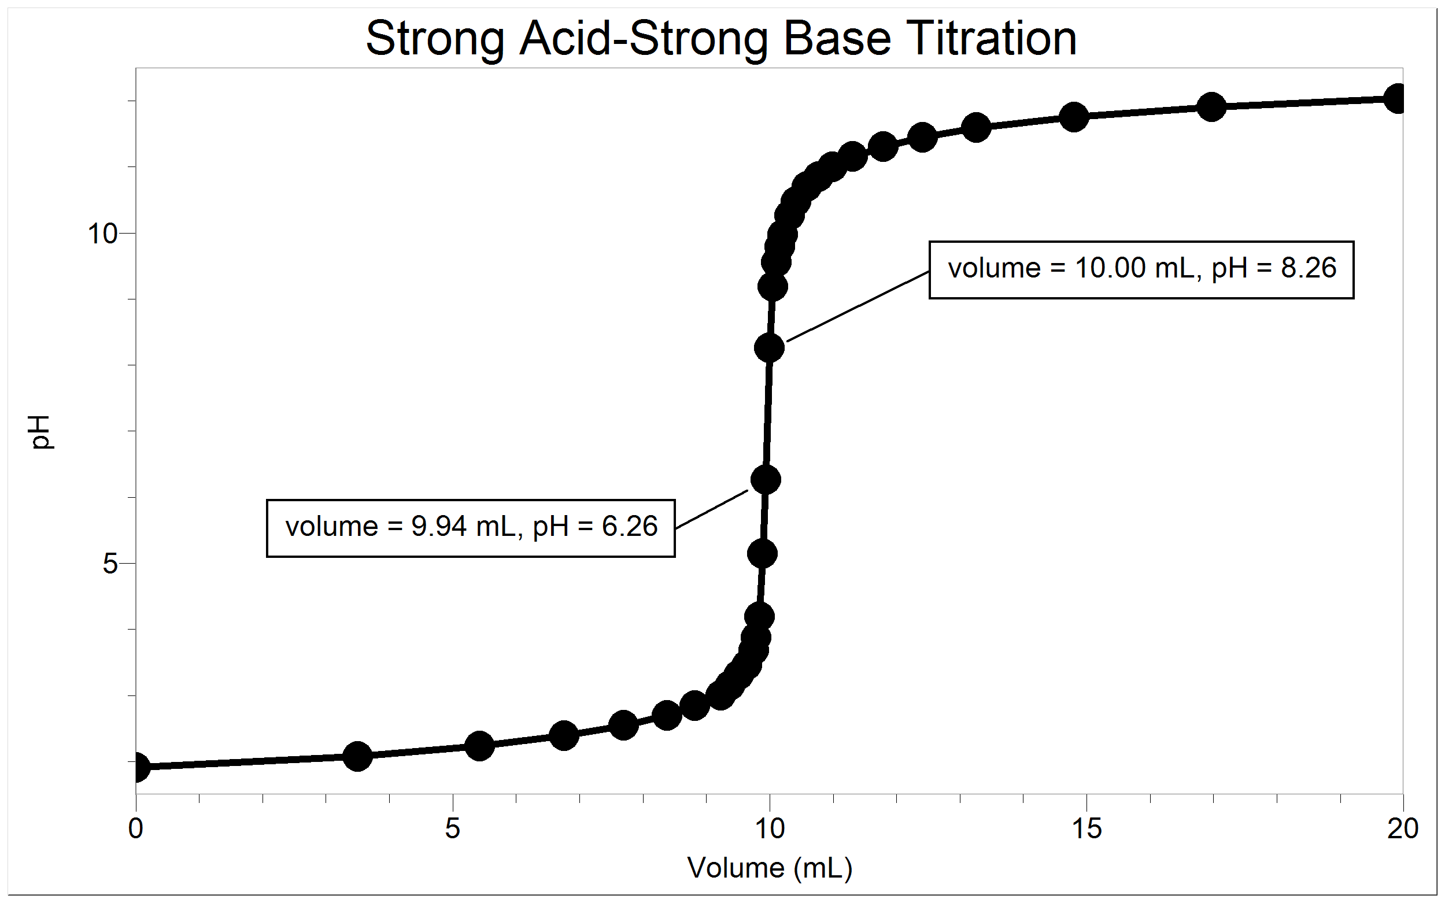
SAMPLE RESULTS Figure 2 Plot of pH vs. volume of NaOH titrant added
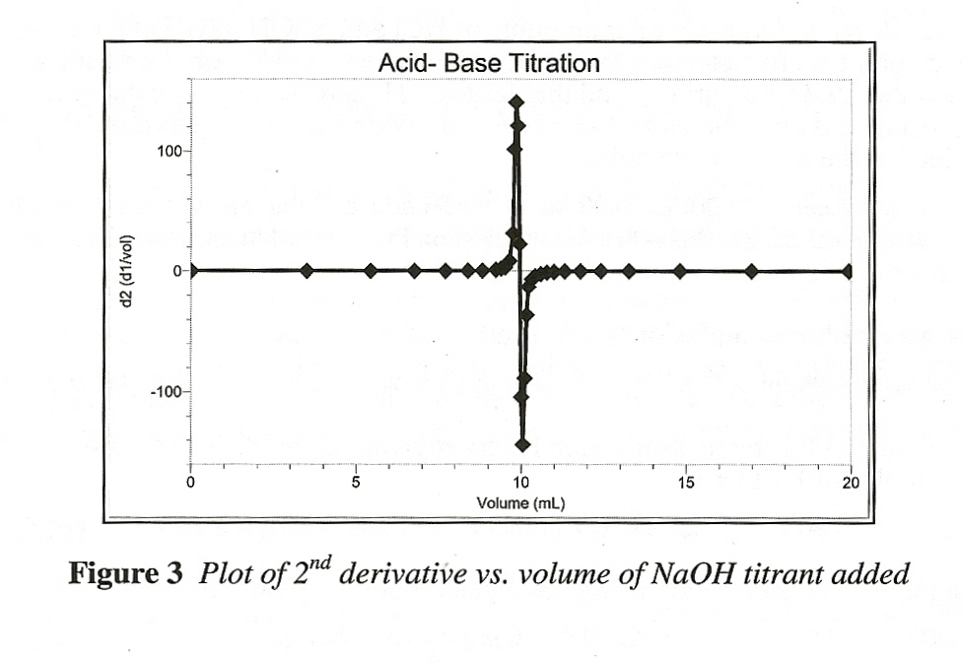
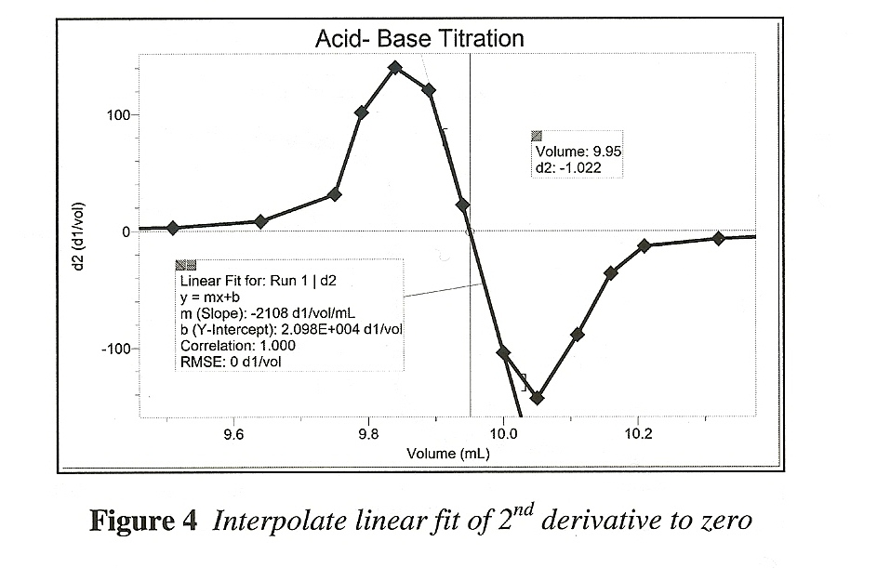

ANSWERS TO THE QUESTIONS
- At the equivalence point, equimolar amounts of HCl and NaOH have been mixed. The equivalence point is characterized by the largest increase in pH upon the addition of a very small amount of NaOH solution. Find that largest pH increase in your data. Add the NaOH volumes before and after the largest increase and divide by two to determine the volume of NaOH added at the equivalence point.
Answers will vary. (9.96 + 10.00)/2 – 9.98 mL of NaOH added to the equivalence point. Alternatively, the volume where the second derivative equals zero on the zoomed-in second derivative plot in Figure 4 above is 9.95 mL.

- Calculate the number of moles of NaOH used.
Answers will vary. 9.95 mL x (1 L/1000 mL) x (0.0985 mol/L) = 9.80 x 10⁻⁴mol NaOH used.

- Using the equation for the neutralization reaction given in the introduction, determine the number of moles of HCl used.

Answers will vary.
9.80 x 10⁻⁴ mol NaOH x (1 mol HCl/1 mole NaOH) = 9.80 x 10⁻⁴ mol HCl used.

- Calculate the HCl concentration using the pipeted volume of unknown HCl.
Answers will vary.
(9.80 x 10⁻⁴ mol HCl)/0.010 L = 9.80 x 10⁻² M HCl.

II. GENERATING RESEARCHABLE QUESTIONS
Note: Researchable questions are assigned by the instructor in the Guided Inquiry approach. Some possible researchable questions for this experiment are listed below:

Recommended for Open or Guided Inquiry (sample results provided)
- How does the curve for the titration of acetic acid with NaOH compare to the curve for the titration of HCl with NaOH?
- What is the citric acid concentration in a bottled lemon-flavored soft drink?

Recommended for Open or Guided Inquiry (no sample results provided)
- How do strong acid-strong base, strong acid-weak base, weak acid-strong base, and weak acid-weak base titrations compare?
- What is the titratable acidity of lemon juice (Real Lemon®, ReaLime® , True® Lemon, Newman’s Own Lemonade)?
- What is the phosphoric acid content of Coca-Cola®?
- What is the concentration of my assigned unknown HCl solution?
- What is the acetic acid concentration of vinegar? (See Experiment 15, Acid-Base Properties of Household Products, for procedure suggestions, sample results and tips.)

Recommended for Advanced Students (no sample results provided)
- How much hydrochloric acid can a Tums® table neutralize? (sampel results provided)
- How can an acid-bse titration be used to identify a diprotic-acid?
- How can an NaOH solution be standardized? What is the concentration of my NaOH solution?
- How does the presence of sodium citrate in a soft drink affect its properties?
- How can the dissociation constant of a weak acid be determined by titration?

There are many more possible researchable questions. Students should choose a researchable question that addresses the learning outcomes of your specific standards. Be sure to emphasize experimental control and variables. (Instructors using the Guided inquiry approach select the researchable questions to be investigated by their students. We encourage you to assign multiple researchable questions because this strategy enhances student interaction and learning during phases IV-VII).

III. Planning
During this phase students should formulate a hypothesis, determine the experimental design and setup, and write a method they will use to collect data. Circulate among the student groups asking questions and making helpful suggestions.

IV. Carrying Out the Plan
During this phase, students use their plan to carry out the experiment and collect data. Circulate among the student groups asking questions and making helpful suggestions.

V. Organizing the Data
See section in the ‘Doing Inquiry Experiments’ section for suggestions concerning how students can organize their data for their inquiry presentations.

VI. Communicating the Results
See section in the ‘Doing Inquiry Experiments’ section for a list of inquiry-presentation
Strategies.

VII. Conclusion
See section in ‘Doing Inquiry Experiments’ section for a list of suggestions concerning assessment and ways to utilize the results in subsequent instruction.

SAMPLE RESULTS
Student results will vary depending on experimental design.

A COMPARISON OF HYDROCHLORIC ACID AND ACETIC ACID TITRATION CURVES
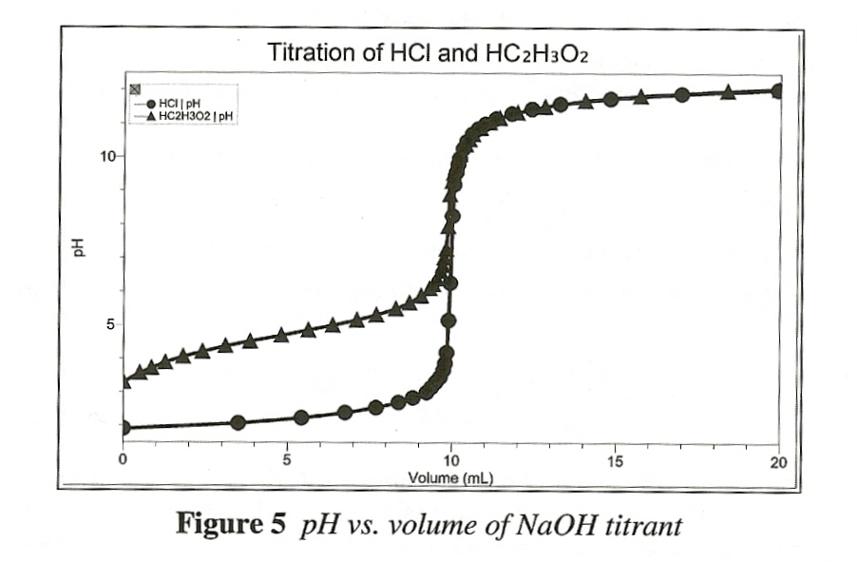

This investigation addresses the question, “How does the curve for the titration of acetic acid with NaOH compare to the curve for the titration of HCl with NaOH?” The two titrations were conducted as described in the Preliminary Activity, except that increments of NaOH solution that raised pH by about 0.15 units were added until about pH 6.5 in the acetic acid titration( instead of pH 3.5).

Four especially interesting points, or regions, of the graph above are:
- The pH values of the diluted solutions before the titrations began: pH 3.30 for the acetic acid titration vs. pH 1.91 for the HCl titration.
- The pH values at the equivalence points: pH 8.32 (versus an expected value of 8.72) for the acetic acid titration and pH 6.62 (versus and expected value of 7.00) for the HCl titration.
- The pH values beyond the addition of 11 mL of NaOH titrant: The pH values were essentially the same at all volumes—pH values of 11.78 and 11.77 for the HC₂H₃O₂ and HCl titration respectively, when 15.00 mL of NaOH titrant had been added, for example.
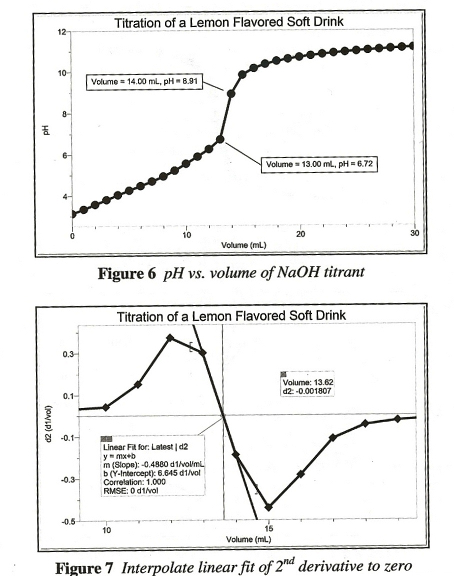
- The pH value at the midpoint of the acetic acid titration was 4.72 (compared to an expected value of 4.74 for the pK_{a} of acetic acid which corresponds to a K_{a} of 1.8 x 10⁻⁵).

This investigation addresses the question, “What is the citric acid concentration in a lemon flavored soft drink?” The titration of this drink, containing water, sugar, carbon dioxide, citric acid, and natural aroma, determined the citric acid concentration to be 172 mg H₃C₆H₅O₇ per 100 mL. See the tips section for details.

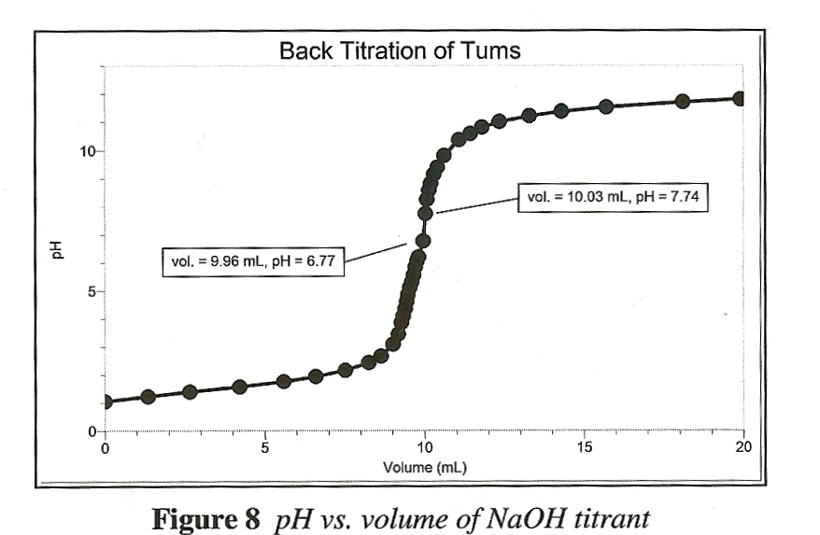
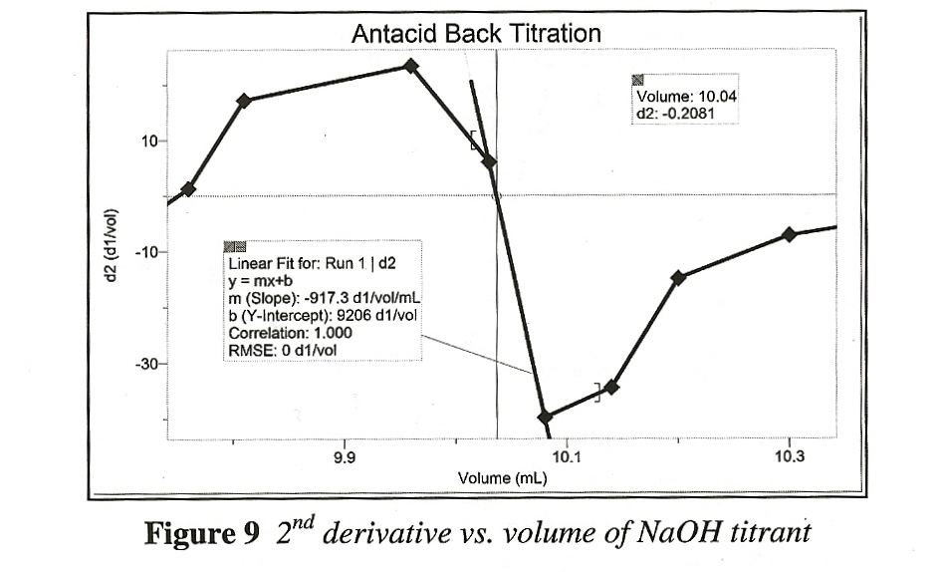

This investigation addresses the question, “How much hydrochloric acid can a Tums EX 750® tablet neutralize?” A 0.199 g portion of a Tums tablet (total mass = 1.995 g) was reacted with excess 0.0997 M HCl. The residual HCl solution was then back titrated with 0.0985 M NaOH solution.

It was determined that the entire table would have neutralized 1.50 x 10⁻² mol HCl. It was also determined that this amount of HCl would neutralize 751 mg CaCO₃ an amount in very close agreement with the 750 mg CaCo₃ per tablet indicated on the bottle label. See the tips section for more details.

TIPS
- The preparation of ~0.1 M NaOH requires 4.00 g of NaOH per liter of solution. HAZARD ALERT: Corrosive solid; skin burns are possible; much heat evolves when added to water; very dangerous to eyes; wear face and eye protection when using this substance Wear gloves. Hazard Code: B—Hazardous.

Solutions of sodium hydroxide are virtually impossible to prepare to a precise molar concentration because the substance is hygroscopic. In fact, solid NaOH absorbs so much moisture from the air that a measured sample of the compound is never 100% NaOH. Standardize the NaOH solution using a standard acid solution, such as potassium hydrogen phthalate, KHC₈H₄O₄. Experiment 6, Standardizing a Solution of Sodium Hydroxide, in the Vernier Advanced Chemistry book is one good source of standardizing procedure.

- The preparation of ~0.1 M HCl requires 8.6 mL of concentrated HCl per liter of solution. HAZARD ALERT: Highly toxic by ingestion or inhalation; severely corrosive to skin and eyes. Hazard Code: A—Extremely hazardous.

The HCl solution can be standardized using standardized NaOH solution.

- The preparation of ~0.1 M HC₂H₃O₂ requires 5.7 mL of concentrated acetic acid, HC₂H₃O₂, per liter of solution. HAZARD ALERT: Corrosive to skin and tissue; moderate fire risk (flash point: 39ºC); moderately toxic by ingestion and inhalation. Hazard Code: A—Extremely hazardous.

- Tips ofr the comparison of HCl and HC₂H₃O₂ titration curves:

- The two acid solutions should have the same concentration.
- The HCl titration procedure can be identical to that of the Preliminary activity.
- For the HC₂H₃O₂ titration, add increments of NaOH solution that raise the pH by about 0.15 units until about pH 6.5 (instead of 3.5). When a pH value of approximately 6.5 is reached, change to one-drop increments. When pH is 9.5, again add larger increments that raise the pH by about 0.15 units.

- Tips for soft drink titrations:
- A sample size of 50 mL works well for citric-acid containing soft drinks when the titrant is ~0.1 M NaOH. For phosphoric-acid containing soft drinks, a sample size of 100 or 200 mL will work well. Other combinations will, of course, work well, too.
- CO₂ must be removed from carbonated drinks by allowing the drink to stand open for two or three days, or by gentle boiling for about 15 minutes.
- Dispense 1 mL increments of the NaOH titrant form a 50 mL buret throughout the titration.
- Citric acid (H₃C₆H₅O₇) is a triprotic acid, but only the last equivalence point is apparent in its titration curve. The ratio of moles of H₃C₆H₅O₇ to moles of NaOH at the observed equivalence point is 1:3.
- Phosphoric acid (H₃PO₄) is also a tripotic acid, and the first two equivalence points are apparent in its titration curve. The first equivalence point is commonly used for calculations and ratio of moles of H₃PO₄ to moles of NaOH at that first equivalence point is 1:1.
- The only acid contained in lemon flavored soft drink tested in the Sample Results section was citric acid. However, some lemon, lime, or lemon-lime drinks contain some malic acid in addition to a much larger citric acid component, and some colas contain some citric acid in addition to a much larger phosphoric acid component. Many high school, introductory-level college, and food-industry titration procedures attribute all the non-carbonic acid acidity to the major acid component.
- Experiment 35, Determining the Phosphoric Acid Content of Soft Drinks, in the lab book Chemistry with Vernier contains a procedure,s ample data, and tips concerning cola titrations.

- Sample soft drink titration calculations:
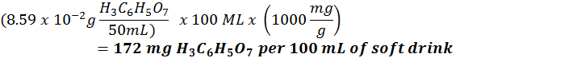

- Tips for antacid titrations:
- For good results, the buffering capability of the antacids must be overcome with excess HCl solution. Similarly, any carbon dioxide present in solution must be expelled with gentle boiling.
- The precision of the balance used is an important consideration in this experiment. We recommend the use of a balane with a precision of 0.001 g or 0.0001 g.
- The procedure can include these steps:
- Determine the mass of the whole antacid tablet.
- Crush the antacid tablet to a fine powder using mortar and pestle. Measure out 0.2 g (±0.001 g or ±0.0001 g) and transfer to a 100 mL beaker.
- Pipet 25.00 mL of ~0.1 M HCl into the beaker and add 25 mL of distilled water.
- Cover with a watch glass and place onto a hotplate. Allow the solution to boil gently for 10 minutes to expel CO₂.
- Using the procedure outlined in the Preliminary activity, back titrate the residual HCl. Note: If the pH is not lower than 2.5, then HCl is not in excess and it is necessary to add a known quantity of HCl and reheat the mixture to expel CO₂ before performing the back titration.

- Sample antacid titration calculations:
HCl_{neutralized} = HCl_{initial} - HCl_{titrated}

HCl_{initial} = 25.00 mL x (1L/1000 mL) x (0.0997 mol/L)= 2.49 x 10⁻³ mol HCl

10.04 mL x (1 L/1000 mL) x (0.0985 mol/L) = 9.89 x 10⁻⁴ mol NaOH used

HCl_{titrated} = 9.89 x 10⁻⁴ mol NaOH x (1 mol HCl/1 mole NaOH)= 9.89 x 10⁻⁴ mol HCl

HCl_{neutralized}=HCl_{initial}-HCl_{titrated} = 2.49 x 10⁻³ mol – 9.89 x 10⁻⁴ mol = 1.50 x 10⁻³mol HCl neutralized by 0.199 g antacid

1.50 x 10⁻³ mol HCl x (1.995g/0.199 g) = 1.50 x 10⁻² mol HCl neutralized by entire 1.995 g tablet

CaCO₃(s) + HCl(aq)→CaCl₂(aq) + H₂O(1) + CO₂(g)

1.50 x 10⁻² mol HCl x (1 mol CaCO₃/2 mole HCl) = 7.50 x 10⁻³ mol CaCO₃ per tablet

7.50 x 10⁻³ mol CaCO₃ x (100.1 g/mole) x (1000 mg/g) = 751 mg CaCO₃ per tablet

- Experiment 25, Titration of a Diprotic Acid: Identifying an Unknown, in the Vernier lab book Chemistry with Vernier is one good source of information concerning the identification of an unknown diprotic acid.

- Experiment 32, The Buffer in Lemonade, in the Vernier lab book Chemistry with Vernier is one good source of information concerning the investigation of buffers in drinks suck as lemonade.

- Experiment 24, Determining K_{a} by the Half-Titration of a Weak Acid, in the Vernier lab book Advanced Chemistry with Vernier is one good source of information concerning the determination of the dissociation constant of a weak acid by titration.
- See Appendix G for tips on using the second derivative method when determining pH titration equivalence points, as shown in Figures 3, 4, 7 and 9, using Logger Pro, the Labquest App, and Easy Data. Appendix G, Special Tasks, contains information in text file form that can be copied and pasted in documents.

- See Appendix F for sensor and senor check information.

- The plans that your students submit for approval should list laboratory safety concerns, including chemical safety concerns, and specify how they will address these safety concerns during their investigations.

