ACID DISSOCIATION CONSTANT, K_{a}
Westminster College

In this experiment you will:
- Gain experience mixing solutions of specified concentration.
- Experimentally determine the dissociation constant, K_{a}, of an acid.
- Investigate the effect of initial solution concentration on the equilibrium constant.

The acid to be used is acetic acid, HC₂H₃O₂, and its dissociation equation is: ${HC}_{2}H_{3}O_{2}\left(aq\right)→H^{+}\left(aq\right)+C_{2}H_{3}O_{2}^{-}\left(aq\right)$

MATERIALS:
Labquest wash bottle
Labquest Application distilled water
pH sensor 100 mL volumetric flask
100 mL beaker pipets
2.00 M HC₂H₃O₂ pipet bulb

PRE-LAB
- Write the equilibrium constant expression, K_{a}, for the dissociation of acetic acid, HC₂H₃O₂. (Use box 2 in the Data and Calculations table of this experiment.)
- You have been assigned two different HC₂H₃O₂ solution concentrations by your teacher. Determine the volume, in mL, of 2.00 M HC₂H₃O₂ required to prepare each. (Show your calculations and answers in Space 4 of the Data and Calculations table.)

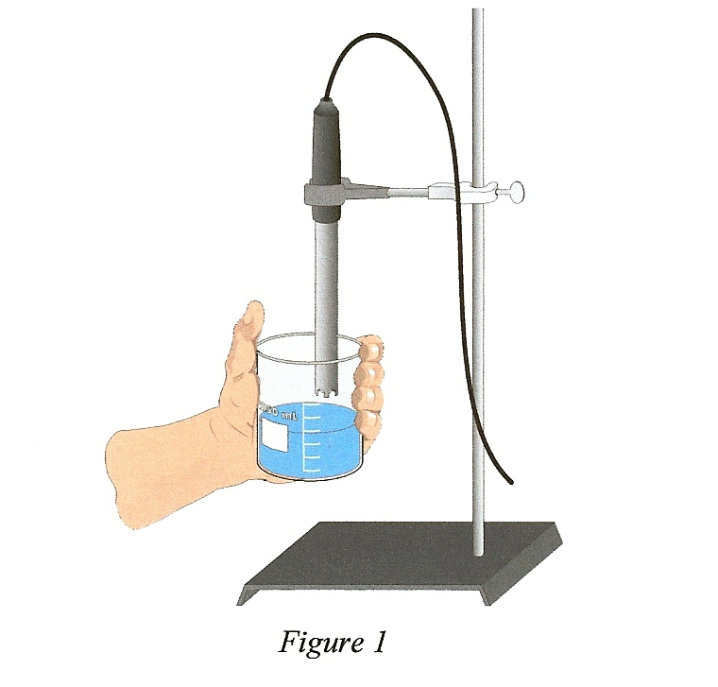

PROCEDURE:
- Obtain and wear safety goggles.

- Connect the pH Sensor to LabQuest and choose New from the File menu. If you have an older sensor that does not auto-ID, manually set up the sensor.

- Put approximately 50 mL of distilled water into a 100 mL volumetric flask.

- Use a pipet bulb (or pipet pump) to pipet the required volume of 2.00 M acetic acid (calculated in Pre-Lab Step 2) into the volumetric flask. CAUTION: Use care when handling the acetic acid. It can cause painful burns if it comes into contact with your skin or gets into your eyes. Fill the flask with distilled water to the 100 mL mark. To prevent overshooting the mark, use a wash bottle filled with distilled water for the last few mL. Mix thoroughly.

- Use a utility clamp to secure the pH Sensor to a ring stand as shown in Figure 1.

- Determine the pH of your solution as follows:
- Use about 40 mL of distilled water in a 100 mL beaker to rinse the electrode.
- Pour about 30 mL of your solution into a clean 100 mL beaker and use it to thoroughly rinse the electrode.
- Repeat the previous step by rinsing with a second 30 mL portion of your solution.
- Use the remaining 40 mL portion to determine pH. Swirl the solution vigorously. Note: Readings may drift without proper swirling! When the pH reading stabilizes, record the pH value displayed on the Meter screen.
- When done, place the pH Sensor in distilled water.
- Discard the acetic acid solution as directed by your teacher.

- Repeat Steps 3-6 for your second assigned solution.

- When you are finished, rinse the probe with distilled water and return it to the senor soaking solution.

PROCESSING THE DATA:
- Use the calculator on LabQuest to determine the [H⁺]_{eq} from the pH values for each solution.

- Use the obtained value for [H⁺]_{eq} and the equation:
$${HC}_{2}H_{3}O_{2}\left(aq\right)→H^{+}\left(aq\right)+C_{2}H_{3}O_{2}^{-}\left(aq\right)$$
to determine [C₂H₃O₂]_{eq} and [HC₂H₃O₂]_{eq}.

- Substitute these calculated concentrations into the K_{a} expression you wrote in Step 1 of the Pre-Lab.
- Compare your results with those of other students. What effect does initial HC₂H₃O₂ concentration seem to have on K_{a}?

OBSERVATIONS:

DATA TABLE:

- Assigned concentration | M | M
- Measured pH

- K_{a} expression

- Volume of 2M acetic acid | mL | mL
- [H⁺]_{eq} | M | M
- [C₂H₃O₂⁻]_{eq} | M | M
- [HC₂H₃O₂]_{eq} | M | M
- K_{a} calculation

