**TEACHER NOTES**

**ACID RAIN LQ22**

*From Chemistry from Vernier*

1. The 1.0 M HCl solution can be prepared by adding 8.6 mL of concentrated acid per 100 mL of solution.

Draw the HCl solution into the Beral pipets through the short, narrow stem. Since a trial requires approximately 1 mL of 1.0 M HCl, or a total of 3 mL for gases, fill the bulb ¾ full (3-4 mL).

1. Solid NaHCO3, NsHSO3 and NaNO2 can be placed in 100 mL beakers to a depth of 1-2 cm.
2. One advantage of the microscale version of this experiment is that it avoids the odors of the two noxious gases, NO2 and SO2. Very little of either gas escapes into the room. You can operate the laboratory ventilation system during the experiment as a further precaution.
3. To make a narrower stem for gas-collecting pipets and HCl pipets, it is necessary to stretch out the stem of the Beral pipet. To do this, place the pipet bulb in the palm of one hand with your thumb against the stem where it joins the bulb. Firmly grip the middle of the stem with your other hand and pull hard on the stem until it yields to the pressure and stretches out to a uniform narrow diameter. You can easily stretch it to the length needed for the gas-collecting pipets. Cut off the stems to a length of 15 cm for the gas pipets, and to a length of 4 cm for the HCl pipets. For the gas-generating pipet, cut the stem of a new Beral pipet to a length of 2 cm. Since it has a wider stem, the HCl and gas-collecting pipets will easily fit into it.
4. The directions in the experiment call for the use of a 100 mL beaker as a support for the Beral pipets. The pipets are placed in the beaker in an upright position, with the bulbs down. Test tube racks for 13 x 100 mm test tubes or 24 well microscale well plates also work well as supports for the Beral pipets.
5. The Procedure directs students to obtain the 1.0 M HCl from the teacher, and then return it. For safety reasons, we felt it might be better for teachers to directly account for pipets containing HCl. The directions also have students return the used gas-generating and gas-collecting pipets at the end of the period. Whether you choose to dispose, recycle, or reuse the pipets, we recommend that your students not empty or clean the pipets. This way, accidents that might result from carelessly squeezing pipets containing HCl can be avoided. Empty the gas-generating pipets under a fume hood.
6. If you choose to reuse the gas-collecting pipets, you need to ensure that they are perfectly dry. The SO2 and NO2 gases are highly soluble, even in small droplets of water. Draw air in and out of the pipets 10 to 15 times to dry the bulbs.
7. To save time, you may choose to perform Step 3 of the procedure ahead of time. Students 2have very little difficulty adding the NaHCO3 and NaHSO3 powders to the Beral pipets, but have more trouble adding the larger granules of NaNO2.
8. The equations for the production of each of the gases, as performed in this experiment, are:

Carbon dioxide:

Sulfur dioxide:

Nitrogen dioxide:

1. Even though the procedure calls for tap water, distilled water can be also used. We use tap water because it normally contains enough dissolved CO2, HCO3, and CO32- to give it to a small amount of buffering capacity. This stabilizes the pH reading when the pH sensor is first placed in the water and avoids fluctuations or gradual changes in pH that students sometimes encounter with distilled water. In the sample graphs on the next page, the buffering effect causes a smaller drop in pH in the first 5-10 seconds after the gas is added, followed by a more rapid drop.
2. This is a good time to discuss the topic of anhydrides with your students. All three of these gases are oxides of non-metals and represent good examples of acidic anhydrides.
3. A 20 x 150mm test tube works well in this experiment. Test tubes size 18 x 150 mm will not easily allow the narrow stem of the pipet to fit alongside the pH sensor.
4. The stored calibration for the pH sensor works well for this experiment.

**HAZARD ALERTS**

The chemical safety signal words used in this experiment (DANGER, WARNING, and N/A)

are part of the Globally Harmonized System of Classification and labeling of Chemicals (GHS).

Refer to the Safety Data Sheet (SDS) that came with the chemical for proper handling, storage,

and disposal information. These can also be found online from the manufacturer.

See Appendix Cthe Chemical Safety Information in the introduction for more information.

Hydrochloric acid, 1.0 M, HCl: **DANGER**: Causes severe skin and eye damage. Do not breathe

mist, vapors, or spray. May cause respiratory irritation. May be harmful if swallowed. Industrial

exposure to vapors and mists is listed as a known human carcinogen by International Agency for

Research on Cancer (IARC).

Hydrochloric acid, 12 M, HCl: **DANGER**: Causes severe skin and eye burns and damage.

Harmful if swallowed or inhaled. Do not eat or drink when using this product. Do not breathe

mist, vapors, or spray. May be corrosive to metals. Industrial exposure to vapors and mists is

listed as a known human carcinogen by International Agency for Research on Cancer (IARC).

Sodium bicarbonate, solid, NaHCO3: **WARNING**: May be harmful if swallowed. Treat as a

non-food-grade chemical. Prudent laboratory practices should be observed.

Sodium bisulfite, solid, NaHSO3: **WARNING**: Harmful if swallowed. Do not eat or drink when

using this product.

Sodium nitrite, solid, NaNO2: **WARNING**: May intensify fire—oxidizer. Keep away from heat,

sparks, open flames, and hot surfaces. Do not eat or drink when using this product—toxic if

swallowed or inhaled. Avoid breathing dust or fumes.

**SAMPLE RESULTS**

|  |  |  |  |
| --- | --- | --- | --- |
| Gas | Initial pH | Final pH | Change in pH |
| CO2 | 7.15 | 5.93 | -1.22 |
| NO2 | 7.10 | 2.74 | -4.36 |
| SO2 | 7.06 | 2.54 | -4.52 |



*Figure 1 NO2 dissolving in water 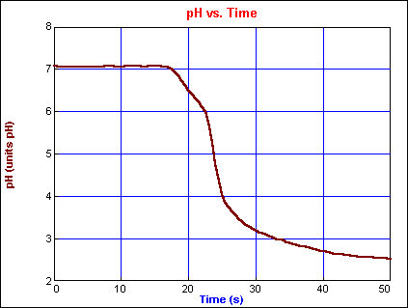 Figure 2 SO2 dissolving in water*

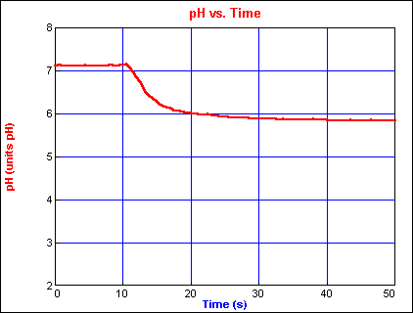

*Figure 3 CO2 dissolving in water*

**ANSWERS TO QUESTIONS**

2. Carbon dioxide, CO2, caused the smallest drop in pH (ΔpH = –1.22).

3. Sulfur dioxide, SO2, caused the largest drop in pH (ΔpH = –4.52). Nitrogen dioxide, NO2,

causes a drop in pH about the same as SO2 (ΔpH = –4.36).

4. When low-sulfur coal is burned, it produces less sulfur dioxide. With lower concentrations of

sulfur dioxide in the atmosphere, less sulfurous acid will be produced by the reaction:

SO2(g) + H2O(1) → H2SO3(aq)

5. Nitrous acid, HNO2, and nitric acid, HNO3, are produced by the reaction:

2 NO2(g) + H2O(g) → HNO2(aq) + HNO3(aq)

6. Carbon dioxide gas, a natural component of the atmosphere, dissolves in rainwater and forms

carbonic acid, H2CO3.

7. The acidity level is lower in actual rainfall because the concentration of SO2, NO2, and CO2

gases in the atmosphere is much lower than in this experiment.