ATWOOD’S MACHINE

LAB MECH 24.COMP
From Physics with Computers, Vernier Software and Technology

INTRODUCTION
A classic experiment in physics is the Atwood’s machine: Two masses on either side of pulley connected by a light string. When released, the heavier mass will accelerate downward while the lighter one accelerates upward at the same rate. The acceleration depends on the difference in the two masses as well as the total mass.
In this lab, you will determine the relationship between the two factors which influence the acceleration of an Atwood’s machine using a Photogate for measuring acceleration.

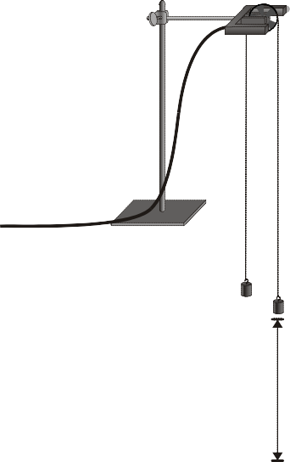
40 cm
Figure 1

PURPOSE

The purpose is with a photogate to measure and study the acceleration of an Atwood’s machine and determine the relationships between the moving masses and the acceleration.

MATERIALS

computer | clamp stand to mount photogate
Vernier computer interface | mass set
Logger Pro  Vernier Photogate with Super Pulley | string

PRELIMINARY QUESTIONS
- If two equal masses are suspended from either end of a string passing over a light pulley (an Atwood’s machine), what kind of motion do you expect to occur? Why?
- For an Atwood’s machine, how would you expect the acceleration to change if you:
  - Move mass from one side to the other, keeping the total mass constant?
  - Gradually increase the mass of both sides?

- Why do the two masses have the same acceleration?

- Draw a free-body diagram of the left side mass. Draw another of the right side mass. Include all forces acting on each mass.

PROCEDURE
Part I Keeping Total Mass Constant
For this part of the experiment you will keep the total mass used constant, but move weights from one side to the other. The difference in masses changes.

- Set up the Atwood’s machine apparatus as shown in Figure 1. Be sure the heavier mass can move at least 40 cm before striking the floor.
- Connect the Photogate with Super Pulley to DIG/SONIC 1 of the interface.

- Open the file “10 Atwoods Machine” in the Physics with Computers folder. A graph of velocity vs. time will be displayed.

- Arrange a collection of masses totaling 200 g on m2 and a 200 g mass on m1. What is the acceleration of this combination? Record your values for mass and acceleration in the data table.
- Move 5 g from m2 to m1. Record the new masses in the data table.
- Position m1 as high up as it can go. Click to begin data collection. Steady the masses so they are not swinging. Wait one second and release the masses. Catch the falling mass before it strikes the floor or the other mass strikes the pulley.

- Click the Examine button and select the region of the graph where the velocity was increasing at a steady rate. Click the Linear Fit button to fit the line y = mt + b to the data. Record the slope, which is the acceleration, in the data table.

- Continue to move masses from m2 to m1 in 5 g increments, changing the difference between the masses, but keeping the total constant. Repeat Steps 6 - 7 for each mass combination. Repeat this step until you get at least five different combinations.

Part II Keeping The Mass Difference Constant

For this part of the experiment you will keep the difference in mass between the two sides of the Atwood’s machine constant and increase the total mass.
- Put 120 g on m1 and 100 g on m2.
- Repeat Steps 6 – 7 to collect data and determine the acceleration.

- Add mass in 20 g increments to both sides, keeping a constant difference of 20 grams. Record the resulting mass for each combination in the data table. Repeat Steps 6 - 7 for each combination. Repeat the procedure until you get at least five different combinations.

DATA TABLE

Part I: Keeping Total Mass Constant
Trial | m1 | m2 | Acceleration | Δm | mT
 | (g) | (g) | (m/s2) | (kg) | (kg)
1
2
3
4
5
Part II: Keeping The Mass Difference Constant
Trial | m1 | m2 | Acceleration | Δm | mT
 | (g) | (g) | (m/s2) | (kg) | (kg)
1
2
3
4
5

ANALYSIS
- For each trial, calculate the difference between m1 and m2 in kilograms. Enter the result in the column labeled Δm.
- For each trial, calculate the total mass in kilograms.

- Using Logger Pro, plot a graph of acceleration vs. Δm, using the Part I data. Based on your analysis of the graph, what is the relationship between the mass difference and the acceleration of an Atwood’s machine?

- Plot a graph of acceleration vs. total mass, using the Part II data. Based on your analysis of the graph, what is the relationship between total mass and the acceleration of an Atwood’s machine?

- Develop a single expression for the acceleration of an Atwood’s machine, combining the results of the previous two steps in the analysis.

EXTENSIONS
- Draw a free body diagram of m1 and another free body diagram of m2. Using these diagrams, apply Newton’s second law to each mass. Assume that the tension is the same on each mass and that they have the same acceleration. From these two equations, find an expression for the acceleration of m1 in terms of m1, m2, and g. Compare the expression to your result in Step 5 of Analysis.

- For each of the experimental runs you made, calculate the expected acceleration using the expression you found with Newton’s second law of motion and the specific masses used. Compare these figures with your experimental results. Are the experimental acceleration values low or high? Why?

- An unknown mass can be placed on one side of the Atwood’s machine. Using lab measurements and any necessary calculations, the mass of the unknown can be determined. Try it.

- How does the force exerted upward by the pulley change as the system begins accelerating? Why? Set up an experiment to determine how this force changes.
- How does the tension in the string change as the masses start to move? Or does it?

