
ARTHROPOD CLASSIFICATION KIT
Westminster College
From Flinn Scientific

The arthropod classification kit contains fifteen representative plastic models. Supplies of specific plastic organisms vary from time to time (just like live organisms!) The following list of classes and orders will help you classify each of your arthropods.

Class Arachnida
Order Araneae: Spiders Order Scorpionida: Scorpions

Class Crustacea
Crayfish

Class Chilopoda
Centipedes

Class Insecta
Order Coleptera: Beetles Order Orthoptera: Grasshoppers
Order Odonata: Dragonflies Order Mantodea: Praying Mantis
Order Hymenoptera: Bees, Wasps Order Diptera: Flies, Ants
Order Lepidoptera: Butterfly
Note: Many of the models have their name marked on the bottom.

INTRODUCTION
Welcome to the world of arthropods. The Phylum Arthropod comprises about 80% of all animal species and is one of the most successful groups of animals in terms of number of species and adaptability. About 1 million species of arthropods have been identified by scientists, but that may only be a small fraction of the total number of arthropod species living on the Earth today.

Arthropods are found in all types of environments including the deep se and the mountains. They have adapted to life on land, underground, in fresh and salt water, urban settings, deserts, and in the air. Many arthropods are familiar to humans and play an important role in our lives.
PHYLUM ARTHROPODA

Arthropods are a very interesting and diverse group of animals. They get their name from Greek words arthro-joint and poda-feet. Arthropods are joint-footed animals.

The most prominent characteristic of arthropods is their exoskeletons or outer skeletons. The exoskeleton gives soft tissues support and protection, and provides an anchoring place for muscles. The arthropod exoskeleton is made of a tough, hard substance called chitin. The exoskeleton is composed of three layers. The waxy outer layer is waterproof, keeping water out and important body fluids inside. The middle layer is the hard layer that protects the animal, gives form, and provides support. The inner layer is flexible at the joints and allows the animal to move freely.

One of the difficulties with the exoskeleton is that it does not grow with the animal. As the arthropod grows, the exoskeleton must be replaced. The replacements process is called molting. During molting, the underlaying skin separates from the exoskeleton and exoskeleton “slides” off. Just prior to molting, the animal secretes new chitin material which hardens into a new exoskeleton. The new exoskeleton is soft and somewhat flexible which provides room for growth. Unfortunately, the animal faces two dangers during this process: attack from predators and dehydration. Many arthropods will seek shelter during molting.

The exoskeleton of arthropods is divided into segments or sections to allow for movement. Each of the sections are held together by a flexible membrane (the inner layer). All arthropods have joints between their sections. To move a joint, an animal must have two muscles connected to it: one to contract or bend the joint and one to straighten out the joint. In arthropods, both the body and legs have jointed-exoskeleton sections.

Arthropods have well-developed nervous and circulatory systems. All arthropods have an open circulatory system and a dorsal (near the back) heart that pumps blood from the posterior (hind) end to the anterior (front) end. The blood carries both food and waste. The nervous system and special sensory organs vary greatly between the species. The respiratory system usually consists of a network of tubes that extend throughout the body.

Arthropods are divided into five major classes as shown in the figure below. There are several minor classes of arthropods that are not readily found or referred to in standard materials.

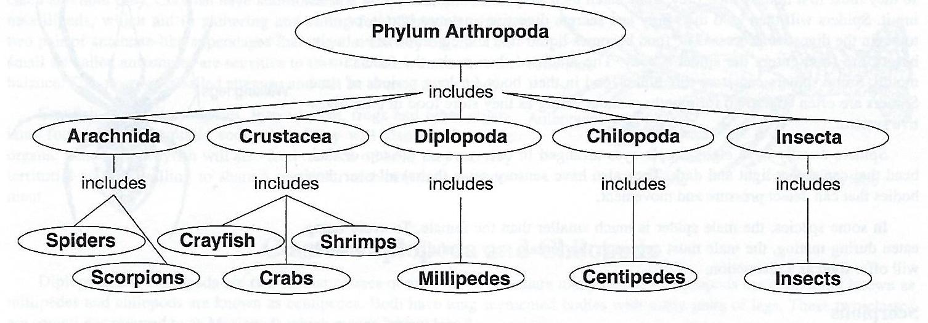

CLASS ARACHNIDA
Arachnids are animals that belong to the Phylum Arthropoda, Class Arachnida (Arachnoidea). Members of this class include spiders, scorpions, mites and ticks, and harvestman (daddy longlegs). The animals in this class are very different from each other in appearance.
Most members of this class live on land, but many species are found in wet, moist places and in the water. Scientists believe arachnids were the first group of arthropods to become adapted to a land environment millions of years ago. The horseshoe crab is an arachnid that can be traced back to Cambrian Period and is often called a “living fossil”.
Animals in Class Arachnida do share some common features. They have four pairs of legs, two regions of their bodies, and no antennae. In addition to their eight legs, they have two other pairs of appendages. The first pair are two clawlike fangs called chelicera that have poison glands at each base. The chelicera are used to inject poison into prey. The second pair, called pedipalps, are used for feeding and sensory functions.
Arachnids typically have two major body segments. The first fused section is called the cephalothorax and includes the head, thorax, and chest section fused into one section. The second body segment is called the abdomen and contains most of the organs. The bodies of mites, ticks and daddy long-legs are exceptions and are not segmented. Their bodies are a single fused unit.
Arachnids are unique in that they sense their environment in several different ways. They have hair-like sense organs covering their bodies that are sensitive to touch, they have eyes (sometimes as many as eight) that sense light and dark, and they can detect vibrations through their legs.
Most arachnids live on land. The most common types are spiders, scorpions, ticks and mites. Many arachnids help humans by destroying insect pests. The bites of some arachnids, such as black widow spiders and some scorpions can be harmful to humans.
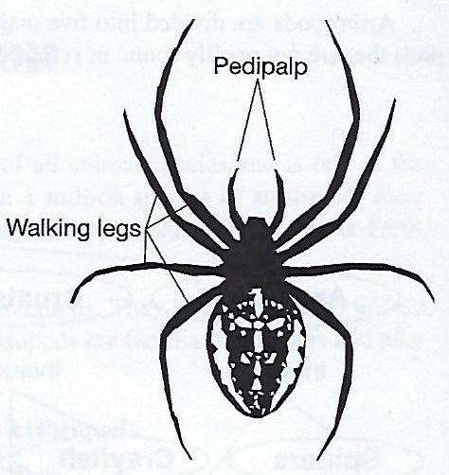
SPIDERS
Spiders are the most common, most familiar and most abundant arachnids. Spiders belong to the Order Araneae. There are about 30,000 species of spiders in the world and over 3,000 different species in the United States. The black widow is the most dangerous. The tarantulas are the largest spiders and have a leg spread from 2 ½ inches up to 10 inches. Spiders are recognized because of the webs they spin. The silk webs are constructed from liquid secreted by spinnerets that are located on the end of the abdomen. The webs are strong and sticky. Not all spiders spin webs.
Spiders have six pairs of appendages attached to the cephalothorax, (front section): four pairs of walking legs, a pair of chelicera, and a pair of pedipalp. The chelicera have a base segment and end in a terminal fang or claw that may contain poison glands. The pedipalps are used as jaws to hold or crush food.
Most spiders are carnivorous and their most common diet consists of insects. Spiders are often the main predators of insects. However, they can only ingest liquids, so they must first liquefy their prey. They catch their prey and immobilize it by poisoning it. Spiders will then hold their prey and secrete digestive enzymes into it, or on it, to begin the digestive process. The food becomes liquid-like and digestion often begins before the food enters the spider’s body. The arachnid then sucks the food into its mouth. Some spiders can store this liquid food in their body for long periods of time. Spiders are often able to go for months without eating as they store food in the digestive system.
Spiders usually have eight simple eyes arranged in two rows on the top of their head that can detect light and dark. They also have sensory setae (hairs) all over their bodies that can detect pressure and movement.
In some species, the male spider is much smaller than the female. To avoid being eaten during mating, the male must approach the female very carefully and frequently will offer food as a distraction.

SCORPIONS
Scorpions are arachnids with two distinctive features: greatly enlarged pedipalps with pincers that can grasp prey and an abdomen that ends in a tapered stinger. The scorpion catches and holds its prey with its pedipalps, curls its stinger over its body and then poisons the prey.
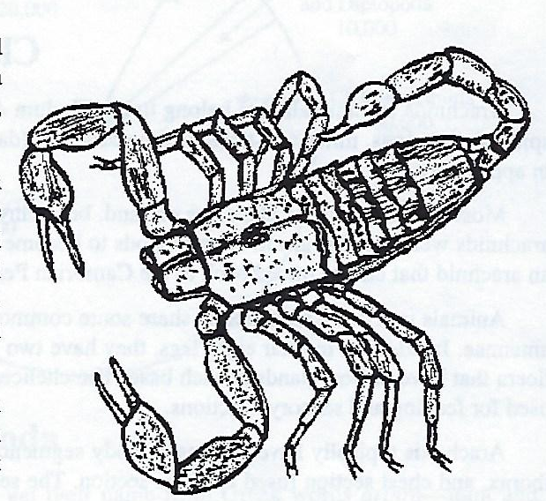
Scorpions range from ½ inch to 8 inches in length. They are found in tropical, subtropical, and desert regions. They are mostly nocturnal and hide under rocks on in crevices during the day. Scorpions eat insects, spiders, and other arthropods. The sting of a scorpion is strong enough to paralyze small mammals, but they usually do not attack non-food animals unless threatened. The sting contains a very effective poison and several scorpions have poison strong enough to be considered harmful to humans.
Scorpions are viviparous, which means their young are born alive. In scorpions, the eggs are hatched within the female. Young scorpions ride on the backs of the females for a week after birth before being on their own. It generally takes about five years for scorpions to reach adulthood.

CLASS CRUSTACEA
Crustaceans are the aquatic class of arthropods. Most crustaceans have gills and require a water environment. Shrimp, crabs, lobsters, water fleas, sow bugs are common crustaceans. The crayfish is the crustacean most widely used to illustrate the characteristics of Class Crustacea in Phylum Arthropoda. Over 20,000 species of crustaceans have been identified.
Crustaceans show tremendous diversity but also share some similar features. One distinguishing feature is a chewing jaw called a mandible. Another feature is an antennae which is a segmented sense organ. Some crustaceans have large, pincer appendages called chelipeds. They are used to obtain food and protect themselves from enemies. Lastly, crustaceans’ exoskeletons contain calcium and other minerals in addition to the chitin which makes their shells very hard.

CRAYFISH
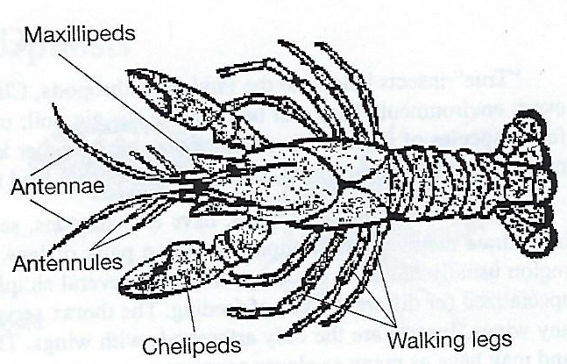
Crayfish, like other arthropods, have an extremely hard exoskeleton composed of chitin which is impregnated with lime (calcium carbonate) salts. The exoskeleton is thinner and softer at the joints to allow for movement.
The body of the crayfish has two basic parts: the cephalothorax and abdomen. The whole body of the crayfish is composed of a series of segments; however, those in the anterior region are covered by a solid protective shell called a carapace making it appear to be only one segment.
Crayfish are decapods, that is, they have five pairs of legs. One pair is the pincers or chelipeds which aid in walking but are modified to catch and hold prey. Crayfish have additional sets of appendages, called maxillipeds, which aid in gathering and eating food. They also have two pair of antennae-like appendages that serve as sensory organs. One small set called antennules are sensitive to taste and touch and help with balance. The other set is called attennae and can be as long as the body.
Crayfish eat snails, tadpoles, insect larvae, frogs and other organisms found in their aquatic ecosystem. They will also eat decaying organic materials. Crayfish will also feed on each other as they are very territorial and not willing to share a particular niche in their environment.

CLASSES DIPLOPODA AND CHILOPODA
Diplopoda and Chilopoda are two similar classes of arthropods that share many features. Diplopods are commonly known as millipedes and chilopods are known as centipedes. Both have long segmented bodies with many pairs of legs. These two classes are sometimes referred to as Myriapods which means “many legs.”
Centipedes and millipedes may appear to be the same at first glance, but are truly very different in structure and lifestyle

CENTIPEDES
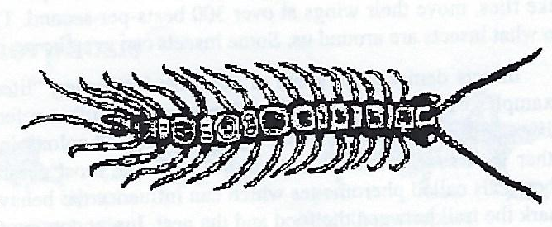
Centipedes have long, slender, segmented bodies that are somewhat flat. The body may have up to 173 segments. A key feature of centipedes is that they have only one pair of jointed legs per body segment. All segments except the one just behind the head and the last one or two on the abdomen contain a pair of legs. Centipedes have on e pair of very long antennae. House or common centipedes (Scutigera forceps) are about two centimeters long and have fifteen pairs of legs. They move very fast. In warmer climates, especially in the tropics, centipedes may grow to 30 centimeters.
Centipedes live in moist areas such as under rocks or leaves. Most centipedes are carnivorous. They eat insects, worms, and a variety of small prey. Centipedes have poisonous claws or fangs to assist in catching prey. Animals are stung and paralyzed before they are eaten. Bites of centipedes can be painful to humans.

MILLIPEDES
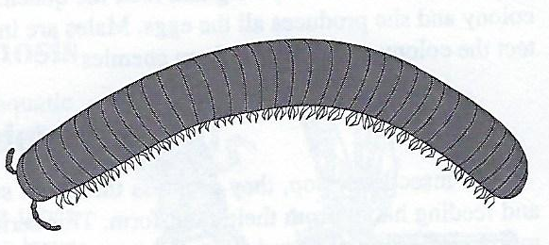
Millipedes differ from centipedes by having more segments, two pairs of legs per segment, and a slightly rounder body. It is believed that during evolution, two segments fused together to produce this unique structure. Millipedes have 25 to over 100 segments. Their bodies are smooth and rounded with short jointed legs and a rounded head. Millipedes move slowly with a “wave-like” foot movement. Millipedes have one pair of short antennae.
Young millipedes have only six segments and three pairs of legs. As they go through the molting process, legs and segments are added to their exoskeletons.
Some species of millipedes roll into a ball when disturbed. They protect themselves by secreting toxic liquid from glands located on each body segment. In some species, this toxic liquid is corrosive and can be ejected up to one meter. The liquid is odoriferous (stinks) and serves as a warning. It is harmless to humans and large animals.
Millipedes are generally herbivorous, eating plants and decaying vegetation. They are air breathing, prefer a moist environment and will sometimes dig small burrows to escape the sun or hot temperatures. In general, they are less active and move slower than centipedes.

COMPLETE METAMORPHOSIS
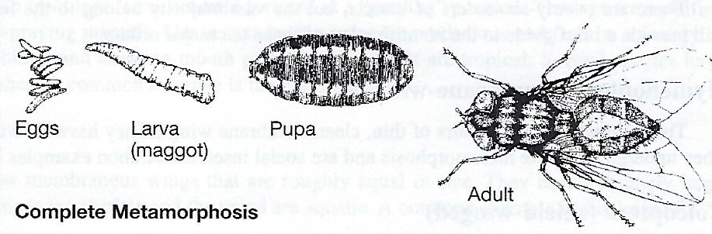
Complete metamorphosis is the more common form of metamorphosis. There are four specific stages in complete metamorphosis: egg, larva, pupa, and adult. Each stage differs in length of time depending on the insect, the weather, and other environmental factors. The egg hatches into a segmented, worm-like larva. The larva stages of different orders of insects are called different names. For example, the larvae of beetles are called grubs while the larvae of flies are maggots.
During the larva stage, the insect eats enormous amounts of food and increases in size. Many larva do not feed on the same food as adults so they do not compete with one another for food. As the larva grows, it molts and sheds its exoskeleton. At the end of this stage, the larva enters the pupa stage. During the pupa stage, the insect is sometimes covered by a case called a cocoon or chrysalis and appears to be resting. In reality, most of the larva’s tissues and organs are being replaced with new tissues and organs. At the end of the pupa stage, the insect is transformed into a fully-formed, adult insect. The adult insect does not undergo any further molting. This adult stage is the only stage with the ability to perform reproductive functions.
Common orders of insects which have Complete Metamorphosis are: Coleoptera (e.g., beetles), Diptera (e.g., housefly and mosquito), Hymenopters (e.g., bees and wasps), Lepidoptera (e.g., moths, butterflies), and Siphonoptera (e.g., fleas).

GRADUAL METAMORPHOSIS
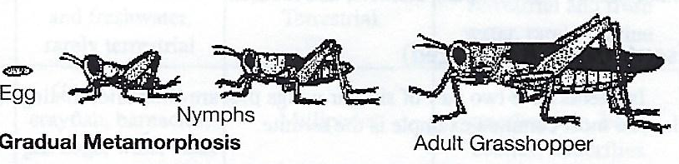
Gradual metamorphosis is an incomplete metamorphosis for terrestrial insects and has three defining stages, the egg, nymph, and adult. In this type of development, the insect emerges from the egg as nymph, or immature insect. The nymph looks very much like the adult but without wings or mature reproductive organs. The nymphs go through a series of molts (changing their exoskeleton) as they grow. The growth and body changes are gradual. Environmental factors such as temperature and moisture conditions affect the speed of growth during the cycle.
Common orders of insects which have gradual metamorphosis are Homoptera (e.g., aphids, leaf hoppers), Orthoptera (e.g., grasshoppers), and Manodea (e.g., praying mantids).

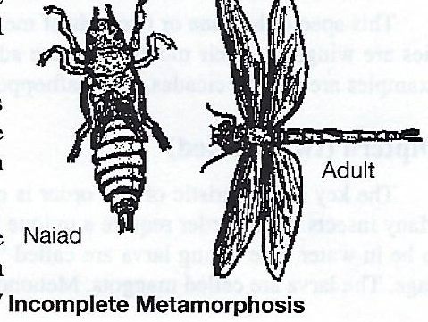
INCOMPLETE METAMORPHOSIS
Incomplete metamorphosis is similar to gradual metamorphosis but for aquatic insects. The three phases are egg, naiad, and adult. One key difference between gradual and incomplete is that the naiad stage does not always look like the adult stage.
The naiad stage is aquatic and the naiads will possess gills or breathing tubes whereas the adult may be terrestrial (live on land). In some species, the naiad may leave the water environment and go through the final molt towards adulthood on land or on a plant.
The mayfly is an excellent example of incomplete metamorphosis. Mayflies mate in the air during flight. The female will lay egg masses on stones in the water. Each mass may contain up to 300 eggs. The young naiads hatch in about 30 days, but may take up to 9 months, with 27 molts to reach adulthood.
Common orders of insects that undergo incomplete metamorphosis are Ephemeroptera (e.g. mayfly), and Odonata (e.g., dragonfly).

ORDER OF INSECTS
There are twenty-six orders of insects, but the vast majority belong to the following ten orders. The following descriptions will provide a brief guide ot the identification of these ten major orders.
Hymenoptera (membrane-winged)
These insects have two pairs of thin, clear membrane wings. They have chewing mouthparts and some females have stingers. They undergo complete metamorphosis and are social insects. Common examples include bees, wasps, and ants.
Coleoptera (shield-winged)
The key characteristic of this species are two sets of wings. One set is a hardened wing which, when closed, covers the top of the body forming a straight line down the back. At rest, the membranous wings are protected underneath the hard-shielded wings. This order contains about 40% of all insect species. Metamorphosis is complete. Common examples include beetles, fireflies, weevils and ladybugs.
Lepidoptera (scale-winged)
These insects have two pairs of wings which are used together for flying. Their bodies and wings are covered with scales that easily rub off. Common examples include moths and butterflies.
Orthoptera (straight-winged)
This group of insects is easy to identify by its long back legs. They use these strong legs for jumping. They have two pair of straight wings. Most orthoptera are plant feeders and are very destructive to vegetation. Metamorphosis is gradual. Common examples are grasshoppers, crickets, and locusts.
Isoptera (equal-winged)
Isopteras have two pairs of similar wings that are shed after mating. They are social insects and undergo gradual metamorphosis. The most common example is the termite.
Hemiptera (half-winged)
These insects have two pairs of wings that overlap to form a “V” over the abdomen. The forward wings are hardened while the hind wings are membranous. Hemiptera look similar to Coleptera but can be distinguished by a triangle on their backs. Metamorphosis is gradual if terrestrial and incomplete if aquatic. Common examples include squash bugs, backswimmers, and water spiders.
Homoptera (uniformly-winged)
This species has one or two pair of membranous wings that are held over the body like a roof or tent when at rest. Some species are wingless. Their mouth parts are adapted for penetrating and sucking on plants. Metamorphosis is incomplete. Common examples are aphids, cicadas, and leafhopper.
Diptera (two-winged)
The key characteristic of this order is only one pair of wings. Their mouth parts are adapted for lapping or piercing/sucking. Many insects in this order require a unique habitat for metamorphosis. Mosquitoes require the firs three stages of metamorphosis to be in water. The young larva are called “wigglers.”: Flies often lay their eggs on decaying matter such as dead animals and garbage. The larva are called maggots. Metamorphosis is complete. Common examples are flies, gnats, and mosquitoes.
Mantodea (prophet)
The unique characteristic of this order are the front legs. They are held forward in a “praying” position. The legs are modified for catching and holding prey (preying mantis—praying mantid). The insects in this order are predacious and feed on a variety of insects including other mantids. Mantids have biting and chewing mouth parts. Most mantids are tropical. Several species have been introduced to the U.S. and are well established. A common example is the praying mantis.
Odonata (tooth)
These insects have two pair of long, narrow membranous wings that are roughly equal in size. They have extremely large eyes and a long, narrow abdomen. Metamorphosis is incomplete and the naiad are aquatic. A common example is the dragonfly.
General Features of the Five Major Classes of Arthropods¹
Feature | Class
 | Arachnida | Chilopoda | Crustacea | Diplopoda | Insecta
Body Divisions | Cephalothorax | Head and Body | Cephalothorax and abdomen | Head and body | Head, thorax and abdomen
Legs | 4 pairs | Many, 1 pair per body segment | Numerous usual 5 pairs | Many, usually 2 pairs per body segment | Three pairs, may also have 102 pairs of wings attached to thorax
Antennae | None | 1 pair | 2 pairs | 1 pair | 1 pair
Habitat | Terrestrial | Terrestrial | Chiefly marine and freshwater, rarely terrestrial | Terrestrial | Terrestrial and fresh water, rarely marine
Examples | Spiders, scorpions | Centipedes | Crabs, shrimp, crayfish, barnacles, pill bugs, water fleas | Millipedes | Ants, flies, grasshoppers, bees, beetles, butterflies
¹General features of the major classes, numerous exceptions exist.

References
Arnett, R.H. Jr.; Jacques, R.L. Jr. Guide to Insects; Simon & Schuster: New York 1981
Emerson, J.H. The Common Spiders of the United States; Dover: New York 1961
Stokes, D.W. A Guide to Observing Insect Lives; Little, Brown: Boston, 1983

