TEACHER NOTES
Westminster College

BAKING SODA AND VINEGAR INVESTIGATIONS
GUIDED INQUIRY VERSION
From Vernier Investigating Chemistry through Inquiry

LAB 2
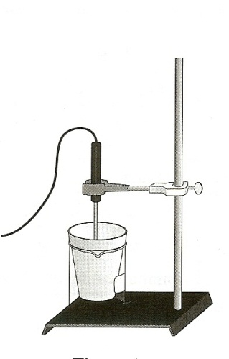
OVERVIEW

In the Prelminary Activty, your students will gain experience using a Temperature Probe to determine the temperature change when 2.00 g of baking soda react with 50.0 mL of vinegar.

During the subsequent Inquiry Process, your students will first learn more about baking soda nad vinegar using the course textbook, other available books, and the Internet. They will then generate and investigate researchable questions dealing with the properties of baking soda and/or vinegar or the reaction between them. (In Guided Inquiry, students will plan and conduct investigations of the researchable questions assigned by you.)

This experiment can be used very early in the school year to introduce the use of probeware, the inquiry approach, laboratory equipment and properties of matter. The follow-up experiment—Experiment 32, Baking Soda and Vinegar Investigations Revisited—employs much of the knowledge and many of the laboratory skills typically gained in a good introductory chemistry course, and it can be scheduled much later in the school year.

LEARNING OUTCOMES

In this inquiry experiment, students will
- Identify variables, design and perform the experiment, collect data, analyze data, draw a conclusion, and formulate a knowledge claim based on evidence from the experiment.
- Gain increased understanding of the physical properties and chemical properties of substances.

CORRELATIONS

IB Topic and Sub-Topic
Topic 5 – Energetics
Sub-Topic 5.1 – Endothermic and Exothermic Reactions
Sub-Topic 5.2 – Calculation of Enthalpy Changes

THE INQUIRY PROCESS

Suggested Time to Complete the Experiment
See the section in the introduction, Doing Inquiry Experiments, for more information on carrying out each phase of an inquiry experiment.

 | Inquiry Phase | Open Inquiry | Guided Inquiry
I | Preliminary Activity | 25 minutes | 25 minutes
II | Planning | 15 mintues | 15 minutes
III | Carrying Out the Plan | 40 minutes | 35 minutes
IV | Organizing the Data | 10 minutes | 10 minutes
V | Communicating the Results | 15 minutes | 10 minutes
VI | Conclusion | 10 minutes | 10 minutes

MATERIALS

LabQuest or Lab Pro utility clamp
Temperature Probe vinegar
Styrofoam cup balance
Baking soda stirring rod
400 mL beaker 50 mL graduated cylinder
Ring stand other items as requested by students

- Preliminary Activity
This inquiry begins with an activity to reinforce prior knowledge of the use of Vernier data collection technology and to introduce a method for collecting temperature data.

Sample Results
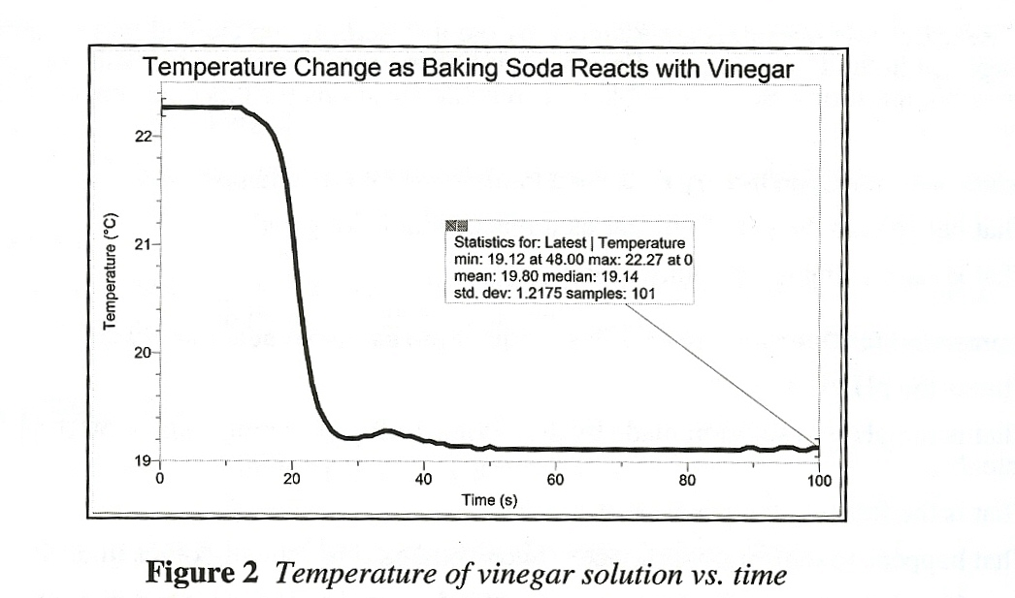

Answers to the Questions
- Subtract the initial temperature from the final temperature to determine the temperature change, Δt, for the reaction.
Answers will vary. 19.1°C - 22°C = -3.2°C.

- Which substance is in the bubbles that are produced as baking soda reacts with vinegar?
Answers will vary. The bubbles contain carbon dioxide gas.

- List two physical properties of baking soda.
Answers will vary. Baking soda is a white crystalline solid. It has a slight alkaline taste, a molar mass of 84.01 g/mol, a density of 2.139 g/cm, and a solubility of 7.8 g/100 mL of water at 18°C. Its water solutions have pH values in the 8.2-8.4 range.

- List two physical properties of vinegar.
Answers will vary. Vinegar has a sour taste and a pungent smell. “White” vinegar is a colorless liquid, other vinegars have an array of colors. The pH of vinegar is typically in the 2.4-3 range. The density of vinegar is approximately 1.01 g/mL, but its density depends on its acidity. The freezing temperature and boiling temperatures of vinegar depend on its acetic acid content. Commercial vinegar, typically with a 5% acetic acid content, has a freezing temperature of about -2°C and a boiling temperature of about 100.6°C.

- List two observations evidencing that a chemical change occurred when you add baking soda to vinegar in the Preliminary Activity.
Answers will vary. Indications that a chemical change occurred include: the formation of a gas, the disappearance of the baking soda solid, and the temperature decrease.

- Generating Researchable Questions

Note: Researchable questions are assigned by the instructor in the Guided Inquiry approach. See the Doing Inquiry Experiments section for a list of suggestions for generating researchable questions. Some possible researchable questions for this experiment are listed below:

Recommended for Open or Guided Inquiry (sample results provided)
- What happens to the pH of vinegar as it reacts with baking soda?
- What is the boiling temperature of vinegar?

Recommended for Open or Guided Inquiry (no sample results provided)
- What is the pH of vinegar?
- What is the pH of a solution made by dissolving 1.00 g of baking soda in 50.0 mL of distilled water?
- What is the freezing temperature of vinegar?
- What happens to temperature of water when solid baking soda dissolves in it?
- How does the reaction of a water solution of baking soda with vinegar differ from the reaction of solid baking soda with vinegar?
- What is the conductivity of vinegar?
- How do the conductivities of different vinegars compare?
- How do the pH values of different vinegars compare?
- What happens to the pressure when vinegar is added to baking soda in a closed container?
- What happens to the total mass during the reaction between baking soda and vinegar?

Recommended for Advanced Students (sample results provided)
- How many mL of vinegar can be neutralized by 1.00 G of baking soda? (What is the mL vinegar/g baking soda ratio in the vinegar and baking soda reaction?)

There are many more possible researchable questions. Students should choose a researchable question that addresses and learning outcomes of your specific standards. Be sure to emphasize experimental control and variables. (Instructors should select the researchable questions to be investigated by their students. We encourage you to assign multiple researchable questions because their strategy enhances student interaction and learning during phases IV-VII.)

- Planning
During this phase students should formulate a hypothesis, determine the experimental design and setup, and write a method they will use to collect data. Circulate among the student groups asking questions and making helpful suggestions.

- Carrying Out the Plan
During this phase, students use their plan to carry out the experiment and collect data. Circulate among the student groups asking questions and making helpful suggestions.

- Organizing the Data
See the Doing Inquiry Experiments sections for suggestions concerning how students can organize their data for their inquiry presentations.

- Communicating the Results
See the Doing Inquiry Experiments section for a list of inquiry-presentation strategies.

- Conclusion
See the Doing Inquiry Experiments section for a list of suggestions concerning assessment and ways to utilize the results in subsequent instruction.

SAMPLE RESULTS
Student results will vary depending on experimental design.
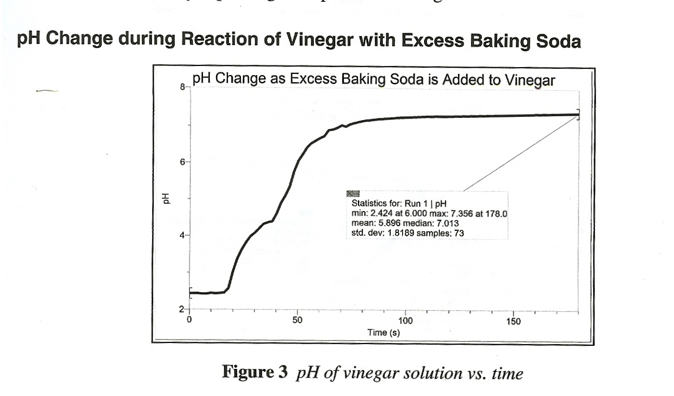

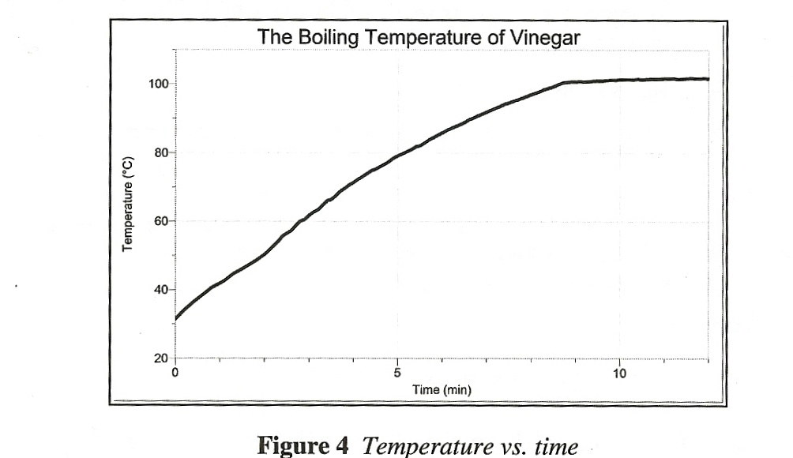
This investigation addresses the question, “What happens to the pH of vinegar as it reacts with baking soda? Excess solid baking soda (8g) was slowly added to 50 mL vinegar in a 250 mL beaker with gentle stirring. The pH of the vinegar solution increased from its initial value of 2.4 to a value of 7.4 during a 180 second period.

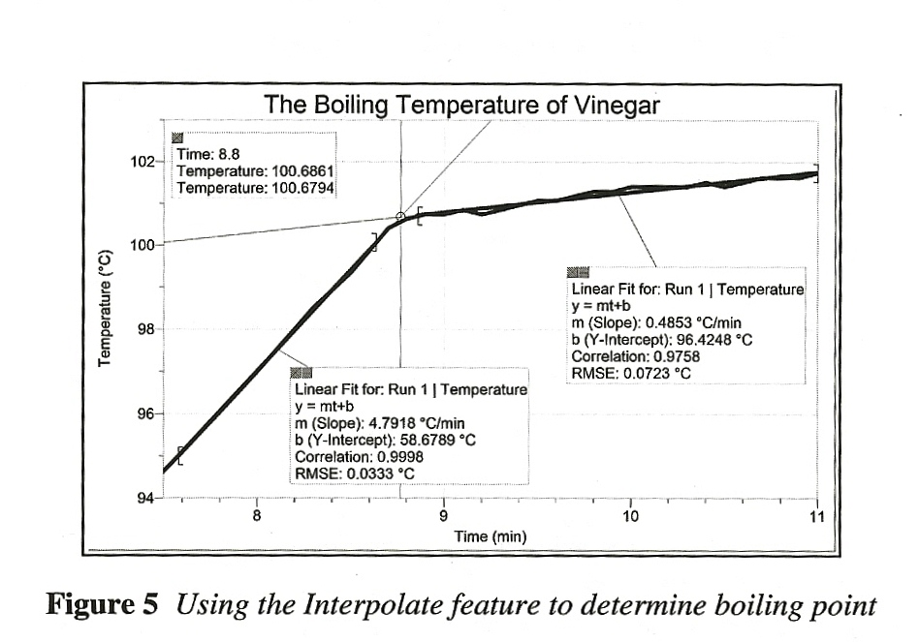
The Boiling Temperature of Vinegar
This investigation addresses the questions, “What is the boiling temperature of vinegar?” A vinegar sample was heated in a salt-water bath. As can be seen in Figure 5 above, the initial boiling temperature was determined to be 100.7°C, and the boiling temperature increased as boiling continued, See the Tips section for details.

Determining the Vinegar to Baking Soda Reaction Ratio

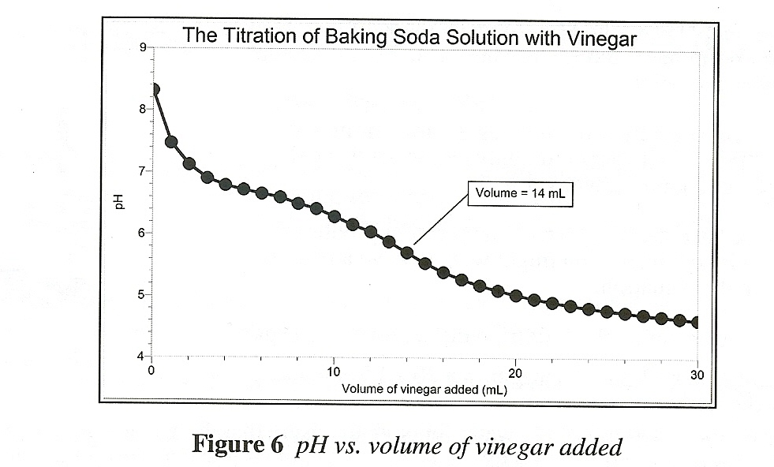
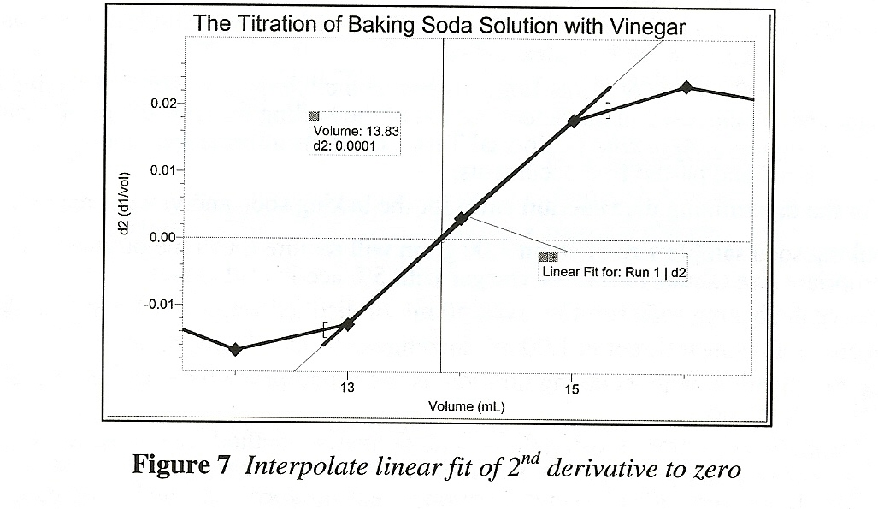
This investigation addresses the question, “How many mL of vinegar can be neutralized by 1.00 g of baking soda?” A baking soda solution made by dissolving 1.00 g of NaHCO₃ in 50 mL of distilled water was titrated with 1 mL increments of vinegar. The volume of vinegar titrant, with an acetic acid content of 5.15%, used at the equivalence point was determined using the second derivative method and was found to be 13.8 mL. See the Tips section for details.

TIPS
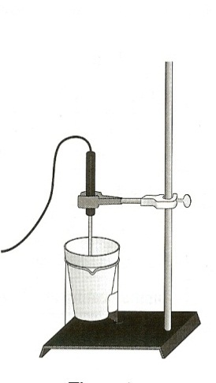
- We recommend placing the Styrofoam cup in a 400 mL beaker during the Preliminary Activity because it stabilizes the cup and provides insulation.

- The acetic acid concentration of vinegar varies from 4 to 8 percent. “White” vinegar commonly has an acetic acid concentration of approximately 5%.

- There will be “accidents” in which the reaction products overflow their container. You might want to have a plan for dealing with this situation.

- Tips for the determining the boiling temperature of vinegar:

- The use of about 12 mL of vinegar in a 20 x 150 mm test tube works well.
- The use of about 400 mL of tap water (enough to ensure that the vinegar sample is completely submerged) in a 600 mL beaker (or a can of equivalent size) for the hot saltwater bath works well.
- Heat the water bath on a hotplate.
- The addition of about 20 g of table salt per 100 mL of water will sufficiently elevate the boiling temperature of hot saltwater bsath.

- Tips for the determining the reaction ratio for the baking soda and vinegar reaction:
- A baking soda sample size of about 1.00 gram will require a volume of vinegar of appropriate size (about 14 mL for vinegar with 5% acetic acid content).
- Dissolve the baking soda solid in about 50 mL of distilled water in a 100 mL beaker.
- Dispense the vinegar titrant in 1.00 mL increments from a 50 mL buret.
- This investigation, with its taxing titration, is only appropriate for students with previous titration experience.

- The plans that your students submit for approval should list laboratory safety concerns, including chemical safety concerns, and specify how they will address these safety concerns during their investigations.

