TEACHER NOTES
Westminster College

BEERS LAW INVESTIGATIONS
GUIDED INQUIRY VERSION
From Vernier Investigating Chemistry through Inquiry

LAB 11

OVERVIEW
In the Preliminary Activity, your students will learn technique for Beer’s law investigations and determine the concentration of an unknown CuSO₄ solution.

Although the Preliminary Activity is written for the Colorimeter, your students may gain greater understanding of this investigaion by using a Vernier Spechtrometer.

During the subsequent Inquiry Process, your students will first learn about solutions an dpossible applications of the Beer’s law technique using the course textbook, other available books, and the Internet. They will then generate and investigate researchable questions that utilize Beer’s law technique. In this Guided Inquiry approach, students will plan and conduct investigations of the researchable questions assigned by you.

LEARNING OUTCOMES
In this inquiry experiment, students will
- Identify variables, design and perform the experiment, collect data, analyze data, draw a conclusion, and formulate a knowledge claim based on evidence from the experiment.
- Learn and apply Beer’s law technique.

CORRELATIONS
IB topic and Sub-Topic
Topic1—Quantitative Chemistry
Sub-Topic 1.5—Solutions
Option A—Modern Analytical Chemistry
Sub-Topic A.2—Principles of Spectroscopy

THE INQUIRY PROCESS
Suggested Time to Complete the Experiment
See the section in the introduction, Doing Inquiry Experiments, for more information on carrying out each phase of an inquiry experiment.

 | Inquiry Phase | Guided Inquiry
I | Preliminary Activity | 40 minutes
II | Planning | 15 minutes
III | Carrying Out the Plan | 35 minutes
IV | Organizing the Data | 10 minutes
V | Communicating the Results | 10 minutes
VI | Conclusion | 10 minutes

MATERIALS
Lab Quest CuSO₄ unknown solution
Vernier Colorimeter 0.40 CuSO₄ solution
Cuvette distilled water
Five 20 x 150 mm test tubes pipet pump or pipet bulb
Test tube rack stirring rod
Two 10 mL pipets or graduated cylinders kim-wipes
Two 100 mL beakers

Preliminary Activity
This inquiry begins with an activity to reinforce prior knowledge of the use of Vernier data collection technology and to introduce a method for collecting Beer’s law data using a colorimeter.

Table 1: Prelminary Activity Data
Trial | Concentration (mol/L) | Absorbance
1 | 0.080 | 0.205
2 | 0.16 | 0.404
3 | 0.24 | 0.599
4 | 0.32 | 0.789
5 | 0.40 | 0.982
6 | Unknown number 1 | 0.669

Concentration of the unkown 0.271 mol/L

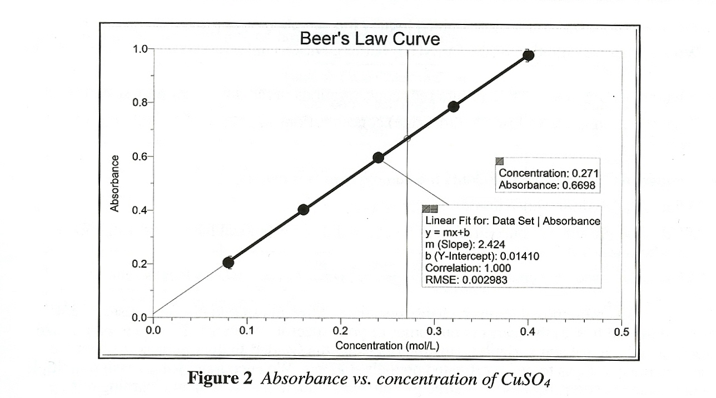

Answers to the Questions
- What was the concentration of your unknown solution (in mol/L)?
Answers will vary. In the Sample Results above, the CuSO₄ concentration is 0.271 M.

- Beer’s law investigations involve the absorption of light by a colored species. The species may be colored itself, such as a colorful food dye in a verage. Alternatively, the species of interest may be colorless, but able to react with an appropriate reagent to produce colored species. Some colorless ions in ground water fit into the latter category. An Internet search using “Beer’s law experiments” as a search topic will reveal numerous possible researchable questions of potential interest to you.
Answers will vary. See the Researchable Questions list below for some possible answers.

Generating Researchable Questions
Note: Researchable questions are assigned by the instructor in this Guided Inquiry approach. See the Doing Inquiry Experiments section for a list of suggestions for generating researchable questions. Some possible researchable questions for this experiment are listed below:

Sample Results provided
- What is the free chlorine content of our swimming pool water (hot tub, spa, tap water, whirlpool)?
- What is the conectration of iron in a multivitamin tablet (iron table, local ground water, food)?

No sample results provided
                - What is the concentration of the Cu(NO₃)₂ (CoCl₂, NiSO₄) unknown solution issued to me by the instructor?
                - What are the relative red #40 (allura red) concentrations in red #40-containing soft drinks?
                - What are the relative yellow #5 (tartrazine) concentrations in yellow #5-containing soft drinks?

Recommended for Advanced Students (No results provided)
- What is the albumin concentration in egg white?
- What is the phosphate concentration in local ground water ( a local lake, a local stream, a household product)?
- What is the nitrate concentration in local ground water ( a local lake, a local stream)?

There are many more possible researchable questions. Students should choose a researchable question that addresses the learning outcomes of your specific standards. Be sure to emphasize experimental control and variables.

Planning
During this phase students should formulate a hypothesis, determine the experimental design and setup, and write a method they will use to collect data. Circulate among the student groups asking questions and making helpful suggestions.

Carrying out the Plan
During this phase, students use their plan to carry out the experiment and collect data.

Organizing the Data
See the Doing Inquiry Experiments section for suggestions concerning how students can organize their data for their inquiry presentations.

Communicating the Results
See the Doing Inquiry Experiments sections for a list of inquiry-presentation strategies.

Conclusion
See the Doing Inquiry Experiments section for a list of suggestions concerning assessment and ways to utilize the results in subsequent instruction.

SAMPLE RESULTS
Student results will vary depending on experimental design.

The Free Chlorine Content of Swimming Pool Water

Table 2: Free Chlorine Data
Trial | Concentration (mg/L) | Absorbance
1 | 0.40 | 0.030
2 | 0.80 | 0.067
3 | 1.20 | 0.121
4 | 1.60 | 0.161
5 | 2.00 | 0.210
6 | Unknown number 1 | 0.066

Concentration of swimming pool sample 0.74 mg/L
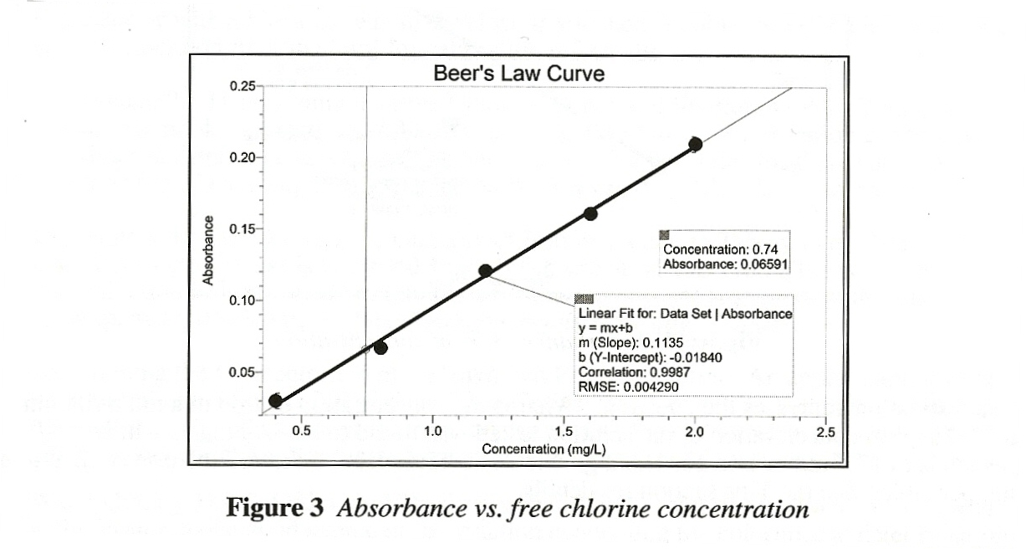
This investigation addresses the question, “What is the free chlorine content of our swimming pool water?” The free chlorine content of the swimming pool water tested was found to be 0.74 mg/L.

The Amount of Iron in a Multivitamin Tablet

Table 3: Iron Data
Trial | Concentration (mg/L) | Absorbance
1 | 2.00 | 0.049
2 | 4.00 | 0.093
3 | 6.00 | 0.137
4 | 8.00 | 0.181
Tablet Solution | 5.45 | 0.125
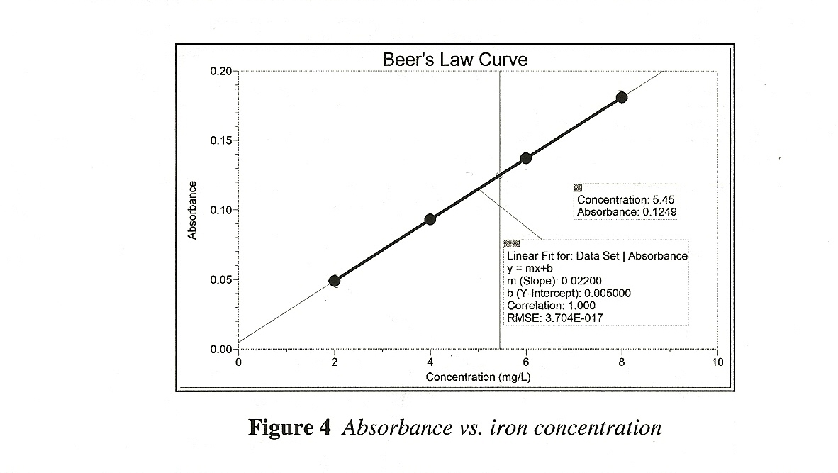

This investigation addresses the question, “What is the concentration of iron in a multivitamin table?” The iron concentration of the solution tested was found to be 5.45 mg/L, which corresponds to the 17.7 mg of iron per 1.302 g tablet. The bottle label indicated the iron content to be 18 mg per table.

TIPS
- The light source for the copper (II) sulfate solution is the red LED (635nm). The nearly monochromatic red light is absorbed by the solution.

- Prepare 100 mL of 0.40 copper (II) sulfate solution by dissolving 9.99 g of CuSO₄•5H₂O in sufficient distilled water to make 100 mL of solution. HAZARD ALERT: Copper (II) sulfate, pentahydrate: Skin and respiratory irritant; moderately toxic by ingestion and inhalation.

- A suitable unknown CuSO₄ solution can be prepared by adding 50 mL of distilled water to 50 mL of the stock 0.40 M Copper (II) sulfate solution.

- You may substitute blue food coloring for the CuSO₄. Two recipes to try are: (a) 2 drops of food coloring per 100 mL of distilled water or, (b) 3 drops food coloring per 150 mL of distilled water. Prepare each mixture and test them as the “0.4 M CuSO₄ solution. Decide which solution produces the optimum absorbance for the experiment.

- The cuvettes should be at least ¾ full to get good absorbance measurements. However, the cuvettes need not be completely full and indeed should not in order to seal the cuvette with a plastic cap without spilling out some solution.
- We recommend that each student lab team use a single cuvette to test their liquids in the Colorimeter. This will eliminate errors introduced by slight variations in the absorbance of different plastic cuvettes.

- There are two models of Vernier Colorimeters. The first model (rectangular shape) has three wavelength settings, and the newest model ( a rounded shape) has four wavelength settings. The 635 nm wavelength of either model is used in this experiment. The newer model is an auto-ID sensor and supports automatic calibration (pressing the CAL button on the Colorimeter with a blank cuvette in the slot). If you have an older model Colorimeter see vernier.com for calibration information.

- The plans that your students submit for approval should list laboratory safety concerns, including chemical safety concerns, and specify how they will address these safety concerns during their investigation.

