BLOOD PRESSURE AND EXERCISE

STANDARDS:

Westminster College

- 3.1.10A, 3.1.12A – Identify the function of subsystems within a larger system; analyze and describe the function, interaction and relationship among subsystems and the system itself.
- 3.1.10B - Apply mathematical models to science and technology.
- 3.3.10A, 3.3.12A - Explain the relationship between structure and function at the molecular and cellular levels; explain and analyze the relationship between structure and function at the molecular, cellular and organ-system level.

INTRODUCTION:
Medical personnel use the heart rate as a vital sign to provide clues as to the presence of many medical conditions. Reflex changes in heart rate are one of the body’s most basic mechanisms for maintaining proper perfusion to the brain and other tissues. Perfusion is the flow of blood through an organ. Low blood volume caused by bleeding or dehydration results in the heart beating faster as it attempts to maintain adequate blood pressure. Excitement, stress, and anxiety activate the nervous system, which may also speed the heart rate and raise blood pressure.
By the second half of the 19th century a non-invasive method for measuring blood pressure had been invented. Called a sphygmomanometer, this instrument is still in use today allowing us to measure this important vital sign. Constant pressure is required to pump blood through the circulatory system. This ensures the delivery of oxygen and nutrients to and the removal of carbon dioxide and waste products from tissues. Positive pressure is created by forceful contraction of the left ventricle of the heart, measured as systole. It is maintained during relaxation of the ventricle by closure of the aortic valve and recoil of arteries, measured as diastole (see Figure 1). The difference between the systolic and the diastolic pressures is called the pulse pressure. This is the throbbing pulsation, or pulse, in an artery during systole. The flexible, elastic arteries are expanded by the blood being forced into them during the contraction of the left ventricle.

Mean arterial pressure (MAP) is a useful measure of the adequacy of tissue perfusion. It is not a simple average of systolic and diastolic blood pressures. This is because diastole continues for twice as long as systole. MAP can be reasonably approximated using the equation:

MAP = diastolic pressure + pulse pressure
3

The mean arterial pressure is directly proportional to cardiac output and inversely proportional to total peripheral resistance, where:

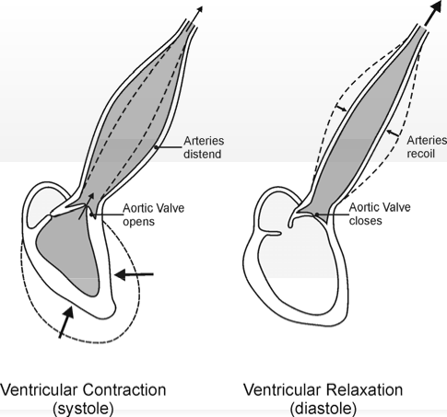Cardiac output is the amount of blood pumped out of the heart with each beat (called the stroke volume) multiplied by the number of beats per minute.
Fig. 1

Total peripheral resistance depends on blood viscosity, length of the arterial system, diameter and elasticity of the blood vessels, and the pressure entering versus leaving the arterial system (systolic pressure minus the pressure in the venous system).

In this experiment, you will examine your blood pressure using the Vernier Blood Pressure Sensor. You will compare blood pressure readings taken before and after exercise and measure changes in systolic, diastolic, and mean arterial pressures. You
will also consider the effect that exercise has on cardiac output and peripheral vascular resistance.

GUIDING QUESTIONS:
- What biological functions do the systole, diastole, and mean arterial pressure measurements record?
- How do the above measurements indicate general health of a person?
- Hypothesize how you think these measurements will change from baseline when you exercise?

MATERIALS

Vernier LabQuest | Vernier Blood Pressure Sensor
LabQuest power supply (working inside) | Area to Exercise

SAFETY
Do not attempt this lab if you have known heart or blood pressure problems.

PROCEDURES

Part I Baseline Blood Pressure
- Connect the Blood Pressure Sensor to LabQuest and turn on the LabQuest (oval button on top left). A Meter screen like the one shown in Figure 2 will appear. Choose New from the File menu.

- The gray Length box on the right side of the screen should automatically be set for 100 s.

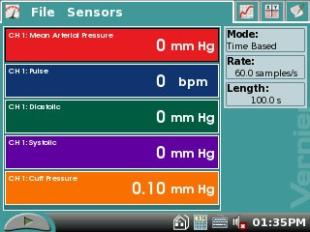Figure 2. Blood Pressure Screen

- Attach the Blood Pressure cuff to the upper arm, approximately 2 cm above the elbow. The two rubber hoses from the cuff should be positioned over the biceps muscle (brachial artery) and not under the arm (see Figure 3).

- Have the subject sit quietly in a chair with forearms resting on his/her lap, or on a table surface. The person having his or her blood pressure measured must remain still during data collection; there should be no movement of the arm or hand during measurements.

- Start data collection by tapping the Start key . The LabQuest will automatically go to Graph mode , and will display a graph of

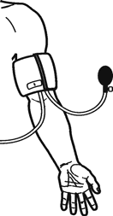
Figure 3

Time (s) vs. Cuff Pressure (mmHg) Immediately begin to pump up the cuff until the pressure reaches at least 160 mm Hg. Under R1: Cuff Pressure in the top left of the screen next to the graph, you will see a live readout of the cuff pressure. Stop pumping when this number reaches 160-170.

- 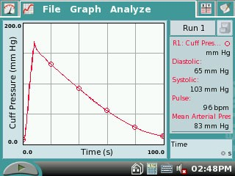The LabQuest will stop collecting data after 100 s, and after a few seconds, will calculate the resting systolic, diastolic, mean arterial pressure and pulse. These numbers will be displayed in the gray box to the right of the graph. You should have data that looks similar to that shown in Figure 4.

- Enter the resting systolic, diastolic, and mean arterial pressures in Table 1. Store the Resting Blood Pressure data by tapping the Cabinet icon .

Part II Blood Pressure After Exercise
Figure 4. Sample Blood Pressure Data

- The next part of the experiment can be done in two ways.

  - With the blood pressure cuff still attached to his/her arm, the subject from Part I of the experiment should run in place for 2 minutes. At the end of 2 minutes, the subject should sit down, placing his or her arm on the table surface.

  - The lab partner may draw two marks to indicate where the two black hoses are on the subject’s arm. Remove the blood pressure cuff and have the subject engage in a physical activity for 2-5 minutes. When putting the blood pressure cuff back on after exercise, line up the black hoses with the marks on the subject’s arm to ensure the consistency of the blood pressure reading. The subject should then sit down, resting his or her arm on the table surface.

- Start data collection by tapping the Start key . Immediately begin to pump up the blood pressure cuff. When the cuff pressure reaches at least 170 mmHg, stop pumping.

- The LabQuest will stop collecting data after 100 s. Immediately feel for the radial pulse (place two or three fingers over the radial artery in the wrist proximal to the thumb) in the arm without the Blood Pressure cuff. Count the beats over 20 s. Multiply by 3 to obtain the number of beats per minute. Record this value in Table 2.

- After a few seconds, the LabQuest will calculate the resting Systolic, Diastolic, and Mean Arterial Pressure. These numbers will be displayed in the gray box to the right of the graph. Store the Blood Pressure after exercise data by tapping the Cabinet icon .
- Record the systolic, diastolic, and mean arterial pressures in Table 2.

REFERENCES
Diana Gordon and Steven L. Gordon, M.D. 2005. Human Physiology with Vernier. Experiment 8: Blood Pressure and Exercise. Vernier Software & Technology. Beaverton, OR. Pp 8-1 – 8-4, 8-1T – 8-2T.

Elaine N. Marieb, R.N., Ph.D. 2004. Human Anatomy & Physiology. Chpt. 19, The Cardiovascular System: Blood Vessels. Pearson Education, Inc. Sixth Ed. San Francisco, CA. pp. 722-723.

CREDITS
Special thanks to Dr. Marosh Furimsky of the Westminster College Biology Department who has supplied knowledge and background reference material for this lab. The lab was adapted and revised by Dr. Stephanie Corrette-Bennett.

DATA SHEET

Name: Group: Date:

Table 1 – Baseline Blood Pressure
Systolic pressure (mm Hg) | Diastolic pressure (mm Hg) | Mean arterial pressure (mm Hg) | Pulse (bpm)

Table 2 – Blood Pressure After Exercise
Systolic pressure (mm Hg) | Diastolic pressure (mm Hg) | Mean arterial pressure (mm Hg) | Pulse (bpm)

ANALYSIS

- a. Describe the trends that occurred in the systolic pressure, diastolic pressure, mean arterial pressure, and pulse with exercise. What is happening during exercise to produce these trends?

b. Assume that the stroke volume increased from 75 mL/beat to 100 mL/beat. Use this information and the change in pulse with exercise to calculate the change in cardiac output (stroke volume × heart rate) that occurred per minute.
Baseline Blood Pressure:
mL/beat X beat/min =
(units)

1b. continued…
Blood Pressure After Exercise:

mL/beat X beat/min =

(units)

Change in Cardiac Output:

- Pulse pressure is the difference between systolic pressure (peak pressure during active contraction of the ventricles) and diastolic pressure (the pressure that is maintained even while the left ventricle is relaxing). Describe the change in pulse pressure seen with exercise. Which component of the blood pressure is most responsible for this change?

- A change in pulse pressure can be seen in a variety of medical conditions. What would you expect to happen to the pulse pressure in the following examples?
  - In atherosclerosis there is a hardening of the arterial walls.

  - A damaged aortic valve does not seal properly and allows blood to flow back into the ventricle during diastole.

