BOUNCING BACK

LAB FORENSICS 2
From Forensics with Vernier

Westminster College

OBJECTIVES
- Explore the use of ground-penetrating radar (GPR) to find buried materials.
- Detect the presence of an object using a motion detector.
- Distinguish between different-shaped objects using a motion detector.

MATERIALS
LabQuest Meter stick
Motion Detector Small box or block of wood Several large boxes (each containing unknown object)

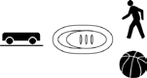
PROCEDURE

- Prepare the Motion Detector for data collection
  - If your Motion Detector has a switch, set it to Normal.
  - Connect the Motion Detector to DIG1 of LabQuest and choose New from the file menu. If you have an older sensor that does not auto-ID, manually set up the sensor.
  - On the Meter screen, tap Length, then change the data-collection length to 10 seconds. Select OK.

- Get to know how a Motion Detector displays data.
  - Place a block of wood or a small box on your desk. Make sure that there is nothing else on the surface of your desk.
  - Hold the Motion Detector about a meter above your desktop and toward one end of your desk. Make sure that the round screen on the detector is facing the desktop.
  - With the Motion Detector in place, choose Zero form the Sensors menu.
  - Start data collection.
  - When data collection begins, slowly move the Motion Detector, at a constant height above the desktop, from one end of your desk to the other end.
  - When data collection is complete, the displayed graph should look similar to the graph below.

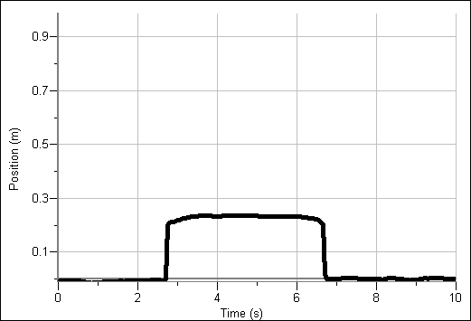

- Your teacher will direct your group to move to one of the suspected “burial sites” for the car. Record the location of the site in the Evidence Record.

- Without looking inside the box, probe each of the suspected burial sites.

  - Set a meter stick across the opening of the box.

  - Rest the Motion Detector on the meter stick starting at one end of the box, with a round screen on the detector facing the bottom of the box.

  - With the Motion Detector in place, choose Zero from the Sensors menu.

  - You need to move the Motion Detector at a speed that will let you move from one end of the box to the other in about 10 seconds. Practice slowly moving the Motion Detector along the meter stick at the correct speed.

  - When you are ready, start data collection. Begin moving the detector just after data collection begins.

  - Examine the shape of the displayed graph. Repeat Step 4e to see if you get a similar shape again. If not, continue repeating until you get a consistent shape. If you are having trouble, ask your instructor for assistance.

  - Make a sketch of the displayed graph in the Evidence Record.

EVIDENCE RECORD

Site Probed by Detector | Sketch of Shape Found by Detector

CASE ANALYSIS
- Analyze the sketches that you have made. Which site contains the buried car? Explain your reasoning.

- Using the figures shown below, determine the height of the object. The cursor location is indicated by an arrow. The time and position values are shown for each cursor location.

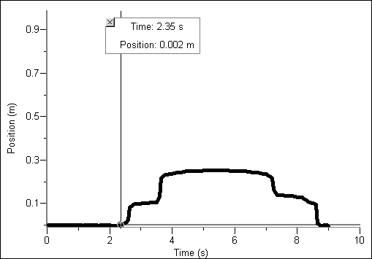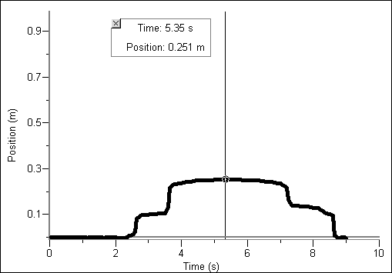

- Why is it important to move the Motion Detector slowly but at a constant speed? What would happen if you didn’t move it at a constant speed?

- What can make the Motion Detector image (or a real GPR image) of an object look different from the actual profile of the object?

- How could someone get a more complete image of the object if they used real GPR?

