Boyle’s Law: Pressure-Volume Relationship in Gases

Westminster College

The primary objective of this experiment is to determine the relationship between the pressure and volume of a confined gas. The gas we use will be air, and it will be confined in a syringe connected to a Gas Pressure Sensor (see Figure 1). When the volume of the syringe is changed by moving the piston, a change occurs in the pressure exerted by the confined gas. This pressure change will be monitored using a Gas Pressure Sensor. It is assumed that temperature will be constant throughout the experiment. Pressure and volume data pairs will be collected during this experiment and then analyzed. From the data and graph, you should be able to determine what kind of mathematical relationship exists between the pressure and volume of the confined gas. Historically, this relationship was first established by Robert Boyle in 1662 and has since been known as Boyle’s law.

OBJECTIVES
In this experiment, you will
- Use a Gas Pressure Sensor and a gas syringe to measure the pressure of an air sample at several different volumes.
- Determine the relationship between pressure and volume of the gas.
- Describe the relationship between gas pressure and volume in a mathematical equation.
- Use the results to predict the pressure at other volumes.

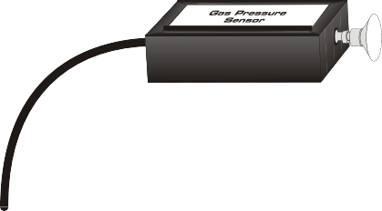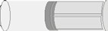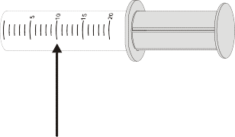
Figure 1

MATERIALS

LabQuest | Vernier Gas Pressure Sensor
LabQuest App | 20 mL gas syringe

PROCEDURE
- Prepare the Gas Pressure Sensor and an air sample for data collection.
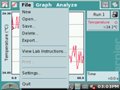
  - Connect the Gas Pressure Sensor to Channel 1 of your LabQuest. Choose New from the File menu.
File - New
File - New

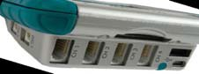
Channel

  - With the 20 mL syringe disconnected from the Gas Pressure Sensor, move the piston of the syringe until the front edge of the inside black ring (indicated by the arrow in Figure 1) is positioned at the 10.0 mL mark.
  - Attach the 20 mL syringe to the valve of the Gas Pressure Sensor.
- Set up the data-collection mode.
  - On the Meter screen, tap Mode. Change the mode to Events with Entry. (This is done by tapping the down arrow and selecting the Events with Entry option.)

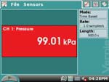
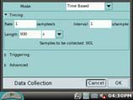
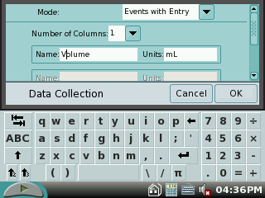
  - Use the keyboard to Then tap the OK.

enter Volume for Name and mL for Units.

- To obtain the best data possible, you will need to correct the volume readings from the syringe. Look at the syringe; its scale reports its own internal volume. However, that volume is not the total volume of trapped air in your system since there is a little bit of space inside the pressure sensor.
To account for the extra volume in the system, you will need to add 0.8 mL to your syringe readings. For example, with a 10.0 mL syringe volume, the total volume would be 10.8 mL. It is this total volume that you will need for the analysis.
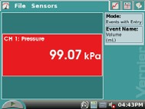
- You are now ready to collect pressure and volume data. It is easiest if one person takes care of the gas syringe and another enters volumes.
  - Start data collection by tapping the start arrow button.

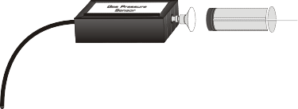
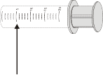
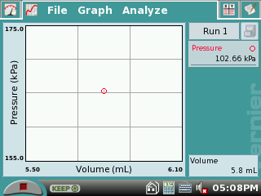
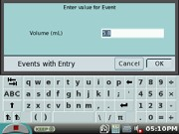
  - Move the piston so the front edge of the inside black ring (see Figure 2) is positioned at the 5.0 mL line on the syringe. Hold
the piston firmly in this position until the pressure value displayed on the
screen stabilizes. Figure 2

  - Tap Keep.

  - Then enter 5.8, the gas volume (in mL) on the screen. Remember, you are adding 0.8 mL to the volume of the syringe for the total volume. Select OK to store this pressure-volume data pair.

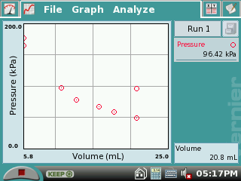
- Continue this procedure using syringe volumes of 10.0, 12.5, 15.0, 17.5, and 20.0 mL.
- Stop data collection by tapping the stop button (the red square).

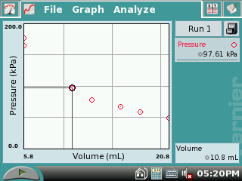
- When data collection is complete, a graph of pressure vs. volume will be displayed. To examine the data pairs on the displayed graph, tap any data point. As you tap each data point, the pressure and volume values are displayed to the right of the graph. Record the pressure and volume data values in your data table.
- Based on the graph of pressure vs. volume, decide what kind of mathematical relationship exists between these two variables.

DATA AND CALCULATIONS

Volume (mL) | Pressure (kPa) | Constant, k (P/ V or P• V)

PROCESSING THE DATA
- If the volume is doubled from 5.0 mL to 10.0 mL, what does your data show happens to the pressure

- If the volume is halved from 20.0 mL to 10.0 mL, what does your data show happens to the pressure?

