BUILDING MOLECULAR MODELS

LAB MOLECULAR GEOMETRY 1
From Sourcebook, National Science Foundation, 1997

INTRODUCTION

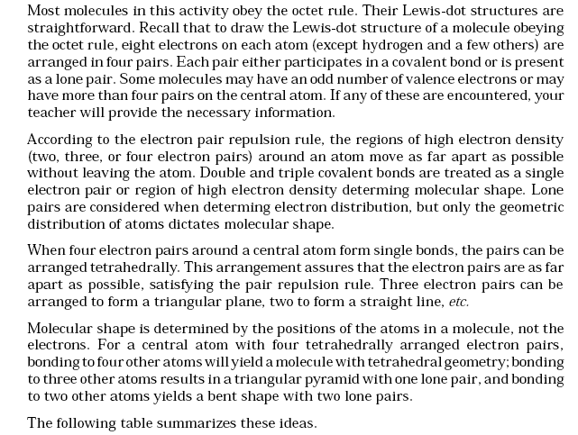

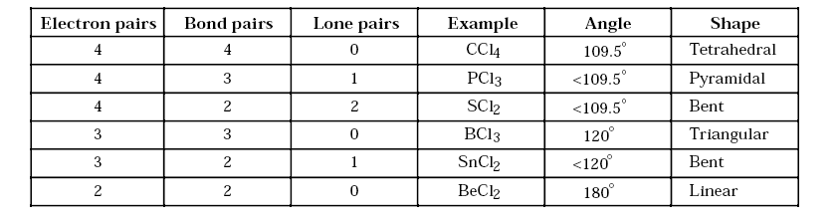

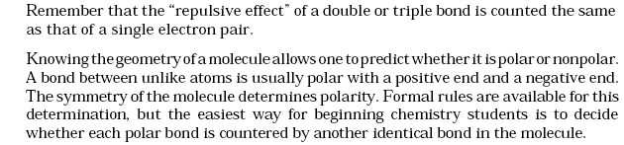
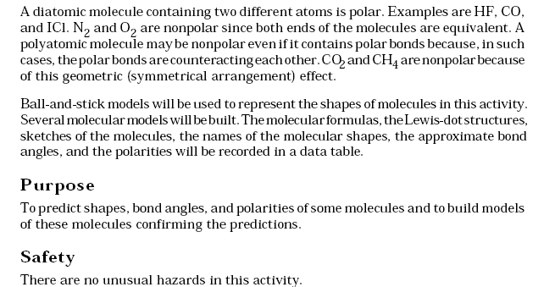

Materials
1 Molecular Visions Molecular Model Kit

