**BUILDING MOLECULAR MODELS**

**LAB MOLECULAR GEOMETRY 1**

From *Sourcebook,*  National Science Foundation, 1997

**INTRODUCTION**

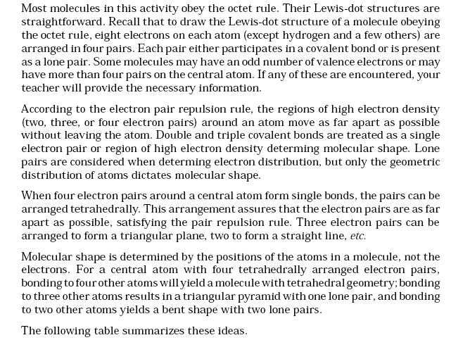

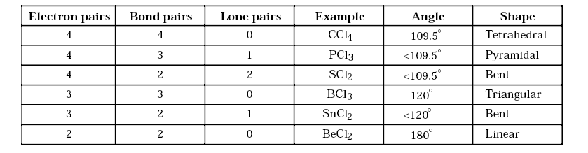

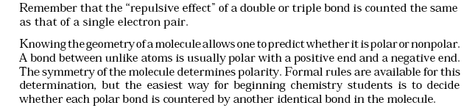

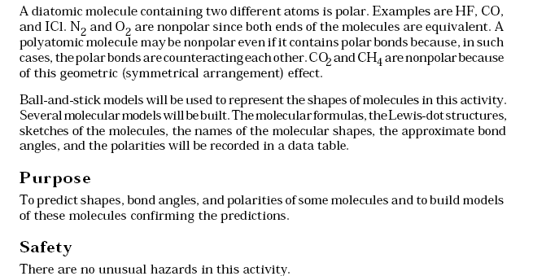

**Materials**

1 Molecular Visions Molecular Model Kit

