CATALASE ACTIVITY: EFFECT OF ENZYME CONCENTRATION

STANDARDS
- 3.3.10B - Explain cell functions and processes in terms of chemical reactions and energy changes.

Westminster College

- 3.3.12B - Identify and describe factors affecting metabolic function (e.g., temperature, acidity, hormones). Evaluate metabolic activities using experimental knowledge of enzymes.

INTRODUCTION
Many organisms can decompose hydrogen peroxide (H2O2) enzymatically. Enzymes are globular proteins, responsible for most of the chemical activities of living organisms.
They act as catalysts, substances that speed up chemical reactions without being destroyed or altered during the process. Enzymes are extremely efficient and may be used over and over again. One enzyme may catalyze thousands of reactions every second.
Both the temperature and the pH at which enzymes function are extremely important. Most organisms have a preferred temperature range in which they survive, and their enzymes most likely function best within that temperature range. If the environment of the enzyme is too acidic, or too basic, the enzyme may irreversibly denature, or unravel, until it no longer has the shape necessary for proper functioning.
H2O2 is toxic to most living organisms. Many organisms are capable of enzymatically destroying the H2O2 before it can do much damage. H2O2 can be converted to oxygen and water, as follows:
2 H2O2 ←⎯→ 2 H2O + O2
Although this reaction occurs spontaneously, enzymes increase the rate considerably. At least two different enzymes are known to catalyze this reaction: catalase, found in animals and protists, and peroxidase, found in plants. A great deal can be learned about enzymes by studying the rates of enzyme-catalyzed reactions. The rate of a chemical reaction may be studied in a number of ways including:
- measuring the rate of appearance of a product (in this case, O2, which is given off as a gas)
- measuring the rate of disappearance of substrate (in this case, H2O2)
- measuring the pressure of the product as it appears (in this case, O2).

At the start of the reaction, there is no product, and the concentration is the same as the atmosphere. After a short time, oxygen accumulates at a rather constant rate. The slope of the curve at this initial time is constant and is called the initial rate. As the peroxide is destroyed, less of it is available to react and the O2 is produced at lower rates. When no more peroxide substrate is left, O2 is no longer produced.

In this experiment, you will measure the rate of enzyme activity under various conditions, such as different enzyme concentrations, pH values, and temperatures. It is possible to measure the concentration of oxygen gas formed as H2O2 is destroyed using an O2 Gas Sensor.

GUIDING QUESTIONS
  - What is being measured as the yeast enzyme catalase breaks down the hydrogen peroxide?
  - What do you observe about the rate of the reaction when the concentration of the catalase enzyme is varied?

MATERIALS
LabQuest | enzyme suspension
LabQuest App | ice
Vernier O2 Gas Sensor | test tube rack
400 mL beaker | thermometer
10 mL graduated cylinder | three dropper pipettes
three 18 × 150 mm test tubes | Logger Pro (optional)
250 mL Nalgene bottle | 3.0% H2O2

SAFETY

The students may want to wear goggles during the lab. Hydrogen peroxide will irritate the eyes if it is accidentally splashed in them.

PROCEDURE

Part I. LabQuest Set-Up
- Connect the O2 Gas Sensor to the LabQuest via a channel port and choose New from the File menu. If you have an older sensor that does not auto-ID, manually set up the sensor. To do this manually:

  - Stay in the Meter mode and select Sensors → Sensor Setup….→. A sensor set-up screen will appear showing all the available probe ports (Fig. 1a).
  - Select the channel that the O2 Gas sensor is plugged into (ex.
Figure 1. Example of LabQuest Screens and Sensor Set-Up

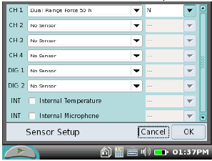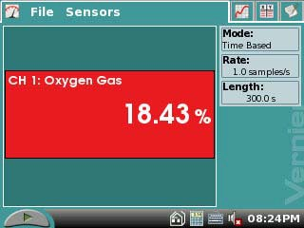
- Sensor set-up screen b. Meter mode screen

CH1 for channel 1), and tap the arrow to the side of the channel box.
  - A list of compatible probes will appear in alphabetical order. Scroll down the list and select “O2 Gas Old”. Select 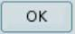 to return to the Meter mode screen.
  - A red box will now be in this window displaying the channel the O2 Gas sensor is
plugged into (Fig. 1b). The LabQuest is reading in % O2.

- To the right of the Meter screen, tap the gray Rate box. This will bring up the Data Collection screen (Fig. 2). Change the data-collection rate to 0.2 samples/second and the data-collection length to 180 seconds.

Part II Testing the Effect of Enzyme Concentration
- Place three test tubes in a rack and label them 1, 2, and 3. Fill each test tube with 5 mL of 3.0% H2O2 and 5 mL of water.
Figure 2. Data Collection Screen

- 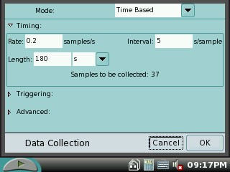Initiate the first enzyme reaction.
  - Using a clean dropper pipette, add 5 drops of enzyme suspension to the test tube labeled #1.
  - Begin timing with a stopwatch or clock.
  - Mix the contents of the tube by tapping the test tube a few times.
  - Pour the contents of the test tube into the clean 250 mL Nalgene bottle that comes with the O2 Gas Sensor.
  - Place the O2 Gas Sensor into the bottle as shown in Figure 3. Gently push the sensor down into the bottle until it stops. The sensor is designed to seal the bottle with minimal force.
  - After 30 seconds have passed, tap the Start icon to begin data collection. The LabQuest screen will change to a graph format, with Time (s) on the x-axis and O2 gas (%) on the y-axis.
  - The LabQuest will automatically stop taking data at the end of 180 seconds.

- When data collection is complete, a graph of O2 gas vs. Time(s) will be displayed. Remove the O2 Gas Sensor from the Nalgene bottle.
Rinse the bottle with water and dry with a paper towel.

- Perform a linear regression to calculate the rate of reaction. If the graph is not completely linear, tap and drag the stylus across a linear portion of the data. Gray shading on the graph will indicate the section of data that will be analyzed using the following steps.
  - While still in the Graph mode , choose Curve Fit from the Analyze menu.
  - Select Linear for the Fit Equation. The linear- regression statistics for these two data columns are displayed for the equation in the form
y = mx + b
  - Enter the absolute value of the slope, m, as the reaction rate in Table I.
  - Select .
  - Store the data from the first run by tapping the File Cabinet icon to the right of the screen.
Figure 3. Set-up of O2
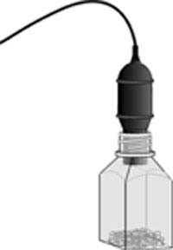sensor and Nalgene bottle for catalase reactions.

- Tap the Table icon at the top of the screen. Choose Clear All Data from the Table menu. Select when prompted.

- Tap the Graph icon to display the graph again.

- Find the rate of enzyme activity for test tubes 2, and 3:
  - Add 10 drops of the enzyme solution to test tube #2. Repeat Steps 4b-8.
  - Remember to store the data from the second run by tapping the File Cabinet icon to the right of the screen.
c. Add 20 drops of the enzyme solution to test tube 3. Repeat Steps 4b–8. This reaction may start almost immediately, so you do not have to wait for 30 seconds before tapping the Start icon to begin data collection.
d. Remember to store the data from the third run by tapping the File Cabinet icon to the right of the screen.
- Graph all three runs of data on a single graph.
  - Tap the gray Run 3 box at the right of the screen, and select All Runs from the drop down menu. All three runs will now be displayed on the same graph axes.
  - Use the displayed graph and the data in Table 3 to answer the questions for Part II.

REFERENCES
The College Board Advanced Placement Program. Biology Lab Manual for Students. Lab Two: Enzyme Catalysis. ♥ 2001 by the College Examination Board. Pp. 19-28.

The College Board Advanced Placement Program. Biology Lab Manual for Teachers. Lab Two: Enzyme Catalysis. ♥ 2001 by the College Examination Board. Pp. 11-18.

Kelly Redding and David Masterman. Advanced Biology with Vernier. (2008) Enzyme Action: Testing Catalase Activity (Method 1-O2). Vernier Software & Technology; 13979 S.W. Millikan Way, Beaverton, OR pp. 2-1(O2) to 2-6(O2), 2T-1(O2) to 2T- 3(O2).

CREDITS
Special thanks to Rebecca Finch at Seneca Valley High School for testing, editing and reviewing this revised protocol. The lab was revised and adapted from the above references by Dr. Stephanie Corrette-Bennett.

DATA SHEET

Name: Group: Date:

Effect of Enzyme Concentration

Table I
Test tube label | Slope, or rate (% O2/s)
5 Drops
10 Drops
20 Drops

QUESTIONS

- How does changing the concentration of enzyme affect the rate of decomposition of H2O2?

- If you increase the concentration of enzyme to 25 drops, what do you think will happen to the rate of reaction? Predict what the rate would be for 30 drops.

