CELL RESPIRATION: MEASURING CONCENTRATIONS OF CO2 AND O2

STANDARDS
• 3.1.12C

• 3.2.10A, 3.2.10B
• 3.3.10A, 3.3.10B
• 3.7.10A, 3.7.10B
- 3.1.9-12.G

INTRODUCTION

Westminster College

Aerobic cellular respiration is the release of energy from organic compounds by metabolic chemical oxidation in the mitochondria within each cell. Cellular respiration involves a series of enzyme-mediated reactions. All organisms, including plants and animals, oxidize glucose for energy. Often, this energy is used to convert ADP and phosphate into ATP. It is known that peas undergo cell respiration during germination.
The equation below shows the complete oxidation of glucose. Oxygen is required for this energy-releasing process to occur.
C6H12O6 + 6 O2(g) ←⎯→ 6 H2O + 6 CO2(g) + 686 kilocalories of energy/mole glucose oxidized
By studying the equation above, you will notice there are three ways cellular respiration could be measured. One could measure the:
- Consumption of O2
- Production of CO2
- Release of energy during cellular respiration
Using a CO2 and an O2 Gas Sensor, you will monitor the carbon dioxide produced by peas during cell respiration. Both germinated and non-germinated peas will be tested. Additionally, cell respiration of the germinated peas at two different temperatures will be tested.

GUIDING QUESTIONS
- How do dormancy and germination affect respiration rate?
- How does the rate of cellular respiration relate to the activity in a cell?
- What effect does temperature have on respiration rate?
- How does the detection of CO2 and O2 relate to cell respiration?

MATERIALS
LabQuest | BioChamber 250
LabQuest App | ice cubes
Vernier CO2 Gas Sensor | two 100 mL beakers
Vernier O2 Gas Sensor | thermometer
25 germinated peas | paper towels
25 non-germinated peas

PROCEDURE

Part I Germinated and Non-Germinated Peas at Room Temperature

- If your CO2 Gas Sensor has a switch, set it to the Low (0–10,000 ppm) setting. Connect the O2 Gas Sensor and the CO2 Gas Sensor to LabQuest using the Channel ports on the top of the LabQuest. It does not matter which sensor goes into which port.
- Choose New from the

File menu. If you have an older sensor that does not auto-ID, manually set up the sensor. To do this manually:

  - Stay in the Meter mode and select Sensors → Sensor Setup….→. A sensor set-up screen will
Figure 1. Example of LabQuest Screens and Sensor Set-Up

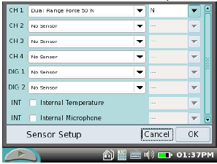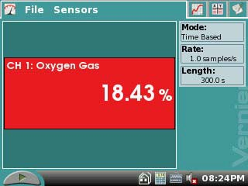
- Sensor set-up screen b. Meter mode screen

appear showing all the available probe ports (Fig. 1a).
- Select the channel that the O2 Gas sensor is plugged into (ex. CH1 for channel 1), and tap the arrow to the side of the channel box.
- A list of compatible probes will appear in alphabetical order. Scroll down the list and select “O2 Gas Old”. Select to return to the Meter mode screen.
- Repeat this procedure (1a.-c.) for the other channel if the CO2 sensor is not
detected automatically.
- A red and blue box will now be in this window displaying the channel the O2 and CO2 sensors are plugged into (Fig. 1b). The LabQuest is reading in % O2 and CO2 (ppm).

- (Optional) For comparison reasons, you might want to have both sensors read in the same units. Tap the CO2 box on the Meter screen (red or blue, depending on which channel port it is in). Choose Change Units
→ ppt. Do the same for the O2 sensor, selecting ppt as the measurement unit.
Figure 2. Data Collection Screen

- 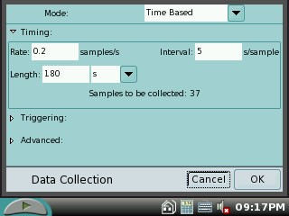To the right of the Meter screen, check the gray
Length box to see if it is reading 300 seconds (s). If not, tap the Length box. This will bring up the Data Collection screen (Fig. 2). Change the data-collection length to
300 seconds using the touch keypad. Select to return to the Meter mode screen when you are finished.

- Measure the room temperature using a thermometer and record the temperature in Table 1.

- Obtain 25 germinated peas and blot them dry between two pieces of paper towel.

- Place the germinated peas into the respiration chamber.

- Place the O2 Gas Sensor into the BioChamber 250 as shown in Figure 3. Insert the sensor snugly. The O2 Gas Sensor should remain vertical throughout the experiment. Place the CO2 Gas Sensor into the neck of the BioChamber 250, supported by the Styrofoam block underneath it.
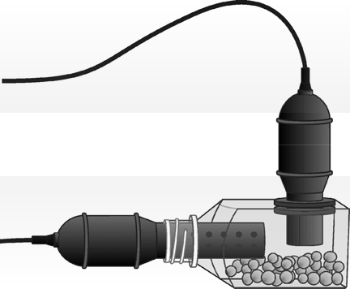Figure 3. Set-up of BioChamber with the CO2 and O2 gas sensors.

CO2 sensor.
O2 sensor.

Styrofoam support

- Wait two minutes, and then tap the Start icon to begin data collection. The LabQuest screen will go to the Graph mode , and will display a separate graph for both the CO2 and O2 sensors vs. time. Data will be collected for 5 minutes. The LabQuest will automatically stop taking data after this time.

- When data collection has finished, two separate graphs will be displayed; one of CO2
vs. time(s) and the other of % O2 vs. time(s).

- Remove the sensors from the respiration chamber. Place the peas in a 100 mL beaker filled with cold water and an ice cube.

- Use a notebook or notepad to fan air across the openings in the probe shaft of the CO2 Gas Sensor for 1 minute. Do not skip this step!

- Perform a linear regression to calculate the rate of respiration. If the entire data set is not linear, press and drag the stylus across a linear portion of the curve. A gray-shaded section will appear; this is the portion of the graph that will be analyzed.
  - While still in the Graph mode , choose Curve Fit from the Analyze menu.
  - Select Linear for the Fit Equation. The linear-regression statistics for these two data columns are displayed for the equation in the form

y = mx + b

where x is time, y is O2 or CO2 concentration, m is the slope, and b is the y- intercept.
  - Enter the slope, m, as the rate of respiration in Table 2.
  - Select .
- Store the data from the first run by tapping the File Cabinet icon to the right of the screen. The screen will clear and be ready to take data for your second experimental trial.

- Repeat Steps 4–13 substituting the germinated peas with non-germinated peas. In Step 10 place the non-germinated peas on a paper towel and not in the ice bath.

Part II Germinated Peas at Cool Temperatures
- Remove the peas from the cold water and blot them dry between two paper towels.

- Measure the temperature of the cold water and record it in Table 1. Repeat Steps 4– 12 using the cold peas. When you have completed Step 12 skip directly to Step 17.

- Graph all three runs of data on a single graph.
  - To view a graph of all three data runs, tap Run 3 and select All Runs. This will display all the data for both the CO2 and the O2 graphs.
  - All three runs will now be displayed on the same graph axes.
  - Use the displayed graphs and Tables 1 and 2 to answer the questions below.

REFERENCES
The College Board Advanced Placement Program. Biology Lab Manual for Students. Lab Five: Cell Respiration. ♥ 2001 by the College Examination Board. Pp. 54-63.

The College Board Advanced Placement Program. Biology Lab Manual for Teachers. Lab Five: Cell Respiration. ♥ 2001 by the College Examination Board. Pp. 35-39.

Kelly Redding and David Masterman. Advanced Biology with Vernier. (2008) Cell Respiration (Method 1 – CO2 and O2. Vernier Software & Technology; 13979 S.W. Millikan Way, Beaverton, OR pp. 5-1 to 5-4(CO2 and O2); 5-1T to 5-3T(CO2 and O2).

CREDITS
Special thanks to John Thompson of Neshannock High School, Neshannock Township, PA and Kim Schmidtke, Portersville Christian School, Portersville, PA for testing, editing and reviewing this protocol. This lab was revised and adapted from the above references by Dr. Stephanie Corrette-Bennett.

DATA SHEET

Name: Group: Date:

Table 1
Condition | Temperature (°C)
Room
Cold

Table 2
Peas | O2  Rate of respiration (%/s) | CO2  Rate of respiration (ppm/s)
Germinated, rm T
Germinated, cold
Non-germinated, rm T

DATA ANALYSIS
- Do you have evidence that cell respiration occurred in peas? Explain.

- What is the effect of germination on the rate of cell respiration in peas?

- What is the effect of temperature on the rate of cell respiration in peas?

- Why do germinated peas undergo cell respiration?

- Why do germinated peas undergo cell respiration? Design an experiment to examine the rates of cellular respiration with peas that have been germinating for different lengths of time: 0, 24, 48, and 72 hours. What results would you predict? Why?

- If you used the same experimental design to compare the rates of respiration of a 25g reptile and a 25g mammal at 10°C, what results would you expect? Explain.

