COMPARING SUNSCREENS BY ABSORPTION OF UV LIGHT

From Science with Handhelds, Vernier Software

INTRODUCTION

Sunscreens are available in many different types and with many different levels of protection. The most common measure of protection from UVB light is the SPF factor. SPF, or sun protection factor, describes the increased amount of time you can be in the sun before your skin starts to burn. For example, a sunscreen labeled SPF 8 means that you can be out in the sun eight times longer before burning than you would without using any protection. Products range from SPF 0 to SPF 50 or higher. But is SPF 50 really twice as protective as SPF 25? You will perform an experiment that will help answer that question.
Figure 1 shows the location of UV light in the electromagnetic spectrum. Notice that the ultraviolet band is broken into three types referred to as UVA, UVB, and UVC. The most harmful of these three, UVC light, is absorbed by the atmosphere and does not reach the Earth’s surface. UVA light is deep-penetrating and causes tanning, wrinkles, and some forms of skin cancer. UVB light is also responsible for many skin problems such as sunburns and several forms of skin cancer.
In this experiment, you will measure the amount of UVB light that passes through various sunscreens. You will then compare it with the amount of UVB light from direct sun and analyze the relationship between them.
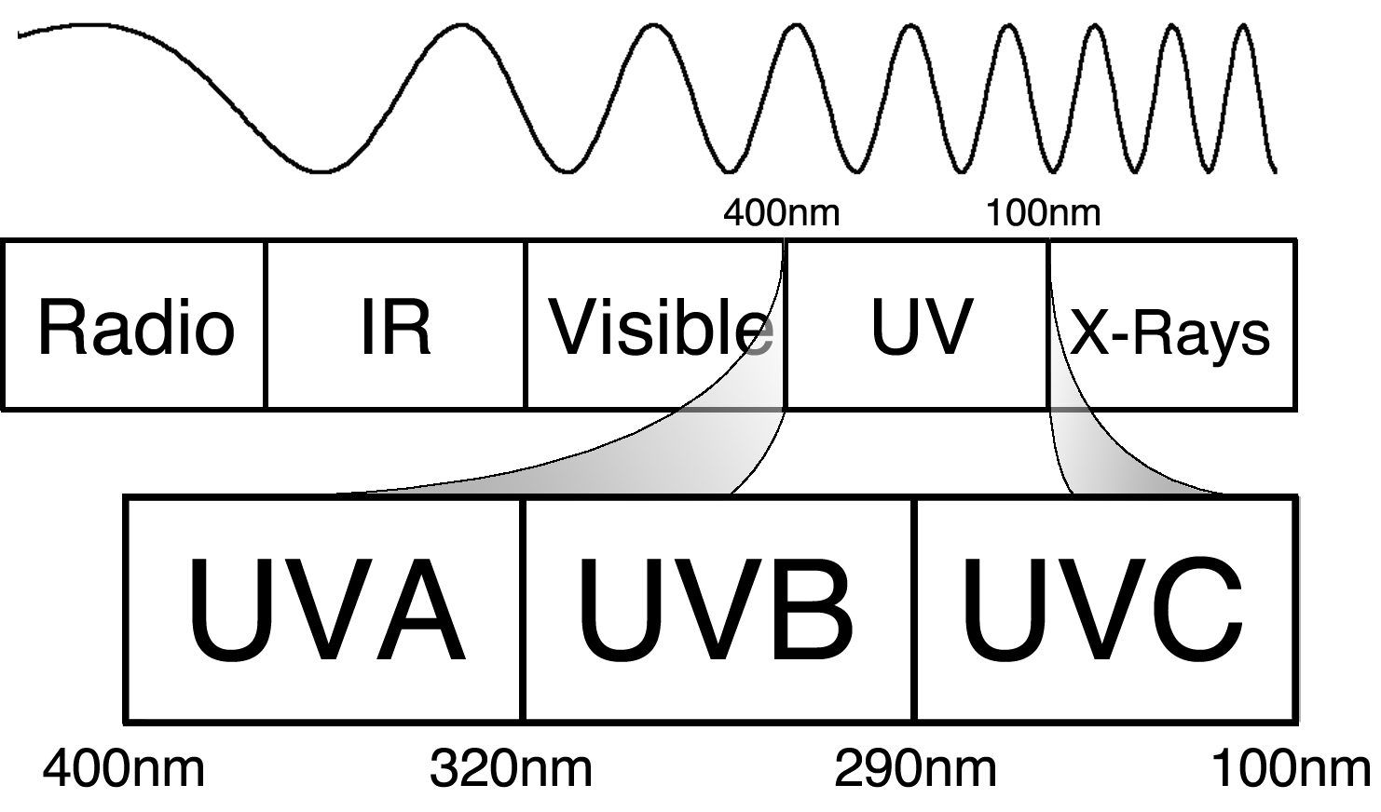
Figure 1
OBJECTIVES
In this experiment, you will
- Use a UVB Sensor to measure UVB light.
- Determine the amount of UVB light allowed through five different sunscreens.
- Analyze the trend of UVB light vs. SPF values.

MATERIALS
LabPro interface | ring stand and clamp
Palm handheld | selection of sunscreens
Data Pro program | two 4 x 6 inch index cards
UVB Sensor | empty film canister
quarter | scissors
tape | plastic wrap

Westminster College SIM
Comparing Sunscreens

PRE-LAB PROCEDURE
1. Obtain the five different sunscreens assigned by your teacher.
2. In the spaces provided on the Data Table, fill in the SPF values, brand names, additional notes, and price per ounce.
PROCEDURE
1. Prepare your test cards.
- Obtain two 4 x 6 inch index cards.
- Using a quarter as your guide, draw three circles on each test card as shown in Figure 2.
- Use scissors to cut out the circles.
- On one test card, label the circle on the left as your control.
- Using both test cards, label the remaining five circles with the SPF values of your five assigned sunscreens. Move from left to right and begin with the lowest SPF value. Note: Your SPF values may be different from those shown in Figure 2.
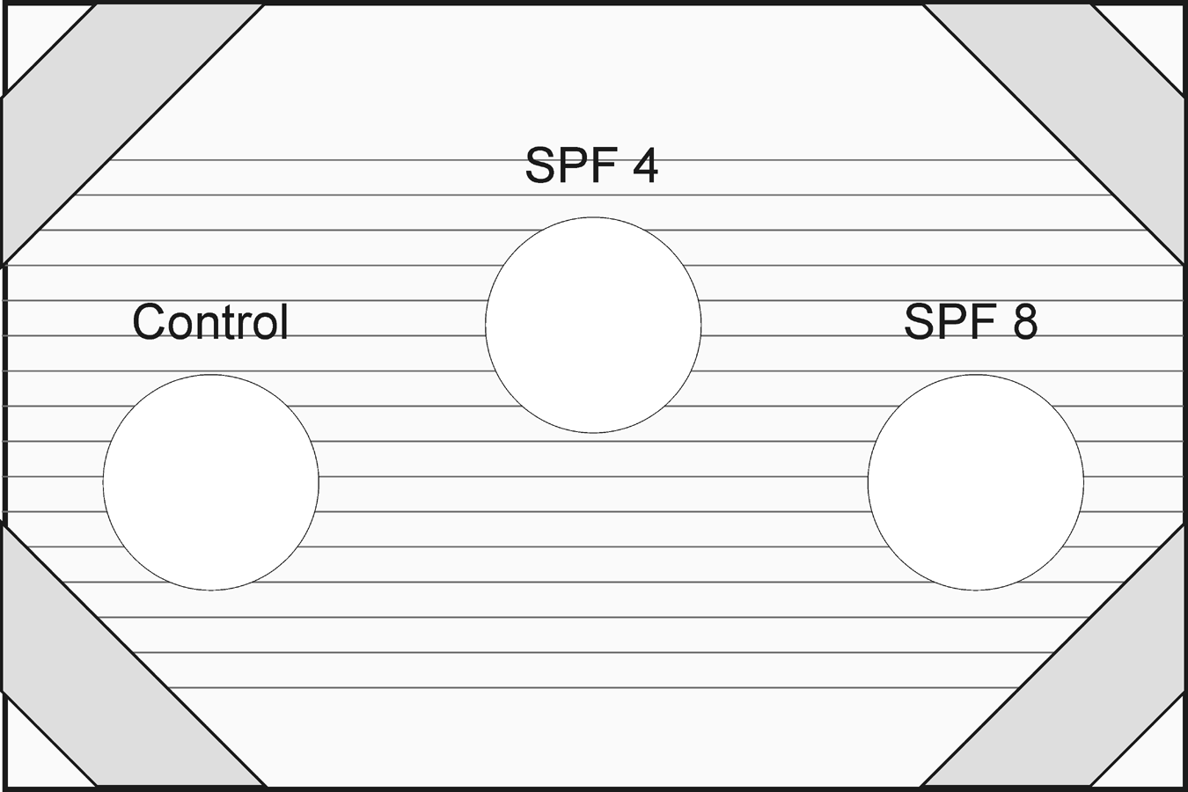
Figure 2
2. Cover the test cards with plastic wrap.
- Cut out a 4 x 6 inch piece of plastic wrap. The person who does this should have clean hands with no sunscreen or lotion on them.
- Lay the plastic wrap neatly on top of one of the test cards. Try to keep the plastic wrap flat so it is not wrinkled, but do not stretch it.
- Tape the four corners as shown in Figure 2.
- Repeat Steps a – c for the second test card.

3. Apply the sunscreens to the test cards.
- Place the first test card in front of you with the plastic side facing up.
- The circle labeled “control” should be kept clean. It will be used to measure the effect of the plastic wrap by itself.
- Starting with the sunscreen that has the lowest SPF, squeeze a very small amount of sunscreen on your finger.
- Spread the sunscreen thinly and evenly over the appropriate circle on the plastic wrap.
- Wipe off your finger well with a paper towel.
- Repeat Steps b – e for all the remaining sunscreens.
- Let the sunscreens dry while you complete Steps 4 – 10.

Westminster College SIM

Comparing Sunscreens
4. If you are not already outside, gather all of your equipment and go outside at this time.
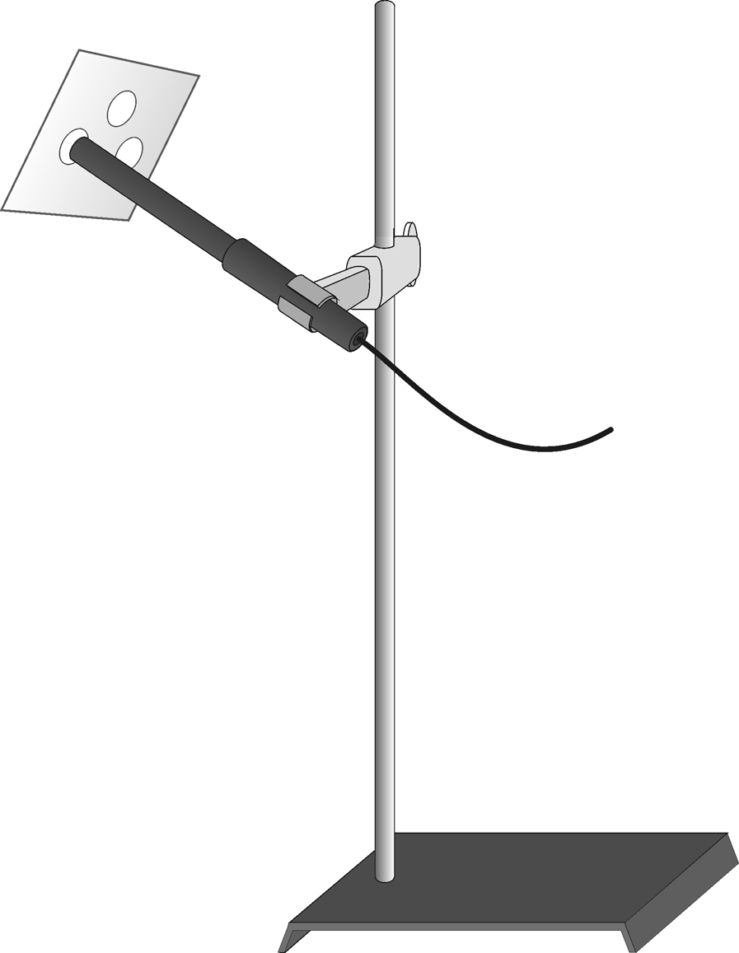
5. Plug the UVB Sensor into Channel 1 of the LabPro interface. Connect the handheld to the LabPro using the interface cable. Firmly press in the cable ends.
6. Use the shadow of the UVB Sensor to aim it correctly without looking directly at the sun.
- Hold the sensor with your thumb and first finger, pointing the sensor in the general direction of the sun.
- Find the sensor’s shadow and observe how it changes shape as you move the sensor around.
- Move the sensor around until the shadow becomes a small round circle. This indicates that the sensor is now pointing directly at the sun.
- Keeping this sensor orientation in mind, clamp the UVB Sensor onto the ring stand as shown in Figure 3.
- Once the sensor is securely on the ring stand, use the shadow again to make final adjustments to assure that the sensor is pointing directly at the sun.
7. Press the power button on the handheld to turn it on. To start Data Pro, tap the Data Pro icon on the Applications screen. Choose New from the Data Pro menu or tap to reset the program.
8. Set up the handheld and interface for data collection.
- On the Setup screen, tap , then choose Events with Entry.
- Enter the Entry Label (SPF) and leave the Unit field blank. You can enter this information using the onscreen keyboard (tap “abc”), or by using the Graffiti writing area.
- Tap twice to return to the Main screen.
9. You are now ready to collect UVB data.
- Tap to begin data collection.
- Hold the test card with the control over the tip of the UVB Sensor. Important: The side with the sunscreen should be facing out, away from the sensor. Sunscreen should never come in contact with the UVB Sensor. It is okay if the plastic lightly touches the tip of the sensor.
- When the reading has stabilized, tap and enter “0”(for SPF 0) using the numerical keyboard displayed on the screen. Tap . The first data pair has now been saved.
- Repeat Steps b – c for each of the five sunscreens typing in their SPF values when prompted.
- Tap when you have finished collecting data, then tap to view a graph of light intensity vs. SPF value.

Westminster College SIM
Comparing Sunscreens
10. To examine the data pairs on the displayed graph, tap or any data point. As you move the examine line, the light intensity and SPF values of each data point are displayed to the right of the graph. Record the UVB light values in the Data Table.
11. Print a copy of your graph or make a sketch of it as directed by your teacher.
DATA
SPF value  on label | UVB intensity (mW/m²) | Brand name  (e.g., Coppertone) | Additional notes on label (e.g., waterproof) | Price per ounce ($)
SPF 0 (Control) |  | N/A | N/A | N/A

PROCESSING THE DATA
1. Study your graph. Describe its shape in relation to how the UVB light intensity changed with different SPF values.

2. According to your data, would a sunscreen labeled SPF 50 block twice as much
UVB light as SPF 25? Explain why or why not.

Westminster College SIM
Comparing Sunscreens

3. According to your data, did the price per ounce or any other factors such as being “waterproof” have any effect on the UVB measurements? Explain.

EXTENSIONS
1. Test a wider variety of sunscreens to confirm or deny your conclusions above.
2. UVA light is not only responsible for tanning your skin, but for wrinkles, cataracts and some types of cancer as well. If you have a Vernier UVA Sensor, test the same sunscreens for their degree of UVA protection.

