CONSERVATION OF ANGULAR MOMENTUM
For textbook compatibility:

LAB MECH 26.COMP

INTRODUCTION
"rotational inertia" and "moment of inertia" are synonyms.

For rotational motion, as with linear motion, conservation of momentum is an important and useful principle. For a mass system rotating about an axis with no external forces acting and dissipative forces negligible (a reasonably well-isolated system), angular momentum is conserved as the system's mass distribution changes or as parts of the system undergo various interactions with each other.

With the angular momentum represented by the vector L, and no outside forces acting (no external torque) then L = constant (or dL/dt = 0). Now angular momentum can be expressed as the rotational inertia, I, times the angular velocity, ω (that is, L = I·ω). At a point on the wheel a distance R from the center of rotation, the angular velocity equals the point’s linear (or tangential) velocity divided by this radius R  ω = v/R, so that
L = I·v/R.

For a mass that can be considered concentrated at a specific distance R from the center of rotation, the rotational inertia, I, is the mass, m, times the radius squared  I = m·R2.
Therefore, substituting for I above, we can say that the angular momentum of the rotating

mass is L = m·v·R.

For a rotating non-concentrated mass (not a single R) an equivalent rotational inertia, Isys ('sys' meaning system) can be expressed for the rotating body where L= I sys·ω. Conservation of angular momentum can be expressed as Lf = Li , or better yet as Isys,f ·ωf = I sys,i ·ωi , where the subscripts f and i distinguish final and initial values.

Part I finding Iwheel (see endnote for alternative method.)-- To obtain the value Isys,i for the rather complicated mass distribution of this experiment (a bicycle wheel), an initial torque experiment is to be performed. To obtain Isys,i of the bicycle wheel, the wheel must be mounted to rotate in a

Fig. 1
Bicycle wheel

R
T

T

m

mg

vertical plane instead of a horizontal plane as it will be for the "conservation of angular momentum" part of the experiment. The torque acting on the wheel is expressed
Τnet = R x Fnet, which for Fig. 1, would be Τnet = R x T. Given the right angle between
the cloth and wheel, we work with magnitudes simply as Τnet = R·T. Similarly, the torque’s magnitude can be expressed as
Torque note: You might think that the force applied to the wheel would be the weight of the falling mass. However, for m to accelerate, the upward force on it, T, must be less than the downward force, mg. The net force on the falling mass is:
Fnet = m·a = m·g – T.

So finally, T = m•g – m•a = m(g – a).
rotational inertia, Iwheel, times angular acceleration, α, written Τnet = Iwheel · α.

For a point on the wheel located a distance R from the center of rotation, the tangential acceleration, a, is a = R · α, and α = a / R.

We equate the two torque formulas — R·T = Iwheel ·α — then substituting for T and α
(T = m(g – a)and α = a / R), we get  R· m(g – a) = Iwheel · a / R.

Finally, we've created something we can solve for Iwheel, the rotational inertial of the bicycle wheel, the goal of Part I. (…which we'll need in order to investigate the conservation of angular momentum in Part II.)

The conclusion of Part I Iwheel = R2 · m(g - a)/a Eq. (1).

Part II discussion—We now create a collision to study—with both "before" and "after," and we need to know the wheel’s rotational inertia, as found in Part I. With the wheel rotating—horizontally now—at a rather constant rate, a mass m´´ is dropped onto the wheel near it’s outer circumference.

Our collision: We will be dropping a bag filled with lead shot onto the wheel. As this bag travels around on the rotating wheel, it may be treated mathematically as a hollow thick- walled cylinder rotating around the wheel’s axis. The rotational inertia of this “addition” to the wheel is calculated by formula:
Im´´ = ½m´´ (r1´´2 + r2´´2)
´´

r1 is the inner radius (axis to closest part of

The entire rotating system’s initial rotational inertia includes both that of the bicycle wheel and that of the very small
the mass) and r2´´ is the outer radius (axis to farthest part of the mass).

mass rotation position indicator (with clamp), whose mass we’ll call m´. The indicator’s rotational inertia will be the product of its mass, m´, and the square of its distance from the axis of rotation, r´. So, the rotational inertia of the system is expressed:
Initial I  Isys,i = Iwheel + Iindicator = R2·m(g – a)/a + m´·r´2 Eq. (2).
Therefore, the initial angular momentum may be obtained—the product of this measurable system’s initial rotational inertia and the experimentally determined horizontal rotational velocity:
Initial L  Li = Isys,i ·ωi.
The system’s final rotational inertia, Isys,f, should be the initial value, Isys,ι, plus the rotational inertia of the dropped mass, Im´´.

Final I  Isys,f = R2·m(g – a)/a + m´r´2 + ½m´´ (r1´´2 + r2´´2). Eq. (3).
Conservation of angular momentum of our system means this:
Lf = Li
or Isys,f ·ωf = Isys,i ·ωi. [since L = I·ω]
So, with the computer and photogate, the speeds νi and νf of the position indicator can be determined (before and after the bag drop). We calculate ωi and ωf [note ω = v /r], and then use with equations 2 and 3 above to calculate and compare final and initial angular momenta. Ideally, Isys,f ·vf /R´ = Isys,i ·vi /R´ Eq. (4).

Use the diagram (an overhead view) here to identify/relate masses and radii: Keeping track of m's and r's will be a challenge, but done with care, will ensure reasonable results.

M, R bicycle wheel (R to outer circumference) R M
m´, r´ rotation pos. indicator (r´ to m´ center)
m´´, r1´´, r2´´ bag of lead shot r1´´
R´ rotation pos. indicator's "trigger" to center m´´ r´

r2´´ m´
(note: any of R´, r´, r1′′ and r2´´ may or may not be equal to R)

PURPOSE
Our "collision" is in the plane of the wheel, the vertical motion of the falling shot being ignored.

- To determine the rotational inertia of a bicycle wheel.
- To study conservation of angular momentum in a system consisting of a rotating bicycle wheel and a bag of lead shot as the wheel and the shot "collide."

MATERIALS

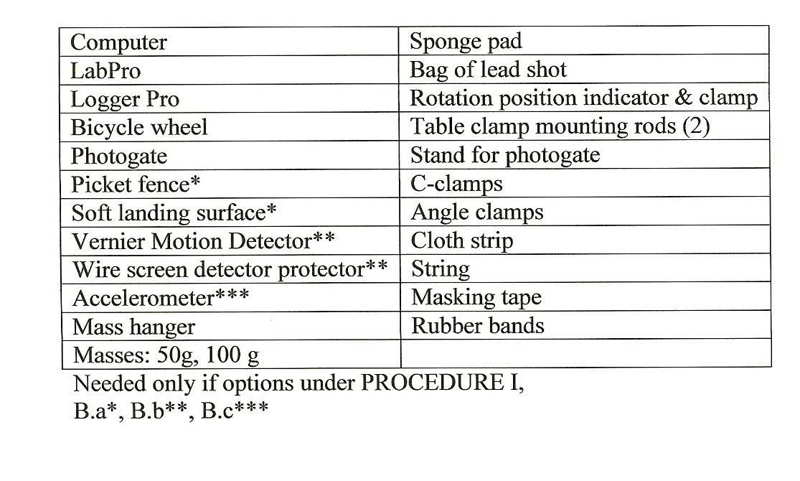
Spo

Conservation of Angular Momentum
PRELIMINARY QUESTIONS

  - Explain how a significant amount of friction in the axle bearing would affect the experiment, and particularly the conservation of the angular momentum.

  - What is the radial velocity of a point on the outer circumference of the rotating bicycle wheel? How does radial velocity differ from tangential velocity?

  - Why does it make sense that for a hoop or cylindrical shell, solid disc or cylinder, and solid sphere, respectively; the rotational inertias, measured about the centers of mass and/or axes, are MR2, 1/2MR2, and 2/5MR2?
(where M is the body’s mass and R is its radius)

  - Explain how it makes sense that angular momentum is a vector quantity. Explain how angular momentum relates to the relative upright stability one experiences when riding a moving bicycle compared to balancing on a stopped bicycle? (…and how might the type/thickness of the wheels and tires influence this stability?)

PROCEDURE I

Collect data to determine the rotational inertia of the bicycle wheel.(See Endnote--last page for alternate method.)

  - Set up the bicycle wheel to rotate in a vertical plane. Do not attach the rotation position indicator to the wheel. Be sure that the cloth strip is in place about the wheel perimeter. The wheel should be far enough above the floor to provide space for the mass attached to the cloth strip to move downward and accelerate the rotation of the wheel.

  - Determine acceleration caused by a known torque : The acceleration, a, is obtained by using one (or more!) of the following tools:
    - Photogate:
Equipment notes: To avoid damage to the picket fence, place a soft landing surface below. The photogate should be mounted so that the plane of the picket fence as it falls is approximately perpendicular to the photobeam.
      - Use the Physics with Computers “5. Picket Fence Free Fall” preset file.
      - Attach the picket fence plastic strip plus a 100-g mass to end of the cloth strip, with the top end of the picket fence at about the height of the wheel axle.
      - Allow it to fall through a photogate placed just below the initial hanging plastic strip.
      - Click Collect to initialize the photogate. Release the picket fence, allowing it to fall and cause the wheel to rotate.
      - Examine the velocity versus time graph and fit a straight line to the quite constant slope of the
region of acceleration. Record the falling mass value and the acceleration in DATA TABLE I. Repeat this activity in order to obtain three trials.

    - Motion Detector:
- Place the wire screen protector over the detector .
- The height of fall should be large enough to obtain adequate data to before coming within about 0.40 m of the detector (or
0.15 m if a “new design” Vernier Motion Detector).
- The path between the falling mass and the detector must be open enough so that undesired reflections from other surfaces won't confuse the detector.

      - Use the Physics with Computers
“6. Ball Toss” preset file.
      - To the end of the cloth strip, attach a 200-g mass, holding it initially at about the height of the wheel's axle and directly above the Vernier Motion Detector on the floor below.
      - Click Collect to initiate data collection. As soon as the clicking of the motion detector is heard, release the mass, allowing it to fall and cause the wheel to rotate.
      - Examine the velocity versus time
graph and fit a straight line to the constant slope of the region of acceleration. The slope of this region of increasing (downward) velocity is the mass's acceleration. Record the falling mass value and the acceleration in DATA TABLE I. Repeat this activity in order to obtain three trials.

    - Accelerometer:

      - Use the Physics with Computers “7. Bungee Jump Acceleration” preset file.
      - To the end of the cloth strip, attach a 150-g mass, that has an accelerometer secured to it.
It is important to have the accelerometer properly oriented to measure vertical acceleration properly.
Its direction-indicating arrow should be pointing vertically downward.
      - Hold the mass initially at about the height of the wheel's axle.
      - Click to define this non-moving state as a state of zero acceleration.
      - Scan a region of the acceleration versus time graph and click the button . The result should be a near-zero acceleration value. You are now prepared for the mass to fall.
      - Click Collect , and then release the mass, allowing it to fall and cause the wheel to rotate.
      - Scan a rather constant acceleration (slope) region of the acceleration versus time graph, and click . Record the falling mass value and the mean acceleration in DATA TABLE I. Repeat this activity to obtain three trials.

DATA TABLE I

Data/Results for determining rotational inertia of the bicycle wheel

Measurement option or options used:

Radius of wheel, R
m

Option |  | Ba Photogate | Bb Motion Sensor | Bc Accelerometer
falling mass, m (kg)
Acceleration, a (m/s2) | Trial 1
 | Trial 2
 | Trial 3
 | Mean
 | Average of trials' mean accelerations

Wheel's Rotational Inertia (calculated), Iwheel (kg·m2)

ANALYSIS I

  - Measure and record R in DATA TABLE I.
Whether you do one, or two, or three of the options; record the measured average accelerations. Compute the averages and if more than one option (the average of the averages) then compute the rotational inertial Iwheel of the bike wheel according to Eq. (1) and record in DATA TABLE I.

PROCEDURE II

Collect data to investigate the conservation of angular momentum of objects interacting within a closed system.

  - Arrange the wheel to rotate in the horizontal plane. Remove the cloth strip and attach the rotation position indicator with the annular “hose” clamp. Place the mounted photogate so that the indicator will move through the photogate, interrupting its beam with each wheel rotation.

  - Create and measure the interaction between the rotating wheel and (initially) non- rotating bag of lead shot. It is recommended that you do one or more trial runs to develop reasonable technique before your actual recorded first run. Proceed with the following.

- Initialize the Physics with Computers “5. Picket Fence Free Fall” preset file. To appropriately scale the distance versus time graph, the time scale value of 0.22 s should be changed to 22.0 s.

- Start the wheel rotating.

The use of the 3 intervals before & 3 intervals after depend on the mass being dropped onto the wheel very close to the time at which the fourth point is being recorded (as the position indicator is about to move through the photobeam).
Some region fitting adjustment may be required to find the “best” before and after slopes.

- Click Collect to initiate the collection of photogate data.

- Observe the distance versus time graph with a data point appearing with each rotation. After three graph-indicated rotations and just before the fourth data point is to be recorded, drop the “added” mass, m´´, (the lead shot bag) onto the spinning wheel toward the outside of the wheel but short of the photogate.

- After a few more rotations, click
to end data collection.

- On this 7-point graph, the slope of the first 4 points (first 3 intervals) yields the initial velocity. The slope of the last 4 points (last 3 intervals) yields the final velocity. Fit each region with a constant slope, and record these velocity values in DATA TABLE II. (See “box” above.)

- Measure the distances, r1´´ and r2´´, from the axis of rotation to the near and far edges, respectively, of the lead shot bag. Record these values in DATA TABLE II.

- Repeat the above procedure for trials 2 and 3.

DATA TABLE II

Data for Investigation of Angular Momentum Conservation
Rotational Speeds and Shot Bag Rotational Inertia

Trial
Slope, m, from Distance Graph (scaled m/s)

† Indicator Linear Speed (m/s)

Wheel Rotational Speed
ω (s-1)
Shot Bag Positional Radii
(m)
Shot Bag Rotational Inertia, Im´´ (kg·m2)
Inner
r1´´
Outer
r2´´

1
before bag drop
after bag drop

2
before bag drop
after bag drop

3
before bag drop
after bag drop

† Indicator Linear Speed = 32.66 x slope, m, from distance graph

Radii and Masses
Radius (m) | Wheel  R | Rotation Position Indicator Center of Mass  r´ | Rotation Position Indicator photocell Trigger R´ | Mass (kg) | Rotation Position Indicator and Clamp  m´ | Lead Shot Bag  m´´

Rotational Inertias & Angular Momenta
Trial | Rotational Inertia |  | Angular Momentum |  | %Change of Angular Momentum
 | Initial, Isys,ι  (kg-m2) | Final, Isys, f  (kg-m2) | Initial, Lsys, i  (kg-m2/s) | Final, Lsys, f  (kg-m2/s)
1
2
3

ANALYSIS II

  - Measure and record the values of R, r′,R′, m′, and m′′ in DATA TABLE II.

  - The “nominal slope values obtained according to the preceding Step 6 are based on the programmed-in picket fence spacings of 0.05 m. Proceed to compute and then record the indicator linear speed column values in DATA TABLE II by multiplying the “nominal” slope by 2πR′ and dividing by 0.05 m. For R′=0.26m (that of our trial runs) the multiplication factor is 32.66 (2π•0.26m/0.05) times “nominal” slope values to obtain the indicator linear speed. Compute/record the wheel rotational speeds in radians/second, by dividing the indicator linear speeds by radius R′. Compute and record in DATA TABLE II lead shot bag rotational inertia, Im′′, column according to

′′2
′′2

Im′′=1/2 m′′(r1
+r2 ).

  - Now the final results for the experiment are to be determined according to the last DATA TABLE section “Rotational Inertias & Angular Momenta.” For the system initial rotational inertia, Isys,ι, according to Eq. (2) take the wheel’s rotational inertia as determined in Part I and recorded under DATA TABLE I (the last entry) and add to it the rotational inertia of the rotation position indicator with clamp, m′r′2--record the result in the DATA TABLE II. Applying Eq.(3), final after collision rotational inertias Isys,f, are obtained and are to be recorded in the table. The Angular Momentum results now are calculated by Eq.(4) by multiplying, respectively, Isys,ι, and Isys,f , by the corresponding data table wheel rotational velocities ωι=νι/R′ and
ωf=νf/R′. These angular momentum Lsym,ι and Lsys,f values, the ultimate results of the experiment, are to be recorded in the table.

G. Compute the percent differences in the final and initial angular momenta. Discuss theses differences with respect to angular momentum being conserved in the experiment.

Endnote: Finding Iwheel, an alternative approach using conservation of energy considerations:
For mass, m, falling from rest and accelerating the bicycle wheel's rotation,

mgh = ½mv f 2 + ½Iwheel ω f 2
where h is the distance that m falls thus giving up some gravitational potential energy, consequently increasing the kinetic energies of 1) itself as it gains speed, and 2) the rotating wheel as it gains rotational speed. Solving for the wheel's rotational inertia, we get:
Iwheel = 2(m·g·h – ½m·vf 2) / ωf 2.
Remembering that vf = R · ωf ,
Iwheel = 2(m·g·h – ½m·vf 2) · R2 / vf 2, which we rearrange and write:

Iwheel = m·R2 (2·g·h / vf 2 – 1) alternate Eq. (1).

Note: By this approach with falling mass arrangement as PROCEDURE I. B.b and computer initialized to Physics with Computers “ 6 Ball Toss,” with graphical data of a computer run; determine and record distance of fall h and final velocity of νf—as well mass m and radius R. Then by alternate Eq.(1), compute Iwheel .

