DETERMINING THE AVOGADRO CONSTANT
From Thanes & Kosmos, Fuel Cell Car & Experiment Kit Lab Manual

LAB MOD.6

Introduction
The numbers of atoms or other entities that is contained in one mole of any substance is known as the Avogadro number. Armando Avogadro developed the concept of the MOLE but he did not calculate the exact number of particles contained in a mole. Scientist who followed in his footsteps did that several years later.

By considering the electron as a particle with a definite electric charge, we can use electrolysis to find a value for the Avogadro constant.

Purpose
The purpose is to find the value of the Avogado constant by an electrolytic method.

SAFETY
Please follow the operating instructions. Wear protective goggles and keep ignition sources at a distance when experimenting. Solar module becomes hot.

Materials
Hydrogen generator (solar module, battery pack or power supply)
Electrolyser Stop watch
Load measurement box (or multi-meter) Lamp 100-150 Watt (if using a solar module)
Connecting leads Distilled water
1 tubing stopper 1 short tube

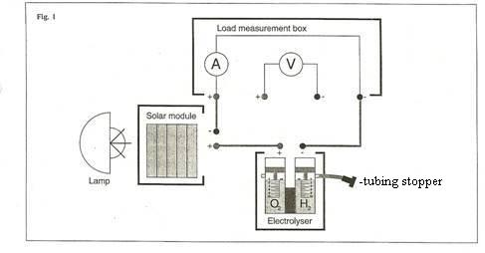

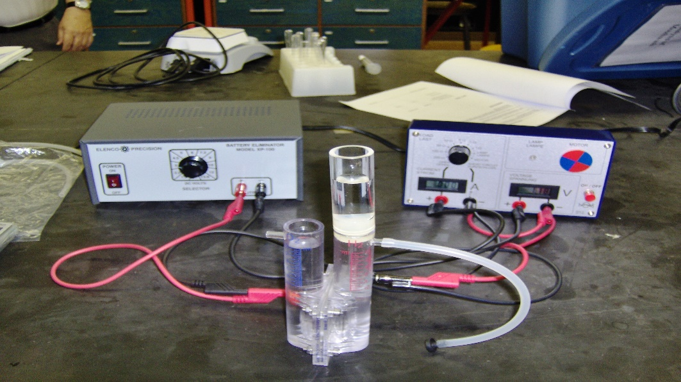

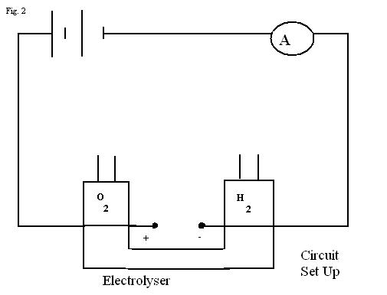

Procedure

- Assemble the solar cell or other generator, electrolyser, load measurement box (or multi-meter) as shown in figure 1(but without the tubing stopper).
- All connections must be correctly made, with the correct polarity. Check with your teacher before proceeding. Collect hydrogen with the switch on load measuring box at “Short Circuit” position.
- Measure the T (ºK) and P (atm.) of lab area.
- When a current is produced (200-300A) and gas is steadily given off, break the circuit, close the short tube on the hydrogen side with a tubing stopper, reconnect the circuit and start the timer.
- Monitor current as is H₂ collected. Stop when 10 mL of H₂ gas is collected. Record time in seconds.
- Investigate the amount of electric charge required to release 10.0 ml of hydrogen gas and then calculate the amount required to release one mole of hydrogen gas.
- Construct a suitable data table and record all pertinent data.
- Use your data, together with the equation for the cathode reaction in the electrolyser and the value for the charge on the electron to find a value for the Avogadro constant.
- Calculate your percent error.

Questions

- What is the equation for the cathode reaction?
- Give reasons why the value you obtain for the Avogadro constant is likely to be different from the accepted value.

- Evaluate the experimental techniques used, identify any precautions taken and describe any difficulties encountered. How were the difficulties overcome?

- What is the percent error?

Extension

Repeat the experiment using oxygen rather than hydrogen.

