Determining the mass of a copper atom

LAB ADV.31
From Vernier Software & Technology, 2004

STANDARDS ADDRESSED
3.4.10 A Explains concepts about the structure and properties of matter.
3.4.12 A Apply concepts about the structure and properties of matter.
3.7.10 A Identify and safely use a variety of tools, basic machines, materials and techniques to solve problems and answer questions.
3.7.10 B Apply appropriate instruments and apparatus to examine a variety of objects and processes.
3.7.10 D Utilize computer software to solve specific problems.

INTRODUCTION

In this experiment, you will confirm the mass of a single atom of Copper by conducting an electrochemical process called electrolysis. In electrolysis, an external power supply is used to drive an otherwise non-spontaneous reaction. You will use two copper strips as the electrodes, placed in a beaker of sulfuric acid. By determining the average current used in the reaction, along with the knowledge that all of the copper ions formed are the 2⁺ cations, you will calculate the number of atoms in one mole of copper and compare this value with Avogadro’s number.

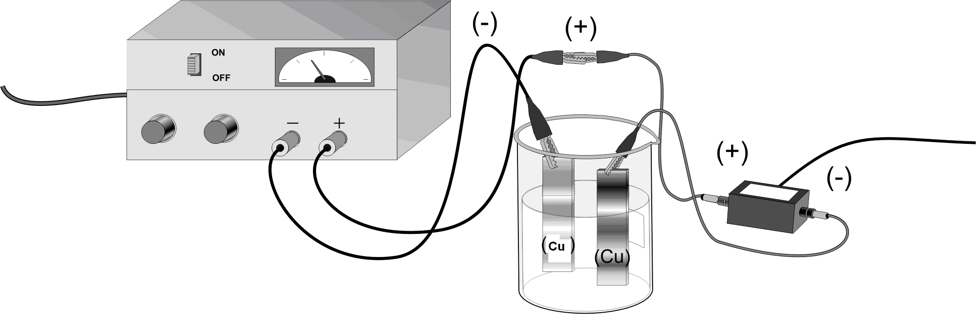

SAFETY

Sulfuric acid: Severely corrosive to eyes, skin and other tissue: considerable heat of dilution with water; mixing with water may cause spraying and spattering. Always add acid to water. Solutions might best be made by immersing the mixing vessel in an ice bath. Extremely hazardous in contact with finely divided materials, carbides, chlorates, nitrates, and other combustible materials.

OBJECTIVES
In this experiment, you will:

- Prepare an electrochemical cell to oxidize a copper electrode.
- Measure the amount of copper that was deposited in the electroplating process and determine the average current used.
- Calculate a value for the mass of a single atom of Copper and compare it to the accepted value.

MATERIALS

Vernier Lab Pro | 1 M H₂SO₄ solution
Laptop with Logger Pro 3.0 or higher | 2 copper strips (anode& cathode)
Vernier Current Probe | Balance (+/-0.000g)
1.5 volt DC power source | distilled water
4 connecting wires with alligator clips | two 250 mL beakers
steel wool

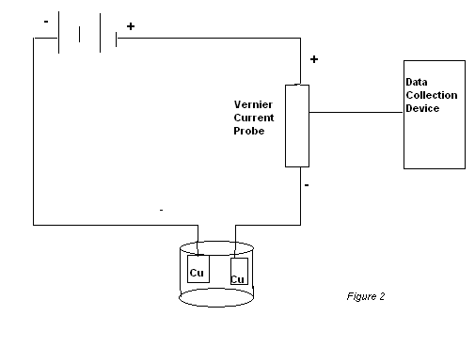

Connect to LabPro

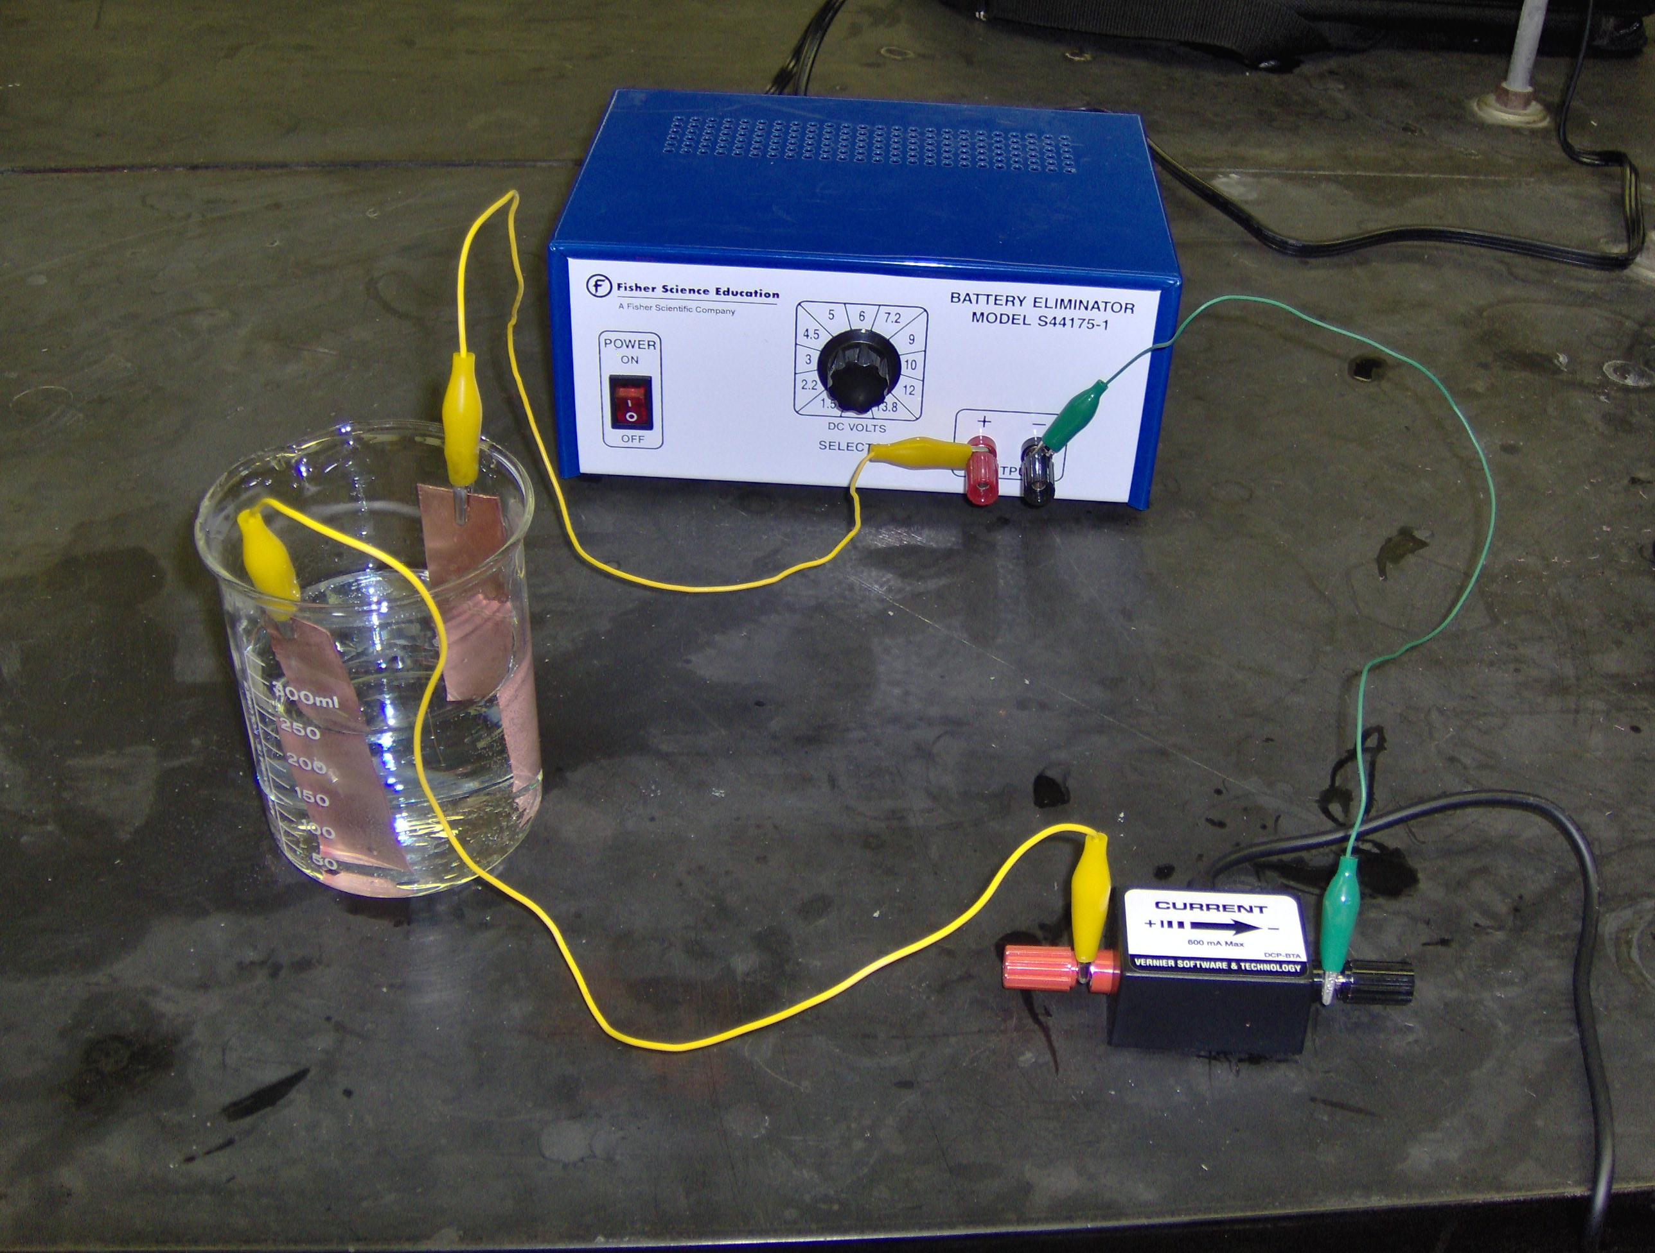

Connect to LabPro

PROCEDURE

- Obtain and wear goggles.
- Use steel wool to clean 2 strips of copper, which will be the anode and cathode of the electrochemical cell.
- Use the balance to measure the mass of both copper strips. Record the mass in your data table.
- Fill a 250 mL beaker about ¾ full with 1 M H₂SO₄ solution. CAUTION: Handle the sulfuric acid with care. It can cause painful burns if it comes in contact with the skin.

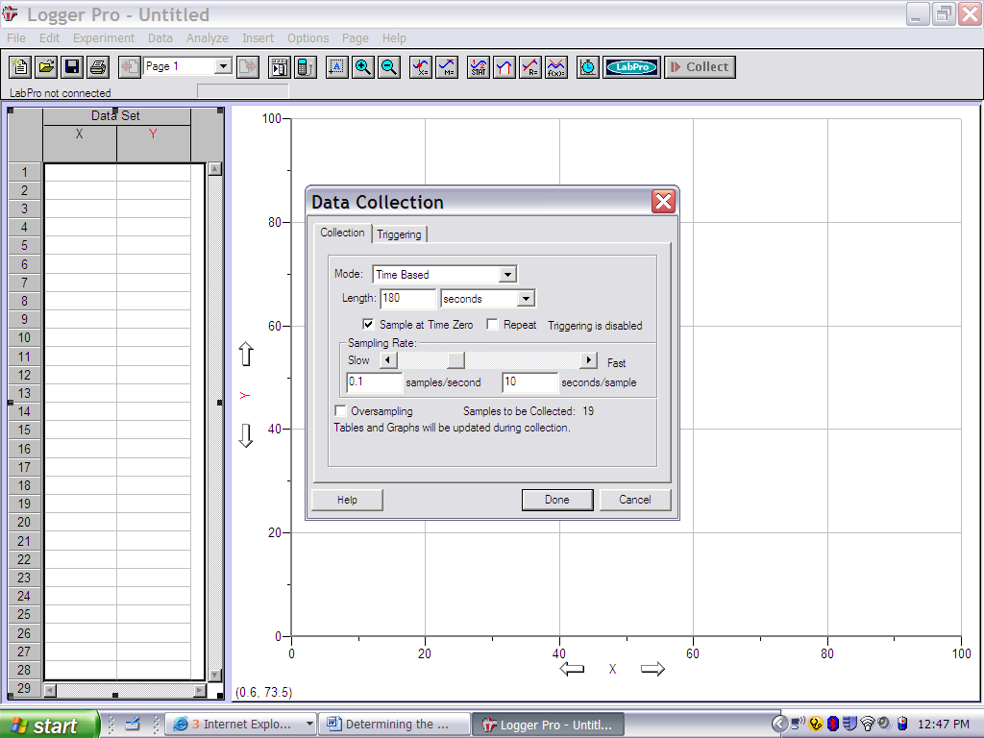
- Obtain a DC power supply and a Vernier Current Probe. Use connecting wires, with alligator clips, to connect the DC power supply, Current Probe, and the two metal electrodes to be used in the electrochemical cell (see Figure 1). Note: Do not place the electrodes in the cell until Step 8.

- Connect the Current Probe to Channel 1 of the Vernier computer interface. Connect the interface to your computer with the proper cable.

- Set up the data collection device to collect data every 10 seconds for 18 collections. (experiment length 180 seconds). See Figure 3.
Fig 3

- Place the electrodes into the 1 M H₂SO₄ solution in the cell. Make sure that the electrodes are immersed in the solution to equal depths and as far apart as possible.

- Turn on the DC power supply and check the current readings. The initial current should be in the 0.2 – 0.6 A range. If the current is not in this range, adjust the settings on the power supply. Once the initial current is in range, turn off the power supply.

- Begin the data collection and turn on the power supply. Data will be collected for 3 minutes. Observe the reaction carefully. Note: Be ready to turn off the power as soon as the data collection stops.

- When the data collection is complete, turn off the power supply and carefully remove the first copper electrode (connected to the power supply) from the H₂SO₄ solution. Carefully rinse the copper electrode with distilled water. Dry the copper electrode very carefully.

- Measure and record the mass of the dry copper electrode, in your data table, for Trial 1.

- Analyze the graph of your data to determine the average current that was applied during the electrolysis. Click the Statistics button, 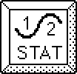. Record the mean in your data table as the average current for Trial 1.

- Repeat Steps 8-13 to conduct a second trial. If time permits, conduct a third trial.

DATA TABLE

 | Trial 1 | Trial 2 | Trial 3
Initial mass of copper electrode (g)

Final mass of copper electrode (g)

Difference in mass (g)

Average current (A)

Time of current application (s)

Number of electrons lost

Number of atoms lost

DATA ANALYSIS

- Calculate the total charge, in coulombs(C), which passed through the electrolytic cell for each trial.

- Use your answers from 1 above to calculate the number of electrons in the electrolysis for each trial. Recall from the famous Millikan oil-drop experiment that the charge of an electron is 1.602 × 10^{–19} coulombs per electron.

- Determine the number of copper atoms lost from the anode in each trial.

- Calculate the number of copper atoms lost at the anode for each trial. The mass lost at the anode is equal to both the mass of copper atoms lost and the mass of copper ions produced (the mass of the electrons is negligible).

- Calculate the mass of a single atom of Copper.

- Determine the percent error.

