DISSOLVED OXYGEN

LAB DO 5
From Water Quality with Calculators, Texas Instruments, 2006

INTRODUCTION

Oxygen gas dissolved in water is vital to the existence of most aquatic organisms. Oxygen is a key component in cellular respiration for both aquatic and terrestrial life.
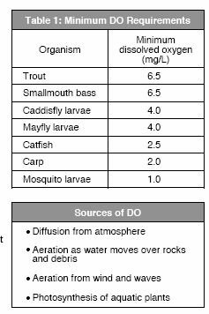
The concentration of dissolved oxygen, DO in an aquatic environment is an important indicator of the environment’s water quality.

Some organisms, such as salmon, mayflies, and trout, require high concentrations of dissolved oxygen. Other organisms, such as catfish, mosquito larvae, and carp, can survive in environments with lower concentrations of dissolved oxygen. The diversity of organisms is greatest at higher DO concentrations. Table 1 lists the minimum dissolved oxygen concentrations necessary to sustain selected animals.

Oxygen gas is dissolved in water by a variety of processes—diffusion between the atmosphere and water at its surface, aeration as water flows over rocks and other debris, churning of water by waves and wind, and photosynthesis of aquatic plants. There are many factors that affect the concentration of dissolved oxygen in an aquatic environment. These factors include:
temperature, stream flow, air pressure, aquatic plants, decaying organic matter, and human activities.

As a result of plant activity, DO levels may fluctuate during the day, rinsing throughout the morning and reaching a peak in the afternoon. At night photosynthesis ceases, but
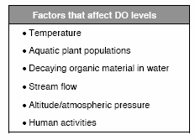
plants and animals continue to respire, causing a decrease in DO levels. Because large daily fluctuations are possible, DO tests should be performed at the same time each day. Large fluctuations in dissolved oxygen levels over a short period of time may be the result of an algal bloom. While the algae population is growing at a fast rate, dissolved oxygen levels increase. Soon the algae

begin to die and are decomposed by aerobic bacteria, which use up the oxygen. As a greater number of algae die, the oxygen requirement of the aerobic decomposers increases, resulting in a sharp drop in dissolved oxygen levels. Following an algal bloom, oxygen levels can be so low that fish and other aquatic organisms suffocate and die.

Temperature is important to the ability of oxygen to dissolve, because oxygen, like all gases, has different solubilities at different temperatures. Cooler waters have a greater capacity for dissolved oxygen than warmer waters. Human activities, such as the removal of foliage along a stream or the release of water, water used in industrial processes, can cause an increase in water temperature along a given stretch of the stream. This results in a lower dissolved oxygen capacity for the stream.

EXPECTED LEVELS

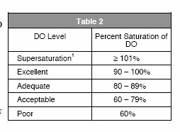
The unit mg/L2 is the quantity of oxygen gas dissolved in one liter of water. When relating DO measurements to minimum levels required by aquatic organisms, mg/: is used. The procedure described in this chapter covers
the use of a Dissolved Oxygen Probe to measure the concentration of DO in mg/L. Dissolved oxygen concentrations can range from 0 to 15 mg/L. Cold mountain streams will likely have DO readings from 7 to 15 mg/L, depending on the water temperature and air pressure. In their lower reaches, rivers and streams can have DO readings between 2 and 11 mg/L.

When discussing water quality of a stream or river, it can be helpful to use a different unit than mg/L. The term percent saturation is often used for water quality comparisons.
Percent saturation is the dissolved oxygen reading in mg/L divided by the 00% dissolved oxygen value for water (at the same temperature and air pressure). T eh manner in which percent saturation relates to water quality is displayed in Table 2. In some cases, water can exceed 1005 saturation and become supersaturated for short periods of time.

MATERIALS

LabPro | 100% calibration bottle
TI Graphing Calculator | small plastic or paper cup (optional)
DataMate program | tissues or paper towels
Vernier Dissolved Oxygen Probe | distilled water
250-mL beaker | Sodium Sulfite Calibration Solution
pipet | DO Electrode Filling Solution
1Supersaturation can be harmful to aquatic organisms. It can result in a disease known as Gas Bubble Disease.
2The unit of mg/L is numerically equal to parts per million, or ppm.

COLLECTION AND STORAGE OF SAMPLES

- Before you begin sampling, fill out the site information on the Data & Calculations sheet. S pace for observations regarding the site is provided at the bottom of the Data & Calculations sheet. Special things to note about the site are the weather, descriptions of the stream reach (flow, depth, shape), and a description of the riparian zone (density of foliage and width of riparian zone).
- It is important to sample as far away from the shore as is safe and under the surface of the water. Samplers consisting of a rod and container can be constructed for collection of samples from areas of the stream otherwise unreachable. In slow- moving water, it is necessary to take samples below the water’s surface at various depths.
- When collecting a sample with a cup or container, prevent mixing of the water sample and air by collecting your sample from below the water surface.
- If you are going to take readings after returning to the laboratory, make sure that there are no air bubble in the water-sample container and that the container is tightly stoppered. The sample should be stored in an ice chest or refrigerator until measurements are to be made. Storing water samples for later testing decreases sample accuracy and is only recommended in cases where measuring at the site is not possible.
- When taking readings in cold (0-10°C) or warm (25-35°C) water, allow more time for the dissolved oxygen readings to stabilize. Automatic temperature compensation in the Dissolved Oxygen Probe is not instantaneous and readings may take up to 2 minutes to stabilize depending on the temperature.

TESTING PROCEDURE

- Prepare the Dissolved Oxygen Probe for use.
  - Remove the blue protective cap if it is still on the tip of the probe.
  - Unscrew the membrane cap from the tip of the probe.
  - Using a pipet, fill the membrane cap with 1 mL of DO Electrode Filling Solution.
  - Carefully thread the membrane cap back onto the electrode.
  - Place the probe in a container of water.

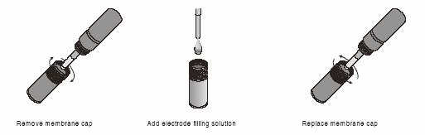
- Plug the Dissolved Oxygen Probe into Channel 1 of the LabPro. Use the link cable to connect the TI Graphing Calculator to the interface. Firmly press in the cable ends.

- Turn on the calculator and start the DATAMATE program. Press to reset the program.
- Set up the calculator and interface for the Dissolved Oxygen Probe.
  - If CH1 displays DO (MG/L), proceed to Step 5. IF it does not, continue with this step to set up your sensor manually.
  - Select SETUP from the main screen.
  - Press to select CH 1.
  - Select D. OXYGEN (MG/L) from the SELECT SENSOR menu.
  - Select OK to return to the main screen.
- Warm up the Dissolved Oxygen Probe for 10 minutes.
  - With the probe still in the water, wait 10 minutes while the probe warms up. The probe must stay connected to the interface at all times to keep it warmed up. If disconnected for a period longer than a few minutes, it will be necessary to warm it up again.
  - Select SETUP from the main screen.
- Set up the calibration for the Dissolved Oxygen Probe. (Optional)
- If you instructor directs you to manually enter the calibration values, select CALIBRATE, then MANUAL ENTRY. Enter the slope and intercept values, select OK, then proceed to Step 7.
- If your instructor directs you to perform a new calibration, follow this procedure.
Zero-Oxygen Calibration Point
  - Select CALIBRATE, then CALIBRATE NOW.
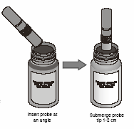
  - Remove the probe from the water and place the tip of the probe into the Sodium Sulfite Calibration Solution. Important: No air bubbles can be trapped below the tip of the probe or the probe will sense an inaccurate dissolved oxygen level. If the voltage does not rapidly decrease, tap the side of the bottle with the probe to dislodge the bubble. The readings should be in the 0.2- to 0.5-V range.
  - When the voltage stabilizes (~1 minute), press .
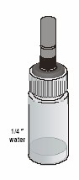
  - Enter “0” as the known value in mg/L.
Saturated DO Calibration Point
  - Rinse the probe with distilled water and gently blot dry.
  - Unscrew the lid of the calibration bottle provided with the probe. Slide the lid and the grommet about ½ inch onto the probe body.
  - Add water to the bottle to a depth of about ¼ inch and screw the bottle into the cap, as shown. Important: Do not touch the membrane or get it wet during this step.
  - Keep the probe in this position for about a minute. The readings should be above 2.o V. When the voltage stabilizes, press .

  - Enter the correct saturated dissolved-oxygen values (in mg/L) from Table 3 (for example “8.66”) using the current barometric pressure and air temperature values. If you do not have the current air pressure, use Table 4 to estimate the air pressure of your altitude.
  - Select Ok to return to the setup screen.
- Setup the data-collection mode.
  - To select MODE, press once and press .
  - Select SINGLE POINT from the SELECT MODE menu.
  - Select OK to return to the main screen.
- Collect dissolved oxygen concentration data in a SINGLE POINT mode.
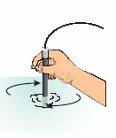
  - Rinse the tip of the probe with a sample of water.
  - Place the tip of the probe into the stream at Site 1, or into a cup with sample water from the stream. Submerge the probe tip to a depth of 4-6 cm. Gently stir the probe in the water sample. Note: It is important to keep stirring until you have collected your DO value.
  - When the readings stabilize (stable to the nearest 0.1 mg/L), select START to begin sampling. Continue stirring. After 10 seconds, the dissolved oxygen concentration will appear on the calculator screen.
  - Record this value and site number on the Data & Calculations sheet (round to the nearest 0.1 mg/L).
  - Press to return to the main screen.
  - Repeat Steps 8 a-e to test a second sample or if collecting data for a second site.

