“VIRTUALLY” PAINLESS DROSOPHILA

GENETICS

STANDARDS
• 3.1.12A, 3.1.12B, 3.1.12C
• 3.2.12B, 3.2.12C
• 3.3.10C, 3.3.12C

Westminster College

INTRODUCTION
Drosophila melanogaster, the fruit fly, is an excellent organism for genetics studies because it has simple food requirements, occupies little space, is hardy and completes its life cycle in about 12 days at room temperature. While you will be using a computer program that simulates Drosophila genetic crosses, it is important to understand the life cycle of this organism (Figure 1).

The Life Cycle of Drosophila

The Eggs: The eggs are small, oval shaped and have two filaments at one end. They are usually laid on the surface of the culture medium and, with practice, can be seen with the naked eye. The eggs hatch into larvae after about a day.

The Larval Stage: The wormlike larva eats almost continuously, and its black mouth parts can easily be seen moving back and forth even when the larva itself is less distinct. Larvae tunnel through the culture medium while eating; thus, channels are a good indication of the successful growth of a culture. The larva sheds its skin twice as it increases in size. In the last of the three larval stages, the cells of the salivary glands contain giant chromosomes, which may be seen readily under low-power magnification after proper staining.

The Pupal Stage: When a mature larva in a lab culture is about to become a pupa, it usually climbs up the side of the culture bottle or on to the strip provided in the culture bottle. The last larval covering then becomes harder and darker, forming the pupal case. Through this case the late stages of metamorphosis to an adult fly can be observed. In particular, the eyes, the wings and the legs become readily visible.

The Adult Stage: When metamorphosis is complete, the adult flies emerge from the pupa case. They are fragile and light in color and their wings are not fully expanded. These flies darken in a few hours and take on the normal appearance of an adult fly. They live a month or more and then die. A female does not mate for about ten to twelve hours after emerging from the pupa. Once she has mated, she stores a considerable quantity of sperm in receptacles and fertilizes her eggs as she lays them. To ensure a controlled mating, it is necessary to use females that have not mated before (virgins).

It is important to realize that a number of factors determine the length of time of each stage in the life cycle. Of these factors, temperature is the most important. At room temperature (about 25°C), the complete cycle takes ten to twelve days.

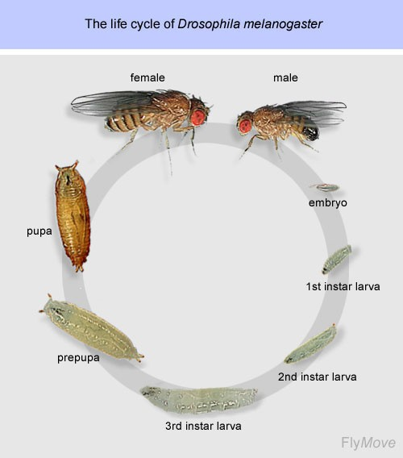
Figure 1.

Drosophila Genetics

Drosophila are useful for studying genetics because they have only 4 chromosomes, with well studied traits that are inherited in a straightforward Mendelian fashion. While performing this lab, it will first be necessary to determine whether an allele, or version of a gene, is dominant or recessive. If an allele is dominant, it will mask the phenotypic trait of other alleles of that gene. In general, if an allele is recessive, it will require that an offspring have 2 copies (one copy on each chromosome) before the phenotypic trait is expressed. It will also be important to determine the mode of inheritance. Genes that are inherited on the sex chromosomes are called sex-linked; genes on the other chromosomes are considered autosomal.

Chi-squareAnalysis

The chi-square test is the statistical test most frequently used to determine whether data obtained experimentally provide a good fit to the expected or predicted data. To determine if observed data fall within acceptable limits, a chi-square analysis is performed to test the validity of a null hypothesis. If there is no statistically significant difference between the observed and expected data, the null hypothesis is considered

valid. If a chi-square analysis indicates that the data vary too much from the expected, an
alternative hypothesis is accepted.

The formula for chi-square is:
2
∑ (o − e)
χ2 =
e
where o = observed number of individuals
e = expected number of individuals
∑ = the sum of the values (in this case, the differences, squared, divided by the number expected

The
χ2 value is then compared to a Critical Values Table (Table 1). The two

components of this table are Degrees of Freedom (df) and Probability (p). Degrees of freedom refer to the number of phenotypic classes minus 1. For example, in a monohybrid cross, you will see two different phenotypes, wild-type and mutant. This would give 1 df, or (2 phenotypes – 1).

The probability, or p value, sets a minimum threshold, or critical value, for the statistical significance of the results obtained for an experiment. For genetic crosses, the p value

used is usually 0.05. If your
χ2 value for a given df is below the value in the table, then

you are 95% sure that the null hypothesis is valid. For example, if
χ2 = 2.16 for 1 df ,

then 3.84>2.16, indicating that your observed data is not statistically different than the expected data, and any variation from your prediction is due to random chance.

Table 1. Critical Values of the Chi Square Distribution
Probability (p) | Degrees of Freedom (df)
 | 1 | 2 | 3 | 4 | 5
0.05 | 3.84 | 5.99 | 7.82 | 9.49 | 11.1
0.01 | 6.64 | 9.21 | 11.3 | 13.2 | 15.1
0.001 | 10.8 | 13.8 | 16.3 | 18.5 | 20.5

In this lab you will use a computer program, DrosophiLab 1.0, to produce virtual genetic crosses of fruit flies. This program allows you to collect data from F1 and F2 generations, and analyze the phenotypic results from:

- A monohybrid cross: In these experiments, the mode of inheritance is determined when a single contrasting pair of characteristics is involved. You will be expected to determine the mode of inheritance and the particular mutation involved.
- A dihybrid cross: In these experiments, the mode of inheritance is determined when two pairs of contrasting characteristics are considered simultaneously. The mutations may not be readily apparent, and you will be expected to make predictions (null hypothesis) about the genotype of the parental generation (P1),

identify the mutations and the mode of inheritance, and design back-crosses to test these predictions.

Chi-square analysis will be used to support your predictions or to help you select an alternative hypothesis.

GUIDING QUESTIONS
- How do the results from genetic crosses allow for determination of genotype of the parent flies?
- How are you able to use genetic crosses to determine if a gene is autosomal or sex-linked?
- How are you able to use genetic crosses to illustrate the principle of independent assortment of two genes?
- What does Chi-square analysis of the data tell you about the results of a genetic cross?

MATERIALS
DrosophiLab 1.0 program Laptop computer
Drosophila chromosome map

PROCEDURE

Part I A Monohybrid Cross

- Turn on the laptop computer. Double click on the DrosophiLab icon . Close the “Tip of the Day” window. A blank program

window will appear.

- 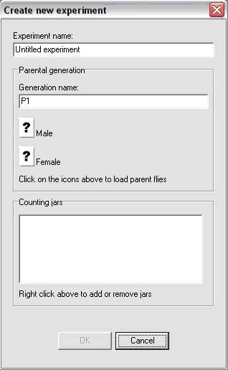Select File>New Experiment from the menus at the top left of the window. The following “Create New Experiment” window will appear (Figure 2). Create an experiment name and type it in the Experiment Name box.

- To start an experiment, you must choose a male and female to be the parent generation (P1). Your instructor will assign an Experiment # to your group. You will select both the male and female with the corresponding number for your first trial. For example, if you are assigned Experiment #2, you will choose the files Expt2m for the male and Expt2f for the female.
Figure 2. New Experiment window

- Click on the “?” icon next to the Male parent. A window showing a series of “.fly” files will appear. Select the male fly file with the appropriate Experiment #, then click Open. If you have selected a parent, a fly icon will appear where the “?” used to be, and the name of the Experiment file will be written to the right of the fly icon.

- Repeat Step 4 to choose a female fly with the appropriate Experiment #.

- Select OK when you have chosen the appropriate male and female P1 generation. The main experiment screen will appear (Figure 3). At the top left portion of the window, there is a microscope window which should be empty. Below this is a box labeled P1, showing the two parent fly icons. To examine one of the parent flies, click on one of the P1 fly icons just below the microscope and drag the fly to the microscope box. A 3D model of the fly should appear as shown in Figure 3.

Figure 3. Main experiment screen

- 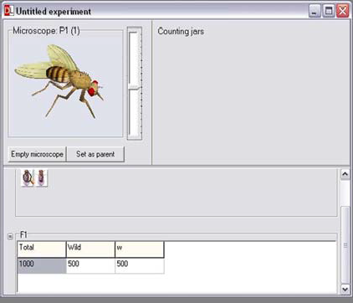There are several ways in which you can manipulate the fly to examine it more
closely. You should experiment with these until you are comfortable using the virtual microscope.
  - Shift + Right click allows you to center the fly in the field of view.
  - Ctrl + Right click allows you to rotate the fly so that you can see certain sections of the body more clearly.
  - The sliding scale to the right of the microscope lets you increase magnification. This is particularly useful for mutations involving the antennae and bristles.

- Examine the first fly under the microscope and determine whether it is a male or female (Figure 4). In general, males are slightly smaller than females. The most distinguishing features are found on the abdomen of the flies. The female has several transverse stripes, and an ovipositor which gives the fly a more pointed abdomen. The male abdomen is darker, and has a much blunter tip. In live flies, there would also be a sex combs, groups of black bristles on the uppermost joint front legs of the male. This detail is not present in the virtual flies.

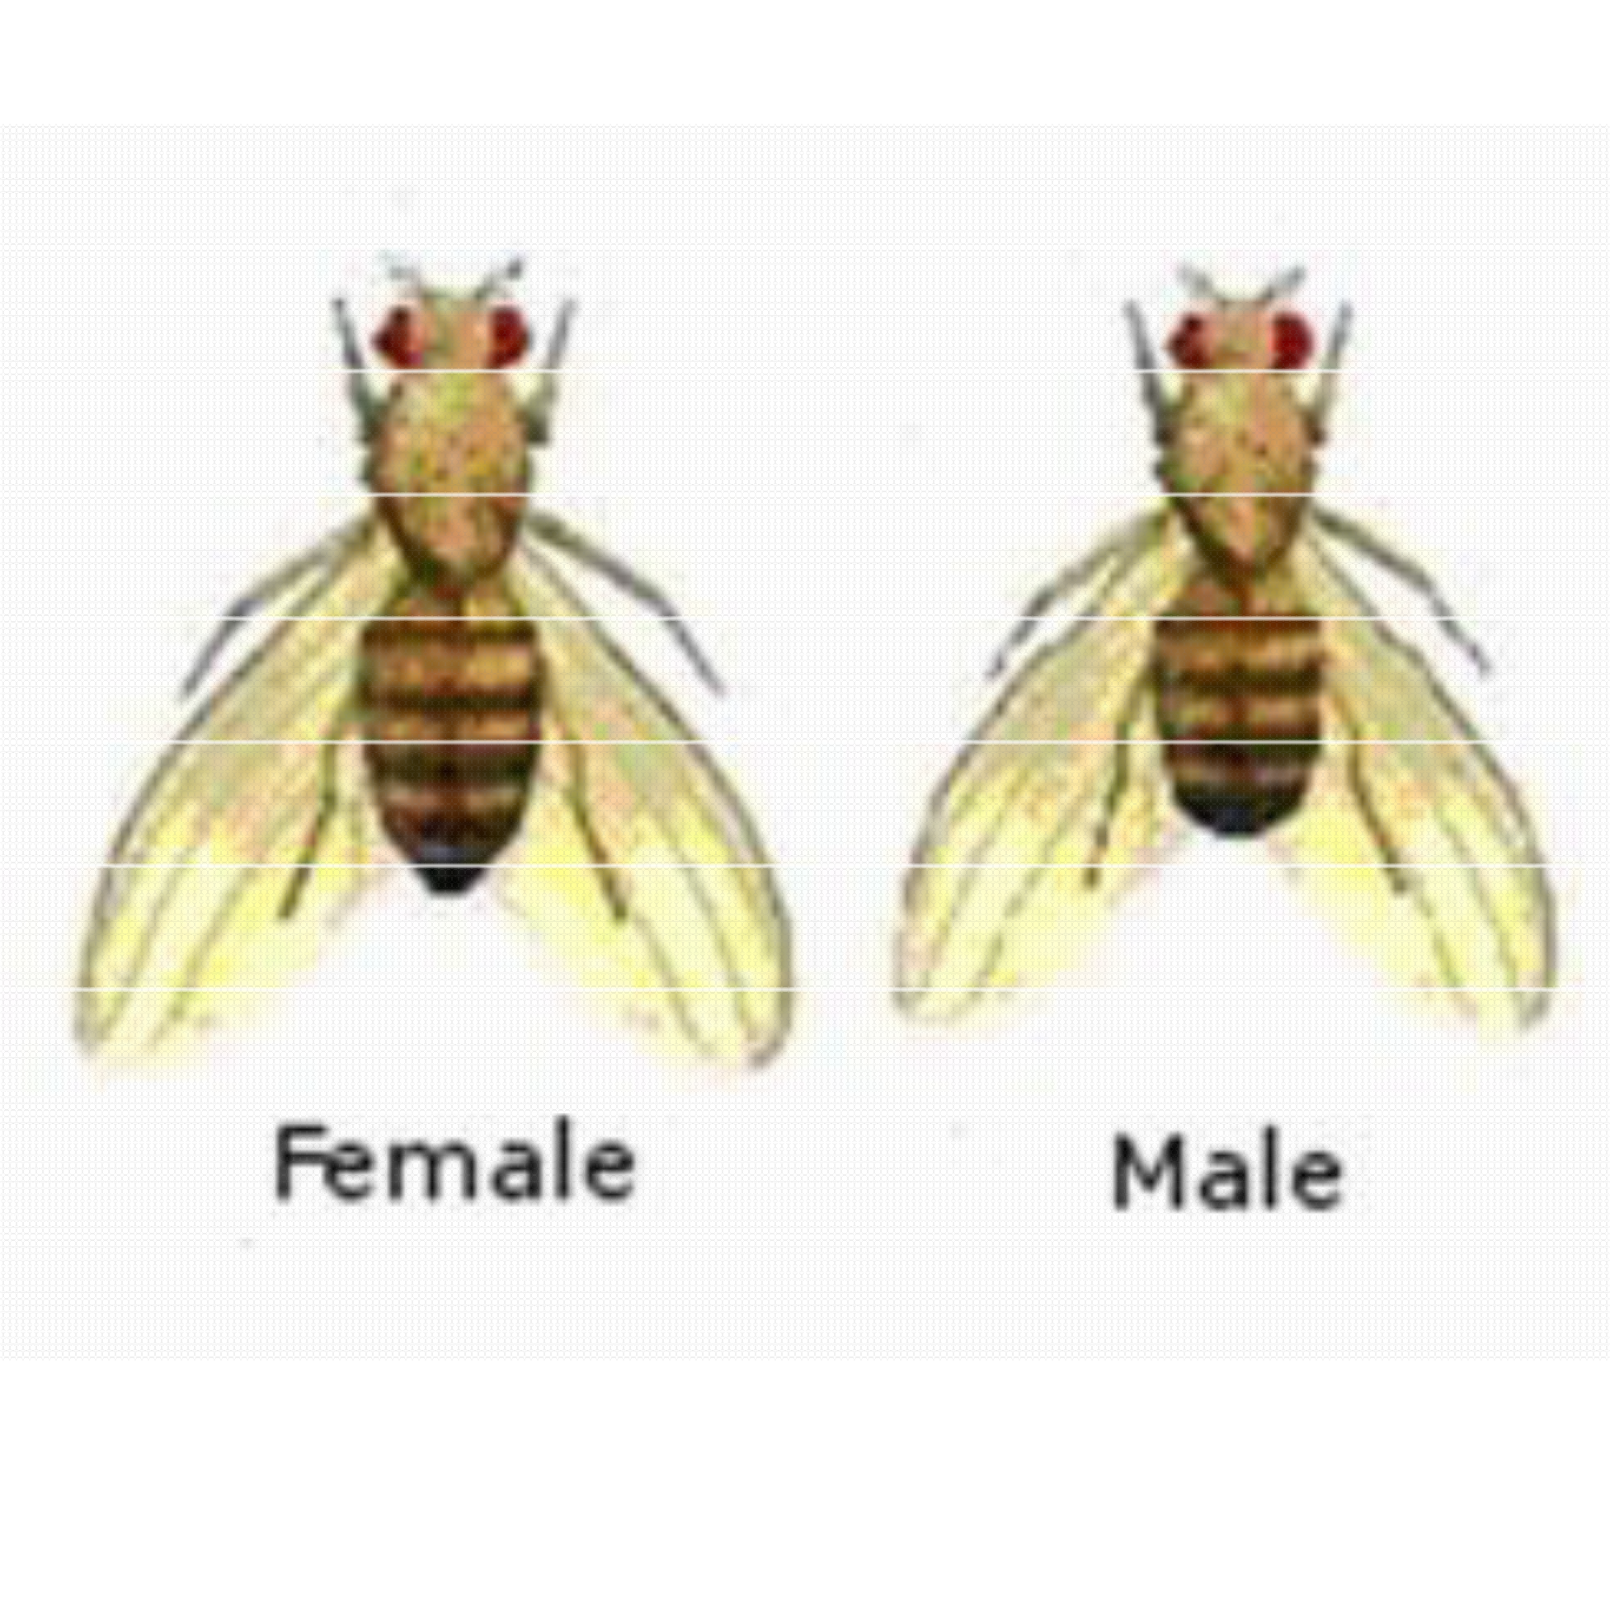Figure 4. Female and Male Drosophila

Abdomen with Several Transverse Stripes
Heavily Pigmented Tip of Abdomen

Pointed Ovipositor Blunt Tip of
Abdomen

- Also note if the fly has any mutation associated with it. Common mutations are in eye color or shape, wing shape, body color, and bristle or antennae morphology. Your instructor will demonstrate the characteristics of a wild-type fly so that you may identify a mutation. Record the sex and create a name for any phenotypic mutations on the Data Sheet under Part I, P1 Data. Select “Empty Microscope” when you are done.

- Drag the second parent fly to the microscope and follow steps 8 & 9. Select “Empty Microscope” when you are finished recording the sex and mutation information.

- To create an F1 generation from these two flies, select Experiment>New Generation from the menus. A “New Generation” window will appear (Figure 5). Under Generation name, keep the F1 and add any mutation name you have given the flies. Set 200 as the Number of offspring, and select the Icons button. Select OK when finished. Note: Any fewer than 200 offspring will result in problems performing a Chi-square test later.

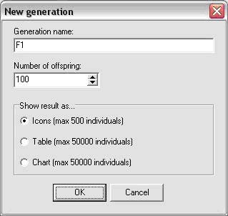Figure 5. New Generation window

- The Main Experiment screen will appear again, this time with an F1 panel displaying 200 fruit fly icons (Figure 6). Just as you would with live flies, you will be required to drag each fly to the microscope and sort it based on sex and phenotype. Based on your initial observations, predict the types and/or numbers of sorting jars you will need (see Data Sheet, Part I). For example, in almost all cases, you will need a wild-type female and wild-type male jar. New jars can be created at any point during the sorting process should you discover a mutation you had not predicted.

Figure 6. F1 Generation displaying offspring icons and counting jars.

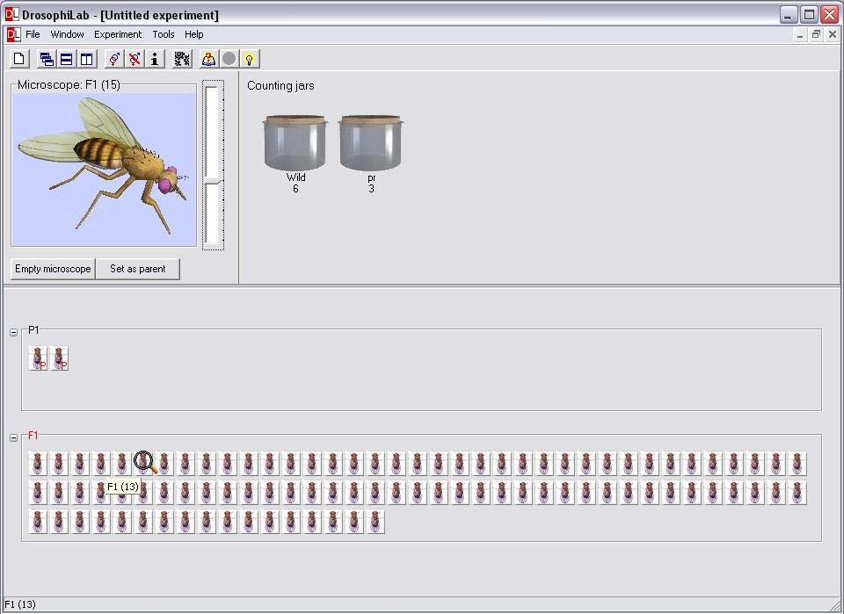

- To create sorting jars, select the Experiment menu>Add counting jar or Ctrl J. A window will appear. Enter a short jar label that is descriptive and clear to you and your lab mates. Click OK. A jar with that label will appear as a jar icon in the Counting Jars panel of the Main Screen (Figure 5). When you drop flies into that container, the computer will keep count for you and post the total number of flies with that phenotype under the jar label.

- Before you start counting your flies and placing them in the counting jars, you should be aware of several quirks in the computer program that can make creating an F2 generation difficult.
  - The counting jars are essentially a fly morgue. Once you place an icon in the jar, that fly is no longer available to be used to create future generations.
  - It is best if you save a male and female of each phenotype, so that if necessary, you can set them as parents for the F2 generation. To save them, select “Empty Microscope” after identifying them, rather than dragging them to the sorting jars. This returns them to the F1 icon panel.
  - Each fly has its own identifying number. To see this number, hold the mouse arrow over a fly icon. It should be written as Generation (#), i.e. F1(2). When saving flies to create a new generation, you might want to record this number, sex of the fly and phenotype to remember which flies you want to set as parents for the F2 generation (see Data Sheet, Part I).

- Sort the remaining flies by phenotype into the counting jars, and record the information in Table 1 in Part I of the Data Sheet. Depending on the genetic cross, you may not need to use all the rows provided.

- The next step is to create an F2 generation by performing an F1 x F1 cross. To set the saved flies as parents for the next generation, right click on one of fly icons in the F1 panel. Choose “Set as parent” from the menu that appears. Be sure to set both a male and a female parent. If you have done this successfully, the icon will turn light pink.

- Follow steps 9-13 to sort and record the results of the F2 generation. There is no need to save any flies for further generations unless your instructor indicates otherwise.

Two Important Notes:
  - It is very, very important to record your data precisely. Unless you have access to a printer, all this data WILL BE LOST when you close the program. While it is not as time consuming as losing a vial of live flies, you will still have to repeat the genetic crosses and sort all the flies again!
  - If you do not have time to perform the F2 cross and collect data, you must save the flies to a fly file! To save the selected flies for the next generation, right click on the pink highlighted fly icon. Choose “Save fly to file…” from the drop-down menu. When giving the file a name, label it with your initials, mutation name and indicate whether the fly is male or female. You will be able to retrieve these files to continue with your F2 cross during your next lab period, but you and your lab group will need to use the same computer throughout the experiment.

Part II Dihybrid Cross and Independent Assortment

- In this part of the lab, you will examine the independent assortment of alleles using a dihybrid cross. Your instructor will assign an experiment number as before, i.e. if you are assigned Dihybrid Experiment #2, you will choose the file Dih2m for the male and Dih2f for the female.

- Examine the first fly under the microscope and determine whether it is a male or female. Note if the fly has any phenotypic mutation associated with it. Mutations for this part of the lab will be readily visible, and will involve the eyes, body and wings. Record the sex and phenotypic mutations of the parents in Part II of the Data Sheet.

NOTE: As this is dihybrid cross, some mutations may not be visible until the F1 generation is produced! If mutations are not evident in the parents, be alert for them to appear in the F1 offspring. Also, there are no tricks to these flies. The experimental flies will NOT have linked genes (genes close together on same chromosome).

- Once you have recorded the sex and phenotype of the P1 generation, follow steps 11- 15 to create F1 offspring. It is especially important to save flies with various mutations of both sexes. Record the sex and phenotype of the saved flies in the appropriate spot in

Part II of the Data Sheet. In this part of the lab you are expected to make predictions about the genotypes of the parent flies and design a back-cross to test those predictions. This may involve a cross between 2 F1 flies or a cross with one of the parents.

- Record the results of the F1 generation in Table 4 on the Data Sheet. Remember to add in the saved fly totals to the totals from the sorting jars.

- When planning a cross to determine the genotype of the P1 generation, use the data from the F1 generation to make a prediction. Questions that might help you with this prediction are:
  - Were any mutations visible in the P1 generation?
  - Did any new mutations appear in the F1 generation?
  - What do you think the mode of inheritance is? Dominant? Recessive? Sex- linked?
  - Do the results from the F1 cross lead you to believe that the parents were homozygous or heterozygous?
  - Are there any flies that you are sure of the genotype? Would using one of these in a cross help determine if there are any “hidden” mutations in one of the parents?

- It may take more than an F2 generation to elucidate the genetic background of the parent flies. Creating Punnett squares to model your predictions may help you decide which saved flies to use for further crosses.

REFERENCES

The College Board Advanced Placement Program. Biology Lab Manual for Students.
Lab Seven: Genetics of Organisms. ♥ 2001 by the College Examination Board. Pp. 78-89.

The College Board Advanced Placement Program. Biology Lab Manual for Teachers.
Lab Seven: Genetics of Organisms. ♥ 2001 by the College Examination Board. Pp. 51-57.

DrosophiLab 1.0, ♥ Hannes Jensen, 2004-2005. Educational links to other Drosophila websites are included in this website.
http://www.drosophilab.com/

Drosophila Life Cycle image obtained from: www.flickr.com/photos/11304375@N07/2993342324/

CREDITS

This lab design was revised and adapted by Dr. Stephanie Corrette-Bennett using the DrosophiLab 1.0 computer download and the AP Biology laboratory manuals.

DATA SHEET & ANALYSIS

Name: Group: Date:

Data for Part I

P1 Data: Sex
Sex
Phenotype Phenotype
Mutation name? Mutation name?

Prediction for phenotypes of F1 generation (estimate #’s male & female offspring and phenotype using symbols created to identify the mutation):

Males (expected): Females (expected):
Punnett Square for F1 prediction:
Female
Male
Phenotype Ratio:
Genotype Ratio:

Saved Flies
F1(#)/Phenotype
Female
Male

Table 1: F1 Generation Data
Phenotype & Symbol | Females | Males

F1 Observations:
Did your observations/ results match your predictions? Perform a Chi-square test on your results and compare them to the Critical Value Table in the introduction.

Chi-square analysis for F1 Generation
Sex/Phenotype | Observed | Expected | (o – e) | (o-e)2 | (o - e)2  e

χ 2 = =
∑ (o − e)
2
e

What do these data tell you about the mode of inheritance of this trait? What is the dominant allele? What is the recessive allele?

What are the phenotypes of the parents that will be used to create the F2 generation?

F1 Parent Data: Sex
Sex
Phenotype Phenotype
Mutation name

Prediction for phenotypes of F2 generation (estimate #’s male & female offspring and phenotype using symbols created to identify the mutation):

Males (expected): Females (expected):
Punnett Square for F2 prediction:
Female
Male
Phenotype Ratio:
Genotype Ratio:

Table 2: F2 Generation Data
Phenotype | Females | Males

F2 Observations:
Did your observations/ results match your predictions? Perform a Chi-square test on your results and compare them to the Critical Value Table in the introduction.

Chi-square analysis for F2 Generation
Sex/Phenotype | Observed | Expected | (o – e) | (o-e)2 | (o - e)2  e

χ 2 = =
∑ (o − e)
2
e
What is the genotype of the parent flies? If you still are unsure of the genotype of one of the parents, can you design a (theoretical) F3 cross that would definitively determine the genotype?

P1 Parent Data: Male genotype
Female genotype

Data for Part II

Dihybrid P1 Data: Sex
Sex
Phenotype Phenotype

Prediction for phenotypes of F1 generation (estimate #’s male & female offspring and phenotype using symbols created to identify the mutation):

Males: Females:

Punnett Square for Dihybrid F1 prediction:
Female
Male
Phenotype Ratio:
Genotype Ratio:

Saved Flies
F1(#)/Phenotype
Female
Male

Table 4: Dihybrid F1 Generation Data
Phenotype & Symbol | Females | Males

Dihybrid F1 Observations:
Did your observations/ results match your predictions? Perform a Chi-square test on your results and compare them to the Critical Value Table in the introduction.

Chi-square analysis for Dihybrid F1 Generation
Sex/Phenotype | Observed | Expected | (o – e) | (o-e)2 | (o - e)2  e

χ 2 = =
∑ (o − e)
2
e

If not, how was it different? Does this tell you something about the genotype of one of the parent flies?

What are the phenotypes of the parents that will be used to create the dihybrid F2 generation?

F1 Parent Data: Sex
Sex
Phenotype Phenotype
Mutation name

Prediction for phenotypes of F2 generation (estimate #’s male & female offspring and phenotype using symbols created to identify the mutation):

Males (expected): Females (expected):

Punnett Square for Dihybrid F2 prediction:
Female
Male
Phenotype Ratio:
Genotype Ratio:

Table 2: F2 Generation Data
Phenotype | Females | Males

F2 Observations:
Did your observations/ results match your predictions? Perform a Chi-square test on your results and compare them to the Critical Value Table in the introduction.

Chi-square analysis for Dihybrid F2 Generation
Sex/Phenotype | Observed | Expected | (o – e) | (o-e)2 | (o - e)2  e

χ 2 = =
∑ (o − e)
2
e

What is the genotype of the parent flies? If you still are unsure of the genotype of one of the parents, can you design an F3 cross that would definitively determine the genotype? Why are you choosing these particular flies as parents?

P1 Parent Data: Male genotype
Female genotype

QUESTIONS

Given the following genetic cross, answer the following questions:

An investigator observes that when pure-breeding, long-wing Drosophila are mated with pure-breeding, short-wing flies, the F1 offspring have an intermediate wing length.
When several of the intermediate-wing length flies are allowed to interbreed, the following results are obtained:

Observed 230 long wings
510 intermediate-length wings
260 short wings

- What is the genotype of the F1 intermediate-wing length flies?

- Write a hypothesis describing the mode of inheritance of wing length in Drosophila (this is your null hypothesis).

- Complete the following table.

Chi-square analysis for Wing-length Cross
Phenotype | Observed | Expected | (o – e) | (o-e)2 | (o - e)2  e

- Calculate the Chi-square value for these data.
χ 2 = =
e
∑ (o − e)
2

  - How many degrees of freedom (df) are there?

  - What is the Chi-square (from table above)?

  - Referring to the critical values chart, what is the probability value for these data?

- According to the critical value of χ2, can you accept or reject the null hypothesis? Explain why.

