THE CASE OF THE DRUNK DRIVER; GC APPROACH
From Science in Motion, Juniata College

STANDARDS ADDRESSED
1.2.11.A, 2.4.11.E
3.4.10.A, 3.7.10.A
3.7.12.A

INTRODUCTION ON GAS CHROMATOGRAPH

Chromatography is a separation technique utilizing a stationary phase and a mobile phase. In gas chromatography, the stationary phase is a solid material packed in a coiled column, and the mobile phase is air.

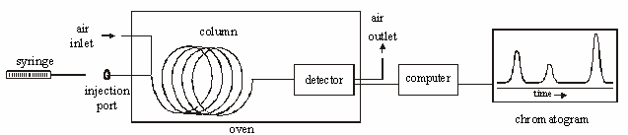

The gas chromatograph is an instrument that allows a chemist to separate a mixture of gases or volatile liquids. Separation is based on the size, structure, polarity of the molecules. 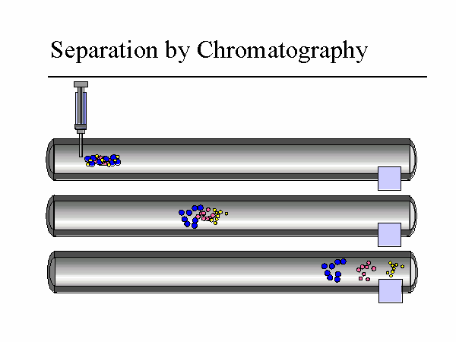
Retention time is used to identify the components, and the area under the curve is used to determine the relative quantities of the components. In this experiment, a HAYSEP-D column is used to separate ethanol, isopropyl alcohol, and methanol.

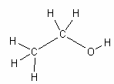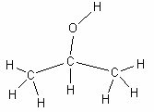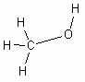

Ethanol | Isopropyl alcohol | Methanol
Boiling Point 78 °C | Boiling Point 82°C | Boiling Point 65°C

SCENARIO
You are a forensic scientist at a local police station. You are presented with a case that involved a drunk driver. A police officer pulled the driver over for erratic driving. As the police officer approached the vehicle, the driver was chugging an unknown substance from an ice tea bottle. The police officer smelled alcohol and quickly took the ice tea bottle from the driver. There was still a small amount of substance left in it. The driver’s blood alcohol level was 0.15; the legal limit in Pennsylvania is 0.08. He is being charged with a DUI and an open container of alcohol in the vehicle. You need to determine whether or not the driver was telling the truth. Does the ice tea have any alcohol mixed into it? To test this you will compare your results for running the following samples on a gas chromatograph; ethanol, ice tea, and the unknown mixture taken from the suspect.

GUIDING QUESTIONS
Please answer the following questions before beginning the lab.
- Which will have the shortest retention time, alcohol or ice tea?

- What information do you know about the following alcohols; methanol, ethanol, and isopropyl alcohol; that would help you determine which would have the shortest retention time?

EQUIPMENT/MATERIALS
air gas chromatograph vial of Unknown Drink
computer with Peak Simple software vial of ethanol
printer vial of ethanol/ice tea mix
all power cords and cables vial of methanol (optional)
10 microliter syringe vial of isopropyl alcohol (optional) 3 ½ Floppy

SAFETY
- Always wear safety glasses in the lab.

- Handle the syringes carefully. The syringes are very dangerous, especially when filled with hazardous chemicals. They also break easily.

- Do not allow the syringe to roll off of the lab bench. When injecting the sample, push the plunger straight so that it does not bend.

- The gas chromatograph is like an oven, so the port may be hot. Use caution.

PROCEDURE
- Turn on the GC, if not already on.

- Log onto the computer: UserName is ‘administrator’, and password is ‘simchem’. Double click on the Peak Simple software icon.

- Set the following conditions from the edit menu by selecting channels, then selecting channel 1 and temperature. Clear, Add, fill in the following using the Tab on the keyboard to move to the next field.
Initial Temp 150°C Hold 10 minutes Ramp 0 degrees / min
Until the temperature is 150°C, OK, OK, OK

- Be sure the time scale at the bottom left starts at zero. Use the arrow to adjust.

- Obtain a microliter syringe and a vial of a known alcohol standard.

- Clean the syringe by rinsing it at least 7 times with this alcohol. With the plunger fully depressed, place the needle into the alcohol sample. Slowly draw up the plunger to obtain a sample of alcohol in the syringe. Remove the syringe from the alcohol sample. Discharge this sample into a waste container. Depress the plunger, and put the syringe needle back into the alcohol sample. Draw up a second sample and discharge it into a waste container. Repeat.

- Place the syringe needle back into the alcohol sample, and obtain 1 microliter of the standard alcohol. Wipe the needle with a Kimwipe to prevent any excess sample from being vaporized prior to injection.

- Click on the Z on the keyboard or θ icon on the run screen to zero the current.

- Insert the needle carefully into the injection port of the GC until the needle stops.

- Inject the sample, and start the data collection simultaneously by depressing the syringe plunger and pressing the space bar on the computer at the same time. Keep the syringe in the port for 10 seconds after injection.

- When the sample peak of a standard returns to the baseline, the run may be stopped by pressing the end button on the computer. After pressing end, print the graph. Be sure to label the graph.

- Repeat steps 4-9 for the other 2 known alcohols and the unknown alcohol. When running an unknown sample, be certain to let the data collect long enough to get all possible peaks.

DATA TABLE

Standard | Retention Time
Ethanol
Ice tea
Methanol (optional)
Isopropyl alcohol (optional)

Unknown 1 | Retention Time (min) | Identity of Peak
Peak 1
Peak 2
Peak 3

QUESTIONS

- What is a control? What purpose do they serve? What sample(s) are serving as controls? Why is it important to run known samples of possible components in the unknown mixture?

- If a supposedly pure sample was properly injected into the gas chromatograph and several peaks were observed, what can be concluded about the sample?

- Why is it important to clean the syringe between samples?

- Why is it important to wipe the needle before injecting the sample into the instrument?

- Ethanol
  - Chemical Formula

  - Structural Formula

- What does the area under the peak represent?

- Did the suspect have any alcohol in his ice tea? How do you know? If so, how much alcohol was in the tea? Show all work.

- Explain why we analyzed the ice tea with the Gas Chromatograph?

- What questions do you still have?

