INSTRUCTIONS FOR TAKING YOUR PULSE

Right Arm
Left Arm
Elbow
Sticky tabs
Elbow
Sticky tab
Black
clip
Green
clip
Red
clip

- Place a sticky tab on the inside of your right arm, about an inch below your elbow and in the center of your arm. The silver part of the tab should face in toward your body.

- Place another sticky tab on your right arm, about an inch above your wrist. Try to line it up with the first sticky tab.

- Place a third sticky tab on your left arm, about an inch below the elbow, with the silver part of the tab facing in toward your body.

- Use the picture to put the right color clip on the right sticky tab. Every one will have time to take her pulse.

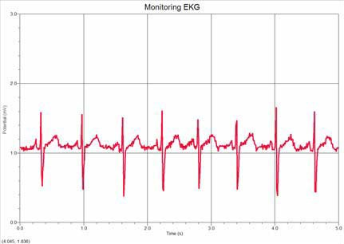
- Once you are hooked up to the computer, rest your arms on the table, relax and breathe slowly.

- When you are ready, have one of your partners click the big green “Collect” button at the top of the computer screen. The program will stop all by itself after 6 seconds. The screen should show something that looks like this!

- Count the number of peaks or spikes and write it down in the chart on the activity sheet, next to Resting Pulse. Each one represents a heartbeat!

- To find out how many times your heart beats in a minute, multiply the number of peaks by ten. When you multiply by 10, you just need to add a zero to the number you already have. This number is your resting pulse! Write it down in the top space under Pulse per Minute.

- Now unclip yourself from the computer. Do not take the sticky tabs off! To get your exercise heart rate, you need to be active for 2 minutes. You could run in place, hop up and down or do jumping jacks! Give yourself plenty of room and be sure you don’t hurt yourself or anyone else when you are doing this part of the activity.

- Clip yourself correctly to the computer again. Use the picture if you don’t remember which color clip goes to which tab. Try not to move as one of your partners starts the computer program again. Count the number of spikes and record it in the space next to Exercise Pulse. This is your Exercise Pulse!

HEART RATE ACTIVITY SHEET

 | Number of Spikes | Pulse per Minute (x 10)
Resting Heartbeat
Exercise Heartbeat

How much faster is your Exercise Pulse than your Resting Pulse?

Why do you think your heart needs to beat faster when you exercise?

