ELECTRICAL ENERGY

LAB ELEC 1. COMP
From Physics with Computers, Vernier Software & Technology, 2003.

INTRODUCTION

In this experiment, you will study a small, inexpensive electric motor used as a crude elevator. You will measure the current through, and voltage across, a motor as it lifts a small mass. If you know the current and voltage, you can calculate another electrical quantity – power. The power used by an electrical device can be calculated from
power = current × voltage
The unit of power is the watt (W). An electrical device that uses 1 W converts one joule of energy to another form every second (1 J/s). If the power provided to a device is constant over time, you can multiply the power by the time and get the energy. If the power provided to a device changes during the experiment, the electrical energy can be determined by finding the area under a power vs. time graph.
You will use this approach to determine the electrical energy used by the motor and compare it to the change in gravitational potential energy of the mass. The gravitational potential energy gained by an object can be calculated if you know the mass and the distance it is lifted. By comparing the electrical energy supplied to the motor with the gain in potential energy of the mass you can calculate the efficiency of the motor as a machine used for lifting.

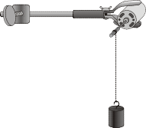
Figure 1

PURPOSE

The purpose of this experiment is to measure the power and electrical energy used by an electric motor in lifting a mass, thereby increasing the gravitational potential energy of the mass. From these results, the efficiency of the motor is calculated and further studied by lifting different masses.

MATERIALS
Computer
Vernier computer interface Wires with clips
Logger Pro Ring stand
One Vernier Current Probe and Clamp with arm one Vernier Differential Voltage Probe mass set
or, one Current & Voltage Probe System string Adjustable-voltage DC power supply Angle clamp
Electric Motor Small wood dowel or metal rod

SETUP AND PRELIMINARY QUESTIONS

- Connect the Current Probe to Channel 1 and the Differential Voltage Probe to Channel 2 of the computer interface.
- Open the file “30 Electrical Energy” in the Physics with Computers folder.

- Set up the motor apparatus as shown in Figure 1. There should be an axle on your motor where the string can be wound as the mass is lifted. Allow room for the mass to be lifted at least 0.5 m; a longer distance would be better, such as 1 meter, if possible. Make a loop at the end of the string for connecting the mass.
- Connect the circuit as shown. Take care that the positive (red) lead of the Voltage Probe and the red terminal from the Current Probe are oriented toward the + terminal.
- With the power supply off, click , then click to zero both sensors.

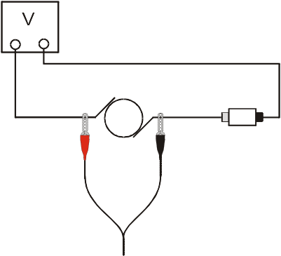
+ -
M
Current
probe
I
Red
Black
Voltage
probe
Figure 3
- Set the voltage control on your power supply to 0 V. Turn on the power supply and gradually increase the voltage setting. Watch the motor to see when it starts to turn slowly. Control the voltage so that the motor turns slowly and lifts the mass slowly. Set the control to 0 V when the mass reaches the top.

- Explain the energy changes that take place as the mass is lifted.
- Without making any measurements, make a guess of what you would expect for the efficiency of this electric motor; that is, guess the percentage of the electrical energy that goes into lifting and the fraction that is wasted as heat.

PROCEDURE

- Check the voltage rating of your motor. This is the maximum voltage you should use. If you are not sure of the rating, ask your instructor. Record the voltage rating in the Data Table.
- Make sure the power supply is set to 0 V. Place a 50 g mass at the end of the string as the load to be lifted. Click to begin data collection. Turn on the power supply and gradually increase the voltage setting. Watch the motor to see when it starts to turn slowly. Control the voltage so that the motor turns slowly and lifts the mass. The goal here is to get a graph of voltage and current readings for the complete process of lifting the mass from the low point all the way to the top. You have 30s to make the lift. If necessary, repeat this step until you get a good run.
- On the power vs. time graph, drag the mouse over the region when the mass was being lifted. Click the Integrate button, . The area under the power vs. time graph will be displayed in a floating box. Note: The area, or integral, value has units of W-s, or J. Record this value in the Data Table.
- Increase the load by 20 g and repeat Steps 2 – 3. Again, make sure you get voltage and current data for the entire lift. Note the mass used in each run in the data table below.
- Repeat Steps 2 – 4 until the motor will not lift the load without exceeding its voltage rating (seems to include 7 runs or to 170g).

DATA TABLE

Distance Mass was lifted (m)
Voltage rating of motor (V)

Run | Load Lifted (g) | Electrical Energy Used (J) | Mechanical Energy Output (J) | Percent Efficiency (%)
1
2
3
4
5
6
7

ANALYSIS

- For each experimental run, calculate the increase in gravitational potential energy of the mass and record it in the Data Table.

- For each run, calculate the efficiency of the motor; that is, what percentage of the electrical energy into the motor was converted to gravitational potential energy? Record your answer in the Data Table.
- For which load was the motor most efficient?
- What happened to the remainder of the electrical energy that went to the motor?

EXTENSIONS

- On Page 3 of the experiment file, plot a graph of the efficiency of the motor as a function of the load. Print or sketch a copy of the graph.
- Investigate the efficiency of the motor at different speeds using the same load.
- Try other motors and see if you can find more efficient ones.
- Use a temperature probe to monitor the temperature change of the motor.
- Show that the following units are equivalent: 1V × 1A = 1 J/s.

- Can you use your motor as a generator? Raise the mass using the motor and hold it at the top by hand. Turn off and remove the power supply. Connect a 10 Ω resistor between the leads on the power supply. Take current and voltage data of the power generated by the falling mass as it turns the motor. You may need to add more mass. Compare the power measured in Logger Pro to the change in gravitational potential energy of the falling mass.

